Geology Assignment #2: Topographic Mapping Name:
37 points total
1. Describe a topographical (“topo”) map to someone who has never seen one before. [2 points]

2. Answer the following questions using the easting and northing reference grid on the map below [5 points]: (http://www.physicalgeography.net/fundamentals/2b.html)
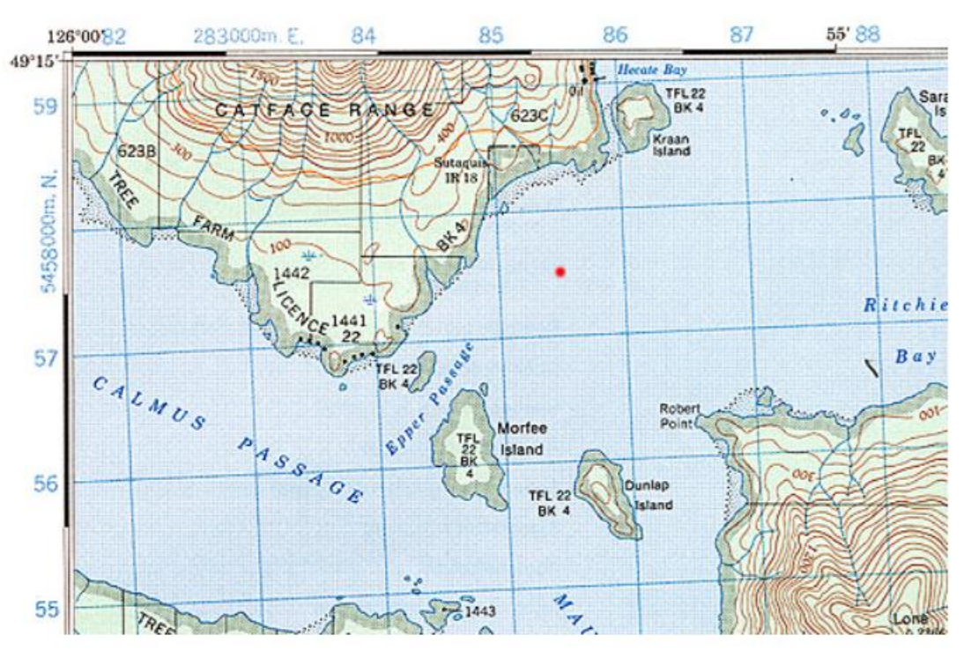
a. What is located at grid reference for:
i. 858558?
ii. 882570?

b. What is the grid reference for:
i. the red dot in the middle of the map?
ii. Robert Point?
iii. The western entrance to Epper Passage?

3. A ratio scale expresses the mathematical relationship between a specific measurement on a map and the distance it represents on the surface of the Earth. [2 points]
a. What does the ratio scale 1:24,000 mean?
b. What is the actual distance on land (in km) of an 8 cm line on a map using that scale (1 km = 100000 cm)?

4. Decide whether a map with a scale of 1:24,000 or 1:50,000 would display features in finer detail. Justify your decision. [2 points]

5. Which map scale shows a larger geographical area: 1 cm = 10 km or 1: 50,000? Explain your reasoning. [2 points]

6. Calculate the approximate surface area of the island in the map shown. Show all your calculations. [2 points]
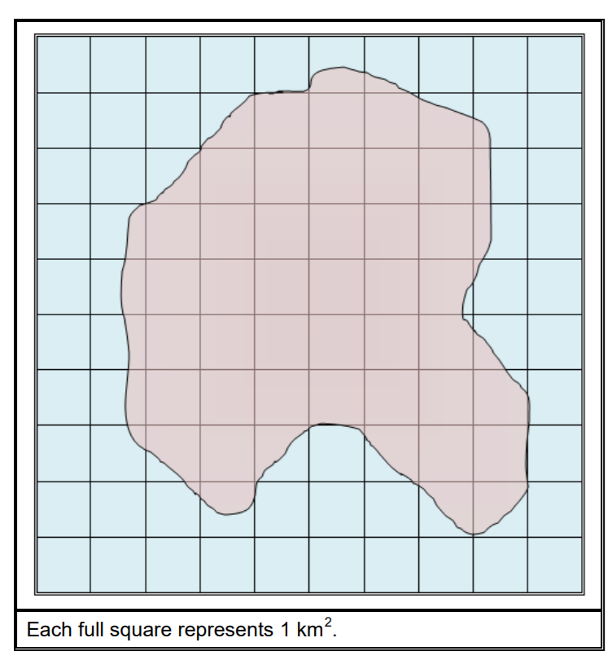

7. On the map shown below, identify 5 topographic features that are present in the area and explain how you know. [5 points] Go to http://www.physicalgeography.net/fundamentals/2d.html to see what some of the symbols mean on the map.

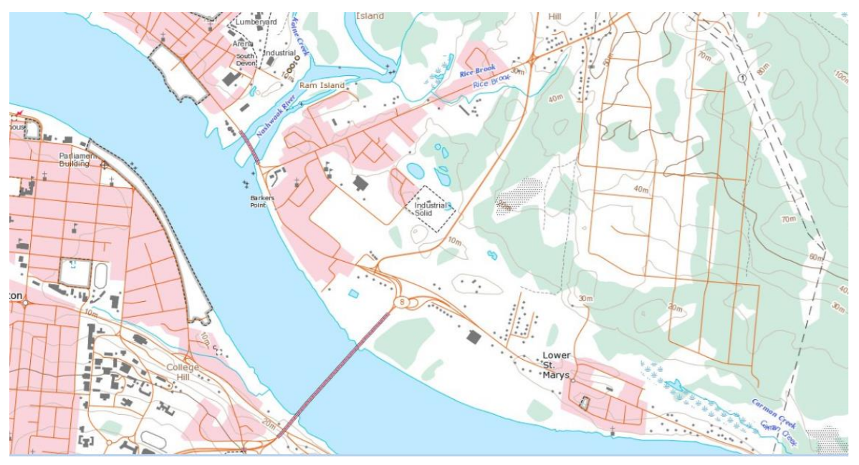

8. Explain the statement: "The spacing of contour lines gives a visual indication of gradient." [2 points]

9. Road signs in hilly or mountainous areas will often indicate the grade (“slope”) of the hill as a ratio such as 1:5, or as a percent, 20% [2 points].
a. Calculate the % grade of the hill shown in the diagram.
b. What is the ratio expression of this gradient?

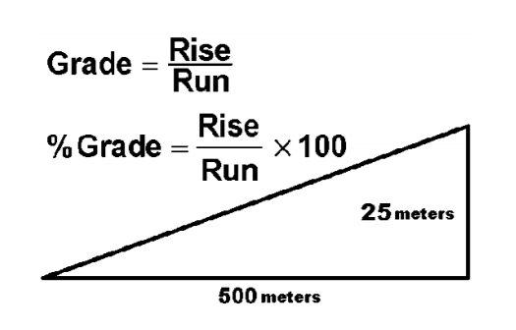

10. Review how to construct a topographic contour profile. Using the map below, create your own profile by hand, then staple your completed image on to your assignment. The contour interval is 10 m. The actual distance on land between the two points is 1.15 km (1150 m).
Draw a contour profile from point A to Point B, dividing the y-axis into increments of 10 m. [2 points]
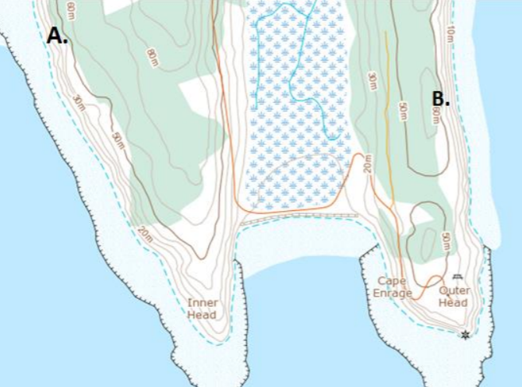
11. Using the same map from the previous question, describe what you would see as you walked along the road from the upper part of the map down to the end. This map shows a well-known NB Bay of Fundy landscape. Describe landforms, vegetation, views and any other points of interest along the way. Identify the star-shaped symbol at the end of your trip. (Not sure? The lat/long designation for the feature is 45.600366 N 64° 782807 W) [2 points]

12. Answer the following questions for the maps indicated.
Map 1: Alma, NB [7 points]
a. What type of landscape is represented on the map (brief description)?
b. In which direction does the largest river flow?
c. What do the varying yellow and green colours tell you?
d. What is the contour interval on the map?
e. What is the highest elevation on the map?
f. What is the feature shown below Joel Head?
g. In which direction does Kinnie brook flow?

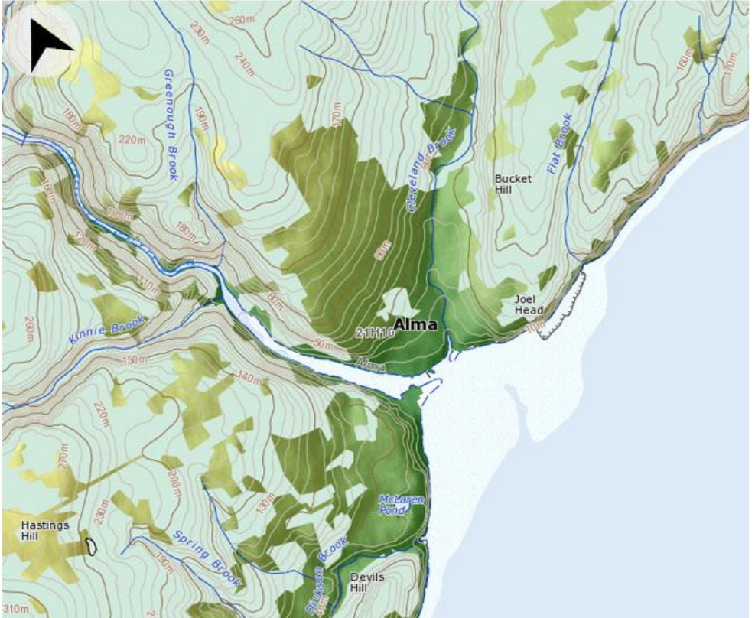

7 Map 2: Alma, NB [2 points]
a. How does this map differ to the first map?
b. What is the highest elevation on the map?

