Physical Geography 110 - Meteorology Assignment
PART A
1. Define what is involved in the field of meteorology.
2. What is the difference between climate and weather? Explain briefly.
3. Identify the five types of air mass found in North America and explain how they influence the vast range of weather that North America experiences.
4. In general terms, why is our weather affected—or created—when air masses meet?
5. Which “jet stream” affects Canadian weather most? Describe it and include its location.
6. Atmospheric pressure has important effects on weather.
a. What are two differences between high and low pressure systems?
b. What do pressure systems have to do with “wind”? [2 points]

7. What are “contrails”?
8. In one line, describe a weather front.
9. In simple terms, state three differences between a warm front and a cold front.
10. Besides weather stations on land, from where and how do meteorologists collect weather data?
11. In Canada, depending on the season, we often hear the terms “humidex” and “wind chill”. Research each term on the Weather Network site (or somewhere else), and explain both.
PART B
Go to this website http://cimss.ssec.wisc.edu/satmet/modules/7_weather_forecast/wf-1.html then answer the following questions:
1. Why is weather forecasting compared to an experiment with several dependent and no controlled variables?
2. Where is it raining on the satellite map on screen 2 of the activity? (You may have to refer to other maps to assign names to the Provinces and States for your descriptions!)
3. Where are the three low pressure centres? [3 points]
4. Where are the three areas of rising air (aka warm fronts)?
5. How can you tell where “fronts” occur on a satellite image?
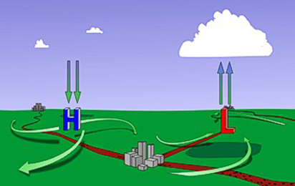
6. Explain the image shown.

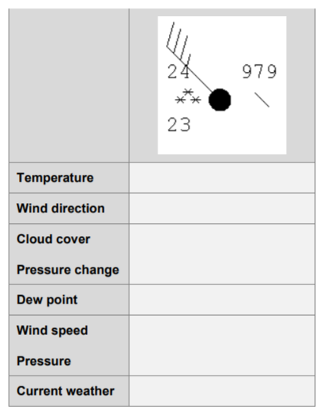
7. Review screen 5 of the activity (Station Weather Plots and Symbols) and interpret the station weather plot in the table below.

8. Create a station weather plot (like part B #7) based on the local forecast for New Brunswick http://weather.gc.ca/canada_e.html . Draw the plot by hand.
9. Except for a few buoys, there are no surface station weather observations over the oceans. For which North American coast (Pacific or Atlantic) does this fact make weather forecasting more challenging, and why?

