Introduction to Determining the Limit of a Function
The limit of a function is defined as the range value (y-value) that a function approaches as x approaches a certain value. One way to determine this outcome is to graph the function and visually determine the range value that corresponds to the value x is approaching.
For example, a function is defined as f (x) = 2x + 1, and you are asked to determine the limit of 2x + 1 as x approaches 2. You begin by drawing the graph of the function like this:
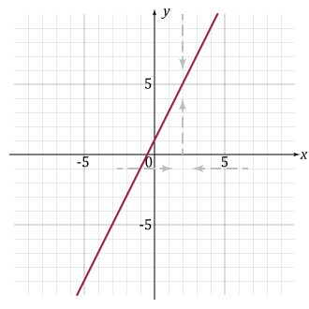
Here, you can see that no matter the direction from which you approach 2 on the x-axis, the corresponding y-value approaches 5.

Now, observe the following table of values based on y = 2x + 1:
x | f (x)
1.5 | 4
1.9 | 4.8
1.99 | 4.98
1.999 | 4.998
1.9999 | 4.9998
1.99999 | 4.99998
x | f (x)
2.5 | 6
2.1 | 5.2
2.01 | 5.02
2.001 | 5.002
2.0001 | 5.0002
2.00001 | 5.00002
Notice that the closer x gets to the value of 2 from either direction, the closer y gets to the value of 5. You can summarize your findings by writing the limit of a function with the proper limit notation:
This reads as the limit of the function f (x) as x approaches a is L. For the example above, you write the following:
As you have seen in previous lessons, some functions produce graphs with asymptotes, which are lines that the graph of a function approaches but never touches or crosses. Limits do not exist when approaching x-values that correspond to the location of vertical asymptotes, or if they do exist, they are not a finite value. This will be explained in more detail in subsequent lessons.
For now, consider the graph of the function 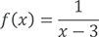:
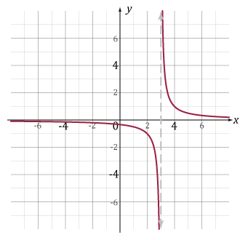
There is a vertical asymptote at x = 3 because the function is undefined at x = 3 (substituting x = 3 into the function would make the denominator zero).
As x approaches 3 from either side, there is no finite number that y approaches. Therefore, the limit as x approaches 3 Does Not Exist (DNE).
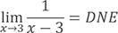
You have also studied graphs that have a point of discontinuity. If the equation of the function 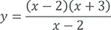 can be simplified to y = x + 3, y ≠ 2.
The graph is show below. There is a point of discontinuity at (2, 5):
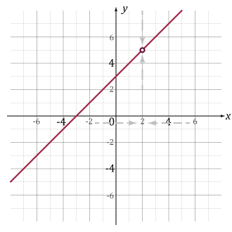
On the graph, as x approaches 2, the y-value approaches 5. Even though the point (2, 5) is a point of discontinuity, the closer the x-value gets to 2, the closer the y-value will get to 5. Therefore, 

