Properties of Matter
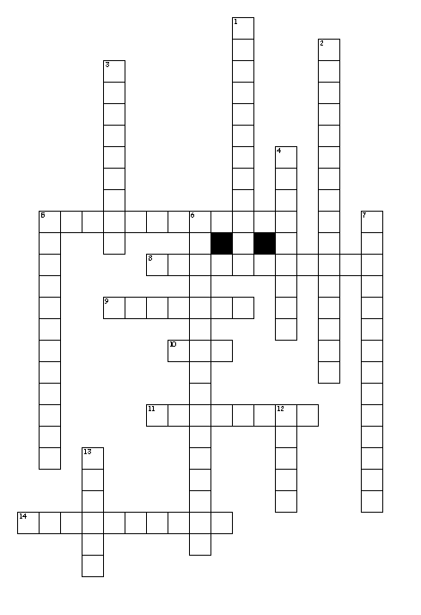

Across
5. The temperature at which a substance changes from a solid to a liquid
8. The solid form of many minerals in which you can see a definite structure of cubes or blocks with a regular pattern
9. The amount of matter per unit volume
10. State of matter where a substance takes the shape of its container and always fills the entire container
11. A measure of the resistance of a solid to being scratched or dented
14. The ability of a substance to dissolve in a solvent such as water
Down
1. The temperature at which a substance changes from a liquid to a gas
2. Describes the behavior of a substance as it becomes a new substance.
3. refers to how easily a liquid flows
4. The ability of a substance to be pulled into wires
5. the ability of a substance to be hammered or bent into different shapes
6. A characteristic or description of a substance that may help to identify it.
7. Property that describes the ability of a substance to react with oxygen to produce carbon dioxide
12. State of matter where a substance has a fixed shape and a fixed volume
13. State of matter where a substance will take the shape of its container but has a fixed volume

