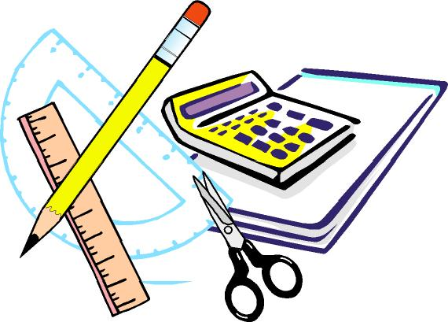
Keswick Valley Memorial School
Grade 3-5 School Supplies List 2021-2022

On the back of the page, you will find the list of supplies that your child will need for next year. This is a general list, there may be some additional items requested by the homeroom teacher at the beginning of the school year.
All books, tools and clothing should be clearly marked as belonging to your child. It is a good idea to keep a back-up set of some supplies at home for project work. We encourage our students to reuse their supplies from past years if they are in good condition.
We encourage you to look around a little before you begin your shopping, as many stores (such as Staples and Wal-Mart – they will price match flyers!) have incredibly low prices on school supplies in late summer, better even than Dollarama or similar places.

Student fee $30 and needs to be paid no later than September 30th.
Fees will cover a variety of consumable items such as: duo tangs, supplies for experiments, crafts, projects and other curricular activities, special events, photo finishing, rewards and incentives, etc.

We are very much looking forward to seeing you in the fall!
Have a fantastic summer!
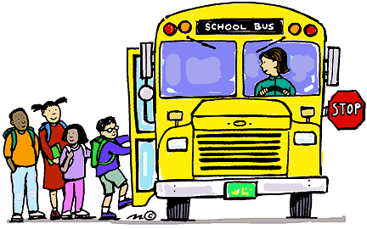
- 3 boxes of tissues (This may need to be replenished before the school year ends)
- 1 heavy-duty plastic duo tang with pockets (for homework and notices)
- 4 ½ plain, ½ lined exercise books (72 pages)
- 2 pkg. of 10-page protectors
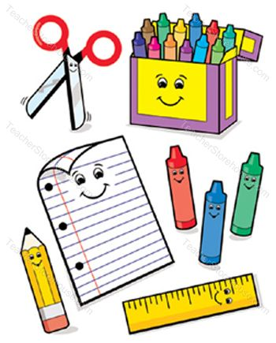
- 2 large glue sticks
- 1 pair of scissors
- 1 pkg. wax crayons
- 1 pkg. Crayola markers
- 1 pkg. pencil crayons
- 1 pkg. of highlighters
- Approximately 50 pencils (“Staedtler” brand or comparable)
- 8 white erasers
- 30cm ruler
- 1pkg. each medium and large zip-lock baggies
- 1 coil notebook
- 1 hard-covered journal (non-coiled, “Composition”)
- 1 sketchbook (not scrapbook)
- 1 pkg. of assorted color card stock
- 1 pkg (200 sheets) loose leaf
- 1 basic calculator
- 3 pkgs. whiteboard markers
- Handheld pencil sharpener (with a cover)
- 1 black fine-tip Sharpie
- non-marking sneakers
- backpack
- pencil case or box
- 1 pair of headphones (Grades 3 & 4 only)
Please do not send binders, liquid paper, electronics and mechanical pencils.
If you have any questions or require clarification, please do not hesitate to contact us by calling the school (363-4717).
Thanks in advance,
KVMS Elementary Team

