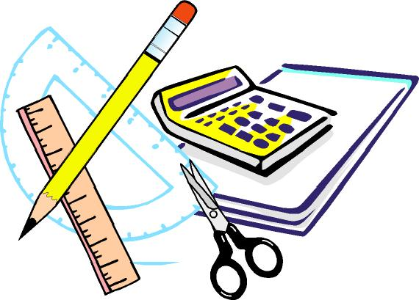
Keswick Valley Memorial School
Grade 1-2 School Supplies List 2021 - 2022

On the back of the page, you will find the list of supplies that your child will need for next year. This is a general list; there may be some additional items requested by the homeroom teacher at the beginning of the school year. It is also a good idea to keep a back-up set of some supplies at home.
We encourage you to look around a little before you begin your shopping, as many stores (such as Staples and Walmart – they will price match flyers!) have incredibly low prices on better quality school supplies in late summer, better even than Dollarama or similar places.

Students are not asked to change into gym clothes at this age but should have a change of clothing in the event of an emergency in a plastic bag with their name on it. They also need proper fitting non-marking soled sneakers for indoors and for Physical Education classes.
Student fees will be $30.00 and is due by September 30th through Cash Online. Fees will cover a variety of consumable items such as: duotangs, supplies for experiments, crafts, projects and other curricular activities, special events, photo finishing, rewards and incentives, etc.

We are very much looking forward to seeing you in the fall!
Have a fantastic summer!
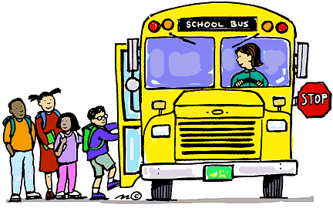

. 2 packages of HB or Dixon pencils *Grades 1 & 2 only
. 1 package of black triangle-shaped pencils (DIXON triconderoga HB2) *2 packages for Kindergarten
. 3 white erasers
. 3 boxes of Kleenex
. 2 packages of whiteboard markers (Dollar Store)
. 1 box (EXTRA – LARGE) Ziploc baggies
. 1 box SMALL (SANDWICH -SIZE) Ziploc baggies
. 2 packages of thick-tip Crayola markers
. 2 black “Sharpie”s
. 2 packages of page protectors (10 per pack)
. 1 piece of white bristol board (to be used for an art portfolio) *Grades 1 & 2 only
. I package of cardstock (any color/ any amount)
. 6 large glue sticks (UHU yellow are the best)
. 1 package of pencil crayons *Grades 1 & 2 only
. 1 package of wax crayons *Kindergarten only
. 1 Half and half Hilroy books (½ plain / ½ lined)

PLEASE LABEL the following items:
. Lunch bag
. Backpack
. Indoor non-marking sneakers (if your child can not tie, please send slip-on or Velcro shoes)
. Change of clothes (put in plastic bag and label bag please)
. 1 pair of metal scissors (if your child is left-handed, please purchase left-handed scissors)
. 1 dry erase white board (Dollar Store ones are perfect!)
. 1 artist sketch book *Grade 2 only
. 1 LARGE coil scrapbook (Hilroy) *Kindergarten only

If you have any questions or require clarification, please do not hesitate to contact us by calling the school (363-4717)

Thanks in advance!
KVMS Primary Team

