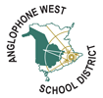
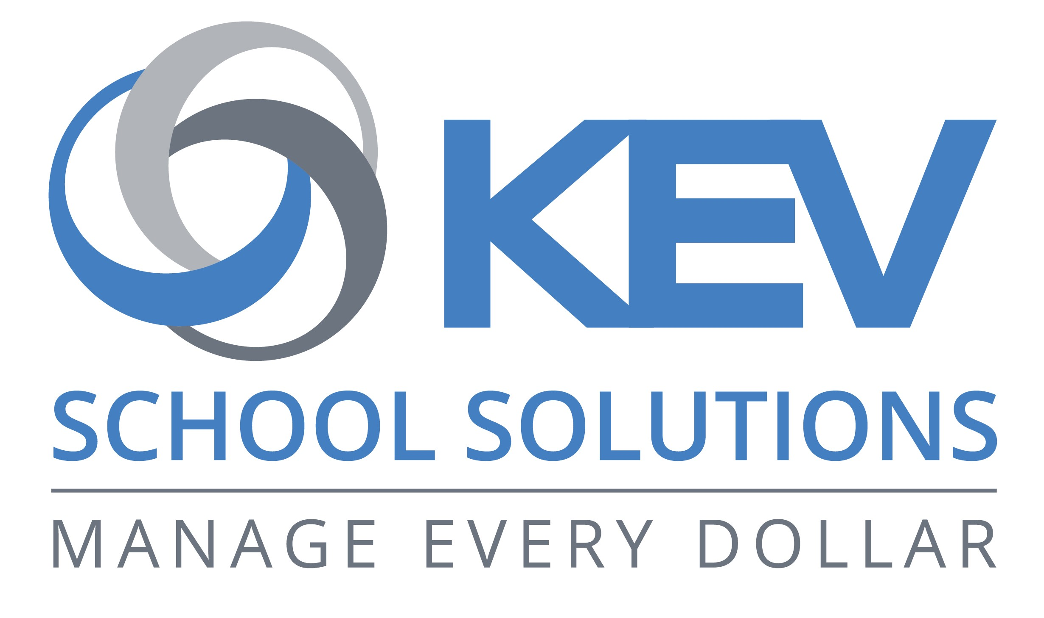
Register today for online school payments

During the COVID-19 pandemic, Anglophone West School District is striving to improve safety and reduce risk wherever possible. One safety measure is minimizing cash and check payments at our schools. To accomplish this, we use SchoolCash Online for all school items and activity fees. We encourage all parents to register now for a free account:
- Be ready to receive email notifications as new fees or items become available for purchase.
- Keep track of all school items and activity fees, pay online, and manage all students in your household from one location.
- Review your account history and view/print receipts.
How to register  - Go to https://anglophonewest.schoolcashonline.com/ and click Register.  - Type your first name, last name, and email address, and create a password.  - Select a security question.  - Select YES to receive email notifications. You will not receive any marketing emails. Selecting YES enables the system to send you fee notifications.  - SchoolCash Online will send a confirmation email. If you don’t receive it, check your Spam folder.  - Use your email address and password to log in. | How to add students to your account  - Sign in to SchoolCash Online: https://anglophonewest.schoolcashonline.com/.  - At the top of the page, navigate to MY ACCOUNT.  - From the dropdown menu, select My Students.  - Click to add a student:  - Type your School Board Name.  - Select your school name from the list.  - Enter student details. The system is fully secure, with PCI certification.  - Click Confirm.  You may add up to eight students on your profile.
How to make a payment
- You will be able to view any available items attached to your students that are set up on your account.
- Select the item which you would like to purchase and click "Add to Cart."
- Once you have finished adding items to your cart, select "Check Out" to make a payment.

