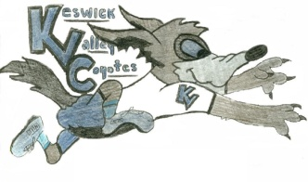
Monday June 1, 2020
Hi everyone, I miss you! Here is a fun challenge you can get involved in. These are fun games and easy to do at home. I uploaded this to the Athletics and Activities page already and school website.
As we enter June we think about track & field, field days and fun end of school events, with this in mind the Phys Ed Team in ASD-W has put together a Spring Games Challenge. These challenges require equipment that most of us have at home or are easily adaptable and we’d like your students K-12, teachers, staff and school community to take part. It is a great Physical Activity & Wellness Challenge for all.
Starting on June 1st we will be releasing a video and challenge card via our Twitter Pages (@jcrossland15 @rosscalder74) and the NBPES YouTube Channel https://www.youtube.com/playlist?list=PL2ZiLbnHH6WF4hDrRZm8Gy8aWjMXbelp2 , the object is to take part in that activity of the day, save your score via the scoresheet attached and share a video taking part using the hashtag #ASDWSpring
Attached are the game cards and score sheet, the YouTube channel will be updated by Monday. All the information above is posted here: http://nbpes.ca/asd-w-nbpes-spring-games-challenge/ If you could include this in your weekly learning options we would appreciate it as well as sharing on your social media channels.
There is no need to register, please share with your students, staff and school communities.
ASD-W Phys Ed Team

