 November 2021
Monday | Tuesday | Wednesday | Thursday | Friday
1 | 2  Hot Lunch – GCB   | 3 | 4  MAS Home/School and PSSC Meeting 6-8 | 5  Hot Lunch - Pizza
8 | 9  Hot Lunch – GCB | 10  Remembrance Day Assembly | 11  No School  Remembrance Day | 12  Hot Lunch – Pizza  Diabetes Awareness Day
15  Dec Hot Lunch Forms Home | 16  Hot Lunch – GCB | 17 | 18 | 19  No School  Teacher PL
22 | 23  Dec Hot Lunch Forms Due  Hot Lunch – GCB | 24 | 25 | 26  Hot Lunch – Pizza  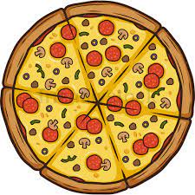
29  Report Cards Home | 30 | News and Notes:  Winter is here! Please send students with hats, mitts, and warm footwear.  Dec 2 – Parent Teacher Interviews in the evening  Dec 3 – Parent Teacher Interviews in the morning (No School for students)  Dec 20 - Holiday Week at MAS!  Dec 23 – Last day of school

