Assessment SP3 SP4

Name: ____________________________

Multiple Choice

- If you roll a die (standard number cube), which is certain to happen?
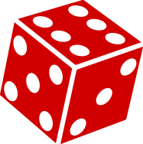
- You will not get a 1
- You will get a number less than 7
- You will get a 6
- You will get a number greater than 10

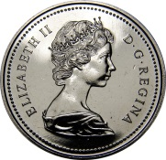
- Sue tossed a coin 20 times. How would you describe the probability of Sue’s coin being heads?
- impossible
- unlikely
- equally likely
- certain

- You roll two standard dice. How would you describe the probability of the sum of the dice being 12?
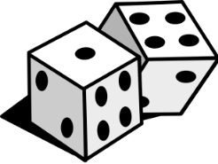
- impossible
- unlikely
- equally likely
- certain

- Jake spun the spinner shown below. How would you describe the probability of Jake spinning an odd number?
2
4
6
8
- impossible
- unlikely
- equally likely
- certain

- You roll two standard dice. How would you describe the probability of the sum of the dice being 7?
- impossible
- unlikely
- likely
- certain

Short Answer:
- Someone put 200 blue cubes and 20 red cubes in a bag. You pull out a cube.
What is the likelihood that the cube you picked will be red? Use the words: impossible, unlikely, likely, or certain to describe. Explain.

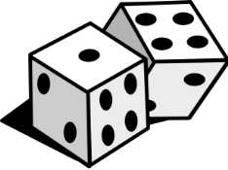
- You roll 2 dice. Why is the probability that they add to 3 not the same as the probability that they add to 7?

- You have a bag of coloured cubes. You pull out a cube, write down the colour and put it back. You do it 20 times. These are the results.
Red 10
Blue 5
Yellow 2
Green 3

Explain what you know about the number of the different coloured cubes in the bag.
- You have a paper bag containing 10 coloured tiles: five red, two blue, one yellow, two green. Your friend is going to draw one tile from the bag. Describe and explain the colour tile(s) that is:
- more likely to be drawn
- equally likely to be drawn
- less likely to be drawn

Constructed Response:
- Draw a spinner and put numbers in the sections to make the following true.
- Spinning a 1 is less likely
- Spinning a 3 is more likely
- Spinning a 2 is impossible

- You have 5 red tiles and 5 yellow tiles. You can place some or all of these tiles in a bag. What would you put in the bags to make each of the following true?
- It is certain to draw a red tiles.

- It is equally likely to draw a red or a yellow tile.

- It is impossible to draw a red tile.

- Give an example of an event happening tomorrow for each probability below. Explain your thinking for each.
- Certain

- Impossible

- Possible

