Week 4 Continuation of Learning May 04-08, 2020.
Grade 2 Belyea

Hello everyone,
This week our Continuation of Learning plan has been designed around suggestions given to teachers from ASD-W. Many resources are being added for teachers to use in their weekly planning. I think you will really enjoy the activities.

On Wednesdays I will be checking my email, from 10-11 am to answer any questions you may have. I really like what parents are doing at home and appreciate your support.
Reminders:
In addition to the activities suggested, students are encouraged to:
- Read daily for 30 minutes- Take time to read to or with your child and encourage them to read independently.
Scholastic Read at home: divided up by day 1, 2 etc.., with activities and reading.
This is a great link for SCIENCE
2.https://classroommagazines.scholastic.com/support/learnathome/grades-1-2.html Grades1-2
https://classroommagazines.scholastic.com/support/learnathome/grades-3-5.html Grades 3-5

3. EPIC books- available during the day
https://www.getepic.com/ - Our class code is zgc2046
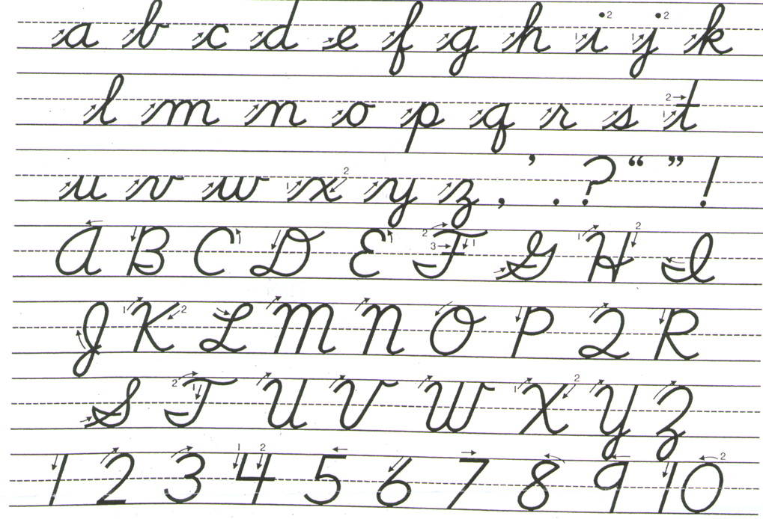
Please practise cursive writing for a few minutes each day. Practise makes perfect!

Grade 2 Literacy Activities
Literacy Learning at Home
Grade Two
Write a thank you letter to your mail carrier, garbage collector, delivery person (Amazon packages, Fed. Ex., Skip the Dishes, etc.). Attach it to your door or garbage can.
SHARE
Set a timer for 5 minutes. Have your child make a list of things that
make them happy. Ask them to choose 3 to write about.
What other words mean happy (joyful, elated, ecstatic)? Challenge your child to use interesting words when talking throughout the day.
EXPLORE
CREATE
Make a word web for a feelings word or a word web
for all the feelings a character in a story had.
WRITE
READ
Read and think about a character in your book or from a show
you have watched. What is this character like? How are you
similar to this character? How are you different from them?
Write a list of similarities and differences.
Here are some options for you to choose from to help improve your literacy
skills while you are at home. Challenge yourself to try one each day and have fun!

List all the things you can do to help the Earth stay
healthy – think about the 3 R’s (reduce, reuse, recycle)

Numeracy- pick one to do each day and have fun!

Get Creative  Make Cloud Dough! Put ½ cup of lotion or conditioner and 1 cup of cornstarch in a bowl and combine. You can add food coloring if you like.  Store it in an airtight container so it stays soft. | Shapes and Sorting  Sort some of your blocks, Lego or other small toys. How did you sort? Can you sort another way?  Look around your house for 3D shapes. Where do you see ball or box shapes?  Work on a puzzle. | Addition  and Subtraction  Roll a die (or make number cards 0-10). How many more would you need to add to get 10?  Choose one domino at a time (or make your own) How many dots on each side? How many altogether?
Get Outside  Hop to a chalk number, count on, and back. Hop to a number and say the number that comes before (1 less) and after (1 more) or 2 more/less.  Find things in nature and put that many things on each number. For example, find 4 sticks or toys and put them on the number 4. | Measurement  Use your cloud dough to form numbers, shapes, or to fill different size containers and compare how much each one holds. Which one holds more? Which one holds less?  Put all the spoons in your kitchen in order from shortest to longest. | Wellness  Find a quiet spot. Close your eyes and put your hand on your belly. Count up as you breathe in, and count down as you breathe out. How high can you count? Start at different numbers!  Write or draw 3 good things that happened this week.
Tech Time
Math Playground: https://www.mathplayground.com/ Free math games
Math Toy Box http://mathtoybox.com/ Games and online tools
Greg Tang Math Games https://gregtangmath.com/

