May 16-22, 2020
Hello Friends!
A few of you have shared with me that your sunflowers have already sprouted. That is so exciting! My daffodils were burried when it snowed, but they are bright and sunny again. I posted a feel good Friday video on the MAS Home and School Facebook group and you can see some of my tulips that have just blossomed. Happy Birthday to Mason who turns 7 on May 16! Remember to go with the flow, make smart choices and keep your dear family happy I love to see what you are up to at home, so keep sending me pictures/videos of all the fun things you are doing!

Parents/Guardians:
These activities can be used as guidelines and altered as needed. If you feel like you need some activities that are more tailored to your child’s level please let me know.
I have gone with the choice mat format again for this week’s plans. There is one for writing, one for word work and reading and a mat for math. Try to choose one activity from each mat to make up your hour of learning each day. I know that some of you are heading back to work and your child may be heading back to daycare. This is going to be yet another adjustment for families so please do not feel pressured to complete a full hour of learning in the evenings. Fit in what you can, when you can. I do recommend practicing sight words and math facts (especially the 10 partner facts) daily. You can do a quick run through using the incremental rehearsal format or post a combination of known and unknown words in a high traffic area and have your child read the words every time they see them (mirror in the bathroom, on the fridge, in a hallway or on a door where they can high five the words as they read). I did not include a daily read aloud, but you can access read alouds on www.getepic.com or www.storylineonline.net. As always, I appreciate your feedback.
I am looking into holding small group sessions on Microsoft teams. This would give the students a chance to connect with each other and would give us a chance to work on specific skills.
Thank you for all of the pictures and videos that you have shared with me. I truly appreciate you including me in your lives. Thank you for all that you are doing for your child.
In addition to the activities suggested below, everyday students are encouraged to:
- Read for 15 minutes- Take time to read to or with your child and encourage them to read independently. This would be a great time to use Raz-Kids if you wish.
- Be physically active for 30 minutes. Please see Ms. Bush’s amazing activities below.
- Take time to play and/or create something. Exercise those imaginations!
- My ‘office hours’ this week are 10:00- 12:00 Wednesday morning, when I will be online and available immediately. Please feel free to email me at any time and I will respond as soon as I am able. If your child has something they would like to share or are struggling with a particular activity please reach out and we can do a video chat or phone call at any time.
Writing Activities for Week 6
Select an activity each day to complete. You can select different activities or repeat your favourites. Some activities will be completed over multiple days.
We write lists ALL the time! A list is how we keep our thoughts organized using words or short sentences that are written on top of each other, moving from top to bottom. A list has:  a title  words or short sentences connected to your title (main idea)  You list could also include pictures.  Practice making a list on whatever topic you are interested in. Some ideas to get you started:  -toys in your room  -favourite foods  -things you see outside  -grocery list  -your schedule for the day | Spring weather is always changing! Listen carefully to how weather reporters share their news. What words do they use? How do they speak? Do they add expression? Write your own weather report then pretend you are on the news and read your report to someone in your house or someone you can call on the phone. You could also record your weather report and send it to someone (like Mrs. Davis).  You could also keep a daily weather journal.
Keep a daily journal to document the growth of your sunflower seeds. Write down the steps you took while planting them and record the changes you see. Write about where you put you plant pot, when you water it and measure the seedling once it sprouts. Add illustrations to your journal. | Draw a detailed picture of a flower or a tree. Label the parts of your flower (roots, stem, leaves, petals) or tree (roots, trunk, branches, leaves).  Write some sentences to tell about your flower or tree.  Ex. This is a tulip. Its petals are pink and it blossoms in the spring.
Go through a photo album or photos on your phone and tell your child the story of that photo, focusing on the story elements of: beginning, middle, end, where it took place (setting) and who was there (characters). Have your child choose a different photo and tell a story that matches the photo. Have them write their story down after they tell it. | Visit https://jarrettlerner.com/activities/ and check out the “Finish This Comic!” section. You can print them off or use them as inspiration and draw your own version. Remember that comics use speech bubbles to tell what the characters are thinking and saying. Below is a letter writing activity from the website.  There are also directions for drawing people so that they look realistic. You can check out all of the other fun activities on his page too.
Students should spend around 20 minutes writing each day. Remind your child that writers:
-start their sentences with capital letters and use lower case letters the rest of the time. Names of people and places, days and months and titles of books and movies also get capital letters.
-level finger spaces between each word.
-do their best to represent every sound they hear when sounding out a word.
-use books, word lists and environmental print to help them spell words.
-take their time and print neatly.

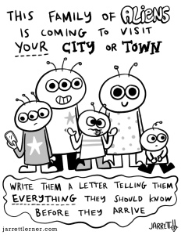

Reading and Word Work Activities
Week 6
Watch the link below to see how we play Hangman in grade 1. Play a few games using sight words, words with long vowel sounds or spring vocabulary words. I’ve attached an illustrated list of spring words that may be useful for this activity as well as writing.  https://www.youtube.com/channel/UCy-GqPVIe9AG60eKQ4ESpCQ | Click on the link below to listen to the story  The Tiny Seed  https://bookflix.digital.scholastic.com/pair/detail/bk0132pr/start?authCtx=U.794217314  How did the story make you feel?  Retell the story by telling where the story happened (setting), who was in the story (characters) and what happened at the beginning, the middle and the end.
Make a chart with a column for each vowel. Read the words on the Spring Words chart and listen for vowels that say their name. Write the word down in the correct column on your chart. How many words have “two vowels walking, the first one does the talking” and how many have a “bossy e” at the end that jumps over a consonant to make the vowel say its name?  a e i o u  baseball | Play sight word SPLAT or try one of the other games from last week’s list.  Can you make up your own game to practice your sight words?
Go on a word hunt in your home for words that have L blends: cl, bl, fl, gl,pl, sl. Write them down as you find them. You can look in books, on signs or posters, on packages, etc.  bl cl fl gl pl sl | Listen to Mrs. Davis read a book. After you listen to the story talk about what you noticed in the book. Was it a rhyming story?  Did you notice anything about the pictures?  How did the story make you feel?  Retell the story by telling where the story happened (setting), who was in the story (characters) and what happened at the beginning, the middle and the end.  https://www.youtube.com/channel/UCy-GqPVIe9AG60eKQ4ESpCQ

Try to practice a few sight words each day. You can put the words on the fridge and have your child read them each time they are in the kitchen. You can also put them in other high traffic areas (bathroom door, on the bathroom mirror, their bedroom door) and have them read the words or point to a word that you say. Tape the word on a wall and have your child jump to high five the word as you say it or they read it. As part of your bedtime routine you could go through the flashcards you made for incremental rehersal.
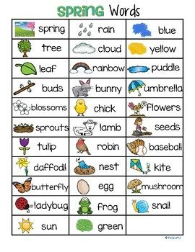

Math Activities Week 6
Select an activity each day to complete. You can select different activities or repeat your favourites.

Play Friends of 10  On a piece of paper have your child write the numbers 1-9. Use a spinner with the numbers 1-9 on it or use a deck of cards with the face cards removed. When your child spins a number/draws a card have them cover the number on their paper that is the 10 partner of the number they drew/spun. If I spun a 7 I would cover the 3 because 7 and 3 make 10. Continue until all of the numbers are covered.  You can write the numbers out twice and play against your child to see who can cover all of their numbers first.  Adding to 10 is a mental math strategy that students use often in grade 2, so it’s an important skill to start learning now. | Have your child roll two dice, use a spinner or draw two cards from a deck. Get them to use those to create an addition or subtraction story problem. They can act it out or write it down and then solve it.  Encourage them to use the counting on strategy where they say the greater number and then count on to add the lesser number. If I spin a 6 and an 8 I would say 8 and then count on 6 more…9, 10, 11, 12, 13, 14 (instead of starting at 1 and counting to 8 then counting 6 more).  https://www.didax.com/math/virtual-manipulatives.html (for dice and spinners)  You can also make a spinner by writing the numbers on a piece of paper in a circle, laying a paperclip or safety pin in the middle then placing the tip of a pencil in the paper clip/safety pin. Hold the pencil with one hand and ping the paperclip to spin it.
Head outside with some chalk and write some numbers to 20 on the ground. Toss a pebble and hop to the number it lands on. Count backwards to zero from the number that you are standing on. Hop to a number and say the number that is 1 more/less or 2 more/less than that number.  If going outside isn’t an option write the numbers on post its and stick them to the floor. | Read the 3D shapes poem below. See how many of the 3D shapes you can build.  To build the shapes you can use:  -playdough and toothpicks/dry spaghetti  -marshmallows and toothpicks/dry spaghetti  -playdough  -lego  -cardboard and tape
Online math options:  www.dreambox.com/canada  www.mathplayground.com  www.abcya.com (free to use on a desktop/laptop) There is an app that you can download for use on an iPad, but there’s a fee.  https://www.didax.com/math/virtual-manipulatives.html | Complete the Number of the Day page that was sent home in the page protector. Focus on numbers 11-20. Once your child has mastered those (representing it in different ways, can count on to that number, knows the word) you can move on to numbers to 50.  Add on question: will you say the number of the day if you skip count by 2s? by 5s? by 10s? Try it to see if your prediction was correct.

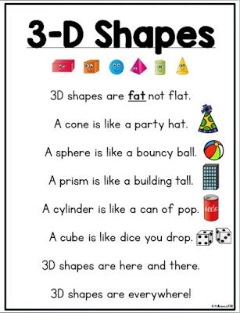

Science
I hope you have started to see some growth in your seed! Be sure to check on the growth often and note any changes. Plants give you lots of information just from watching! Maybe it isn’t getting enough water. Maybe too much. Be sure make notes in your journal! This way you’ll learn how often you need to add water or even if you need more light! Check out the graphic below for some help! Remember when your plant is about 1-2 inches tall you should move it outside during the day. This will get them ready to be planted outside.
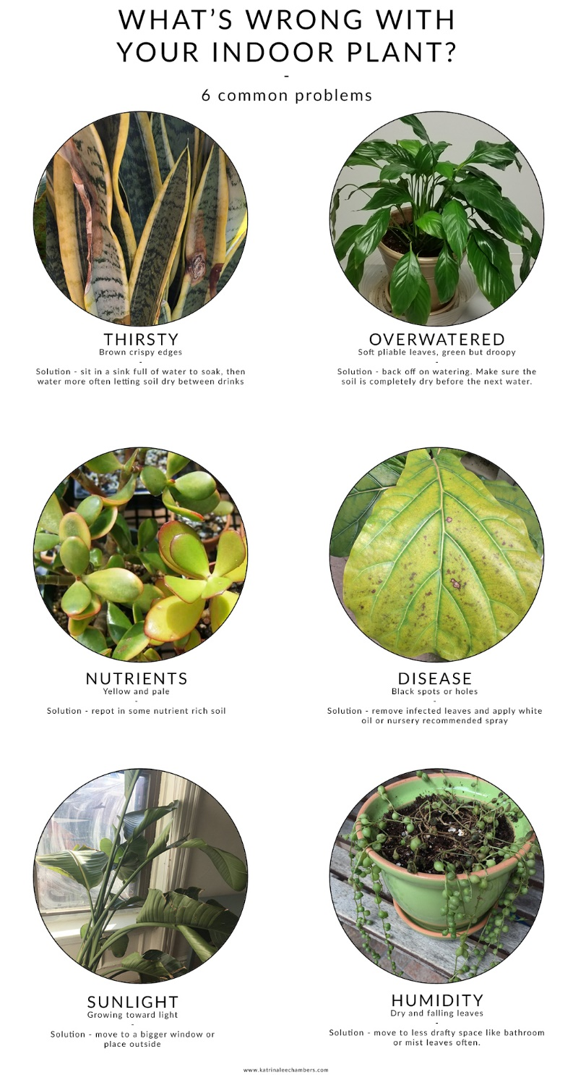 | There are many things in the soil that help make nutrient. One of the most helpful are worms! Check out this video from The Discovery Centre for some learning about worms and how important they are!  Worms are amazing little animals! One of the things discussed in the video is composting! Composting is the process of turning food scraps into soil! If you are not composting talk to your parents to see if you can start composting! It is a great way to help our environment!  Check out the pop bottle compost idea from this page:  https://www.pbs.org/parents/crafts-and-experiments/make-a-composter

Physical Education
Physical Education is self directed at home but if you are looking for a couple of suggestions check out these!
Get out side!!  With all this warm weather it is a perfect time to get outside for a bike ride! Check out these videos on selecting a place to ride and bicycle safety!  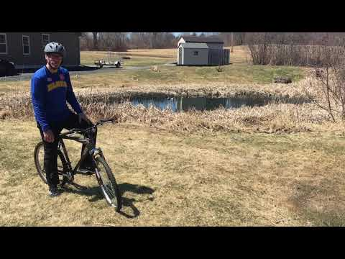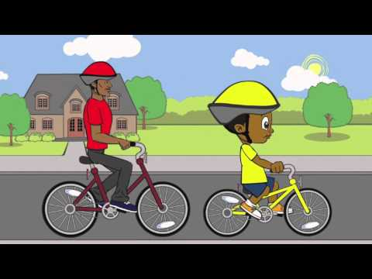  You can also make your own Bicycle Rodeo course at home! Check this site out for some ideas:  https://www.liveabout.com/bike-rodeo-events-365714  I hope you keep practicing your Jump rope skills!  https://www.youtube.com/watch?v=n7u1gvoXdG0  For the Advance Skippers Here are some tricks!  https://www.youtube.com/watch?v=UTntXRW4wYk |  |  |  |  | Stuck inside?  Why not tap into your inner superhero!
Weekly Challenge – Be kind to your furry friends.
Make a toy or a house for a pet!

Online resources:
https://scratch.mit.edu/ or www.code.org Students who wish to access their account can email alison.bush@nbed.nb.ca for their login and password.
https://musiclab.chromeexperiments.com/Song-Maker/ - Make some music. Share your links with Ms. Bush!
https://www.incredibox.com/demo/ - Make beatbox rhythms on this site! A definite favourite in the older grades!
http://isleoftune.com/ - a creative music making site!

