May 23-29, 2020
Hello Friends!
I hope you are spending lots of time outside playing and enjoying the sunny days. I have been drinking my morning coffee on my front step. I’ve also been doing some yard work so I have a place to put up a hamock. Sofie is not very helpful and loves playing with the sticks I’ve been cleaning up. Seeing all the leaves growing on the trees and the new flowers blooming is my favourite part of spring!
Remember to go with the flow, make smart choices and keep your dear family happy I love to see what you are up to at home, so keep sending me pictures/videos of all the fun things you are doing! I miss you all!

Parents/Guardians:
We are in the home stretch! We are entering the next phase of our return to ‘normal’ and we are nearing the end of our home learning activities. Please continue trying to choose one activity from each choice mat to make up your hour of daily learning. I know that some of you are heading back to work and your child may be heading back to daycare. This is yet another adjustment for families so please do not feel pressured to complete a full hour of learning activities in the evenings. Fit in what you can, when you can. I do recommend reading, practicing sight words and math (either skip counting or math facts) daily. Remember that you can access read alouds on www.getepic.com or www.storylineonline.net. As always, I appreciate your feedback.
Thank you for all of the pictures and videos that you have shared with me. I truly appreciate you including me in your lives. Thank you for all that you are doing for your child.

In addition to the activities suggested below, everyday students are encouraged to:
- Read for 15 minutes- Take time to read to or with your child and encourage them to read independently. This would be a great time to use Raz-Kids if you wish.
- Be physically active for 30 minutes. Please see Ms. Bush’s amazing activities below.
- Take time to play and/or create something. Exercise those imaginations!
- My ‘office hours’ this week are 10:00- 12:00 Wednesday morning, when I will be online and available immediately. Please feel free to email me at any time and I will respond as soon as I am able. If your child has something they would like to share or are struggling with a particular activity please reach out and we can do a video chat or phone call at any time.

Writing Activities
Select an activity each day to complete. You can select different activities or repeat your favourites. Some activities will be completed over multiple days.
We write lists ALL the time! A list is how we keep our thoughts organized using words or short sentences. A list has:  a title  words or short sentences connected to your title (main idea)  You list could also include pictures.  Practice making a list on whatever topic you are interested in. Some ideas to get you started:  -toys in your room  -favourite foods  -things you see outside  -grocery list  -your schedule for the day | Spring weather is always changing! Listen carefully to how weather reporters share their news. What words do they use? How do they speak? Do they add expression? Write your own weather report then pretend you are on the news and read your report to someone in your house or someone you can call on the phone. You could also record your weather report and send it to someone (like Mrs. Davis).  You could also keep a daily weather journal.
Visit https://jarrettlerner.com/activities/ and check out the “Finish This Comic!” section. You can print them off or use them as inspiration and draw your own version. Remember that comics use speech bubbles to tell what the characters are thinking and saying. Below is an activity from the website.  You can check out all of the other fun activities on his page too. | Now that we have moved into the next phase of the provincial reopening it’s a good time to reflect on the silver linings (that means good things even what there are sad things happening). What have been your favourite things about your time at home?  My favourite things about staying home have been getting extra cuddles and play time with my dogs, getting to sleep in and baking lots of yummy treats.
Go through a photo album or photos on your phone and tell your child the story of that photo, focusing on the story elements of: beginning, middle, end, where it took place (setting) and who was there (characters). Have your child choose a different photo and tell a story that matches the photo. Have them write their story down after they tell it. | If you could plant a garden what kinds of things would you grow in it? Your garden could be nonfiction (real fruits and vegetables) or it could be fiction (made up plants).  I would plant lots of berries because they are my favourite type of fruit. I would plant carrots, peas and cucumbers because they are my favourite vegetables. I would also plant jelly beans!
Students should spend around 20 minutes writing each day. Remind your child that writers:
-start their sentences with capital letters and use lower case letters the rest of the time. Names of people and places, days and months and titles of books and movies also get capital letters.
-level finger spaces between each word.
-do their best to represent every sound they hear when sounding out a word.
-use books, word lists and environmental print to help them spell words.
-take their time and print neatly.
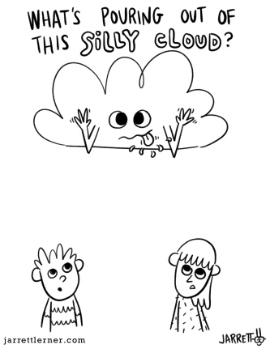
Give the children and the cloud each a speech bubble to help tell the story. What are they thinking or saying?

Reading and Word Work Activities
With more nice weather in the forecast it’s a great time to take sight word practice outside. Have your child write several sight words with chalk then use a qtip dipped in water or a wet rag to erase the word after reading it. You could also do some target practice and try to hit the sight words with water balloons or water guns.  Pick 5 words (familiar and unfamiliar) from the sight word list and write them several times each. Ask your child to circle/cross off/underline all the times they see a given word. Below I’ve included a picture of how you could play this inside with a piece of paper or a white board. | Click on the link below to listen to the story The Curious Garden. https://bookflix.digital.scholastic.com/pair/detail/bk0096pr/story?authCtx=U.794217314  This story reminds me of The High Line. It is a park in New York City that was built on a former New York Central Railroad track. It is a place that is on my travel list if I ever revisit New York. You can head to Google Maps to explore it or www.thehighline.org. Making connections between real life and books is a reading comprehension skill that we practice often. When students can make connections it can help them understand what they are reading by applying their own knowledge to the subject matter.
Take your books outside, find a comfy spot and read! | Play sight word SPLAT or try one of the other games from the previously provided list. Let me know if you would like another copy of the list.  Can you make up your own game to practice your sight words?
Go on a word hunt in your home for words that have L blends: cl, bl, fl, gl,pl, sl. Write them down as you find them. You can look in books, on signs or posters, on packages, etc.  You can also do this activity as an I Spy game, played inside or outside (take a clipboard if you head outside). I Spy with my little eye something that starts with fl (say the sound). When your child guesses flag ask them how they think it would be spelled and record it on their chart.  bl cl fl gl pl sl | Listen to Mrs. Davis read a book. After you listen to the story talk about what you noticed in the book. Was it a rhyming story?  Did you notice anything about the pictures?  How did the story make you feel?  Retell the story by telling where the story happened (setting), who was in the story (characters) and what happened at the beginning, the middle and the end.  https://www.youtube.com/channel/UCy-GqPVIe9AG60eKQ4ESpCQ
Try to practice a few sight words each day. You can put the words on the fridge and have your child read them each time they are in the kitchen. You can also put them in other high traffic areas (bathroom door, on the bathroom mirror, their bedroom door) and have them read the words or point to a word that you say. Tape the word on a wall and have your child jump to high five the word as you say it or they read it. As part of your bedtime routine you could go through the flashcards you made for incremental rehersal.

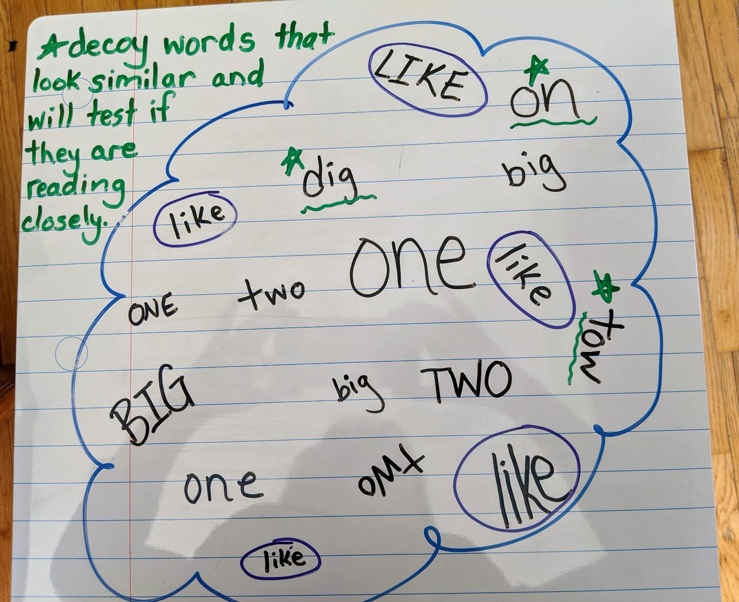

Math Activities
Select an activity each day to complete. You can select different activities or repeat your favourites.

Addition and Subtraction (N10)  Play Friends of 10  On a piece of paper have your child write the numbers 1-9. Use a spinner with the numbers 1-9 on it or use a deck of cards with the face cards removed. When your child spins a number/draws a card have them cover the number on their paper that is the 10 partner of the number they drew/spun. If I spun a 7 I would cover the 3 because 7 and 3 make 10. Continue until all of the numbers are covered.  You can write the numbers out twice and play against your child to see who can cover all of their numbers first.  Adding to 10 is a foundational mental math strategy. | Addition and Subtraction (N9, N10)  Have your child roll two dice, use a spinner or draw two cards from a deck. Get them to use those numbers to create an addition or subtraction story problem. They can act it out or write it down and then solve it.  Encourage them to use the counting on strategy where they say the greater number and then count on to add the lesser number. If I spin a 6 and an 8 I would say 8 and then count on 6 more…9, 10, 11, 12, 13, 14 (instead of starting at 1 and counting to 8 then counting 6 more).  https://www.didax.com/math/virtual-manipulatives.html (for dice and spinners)
Skip Counting (N1)  Head outside with some chalk and play hop scotch. Practice skip counting by filling in the squares with the numbers you would say when counting by 2s, 5s or 10s.  If playing outside isn’t an option you can bring the game indoors using post it notes or taping numbers to the floor. | Discussing mathematical thinking  Below are two Which One Doesn’t Belong cards. There is no right or wrong answer with these cards, as long as your child can support their reasoning. The ability to explain one’s thinking is a skill that applies to all areas of learning. This is also a great activity to show that there is often more than one way of thinking. You can explore the link below for other WODB examples.  http://wodb.ca/numbers.html
Online math options:  www.dreambox.com/canada  www.mathplayground.com  www.abcya.com (free to use on a desktop/laptop) There is an app that you can download for use on an iPad, but there’s a fee.  https://www.didax.com/math/virtual-manipulatives.html | Number of the Day (N1, N3, N4, N7, N8)  Complete the Number of the Day page that was sent home in the page protector. Focus on numbers 11-20. Once your child has mastered those (representing it in different ways, can count on to that number, knows the word) you can move on to numbers to 50.  Add on questions: will you say the number of the day if you skip count by 2s? by 5s? by 10s? Try it to see if your prediction was correct.  What two numbers could you add together to equal the number of the day?

For this card it could be argued that the 6 doesn’t belong because it’s blue (colour is an attribute that children are taught to use when sorting, so this would be an appropriate answer). You could also argue that the 10 doesn’t belong because the other balloons only have one digit numbers in them. The 5 doesn’t belong because the other numbers are even/add up to an even number (we had not spent much time learning about even and odd numbers yet in class so this one may take some expalining). 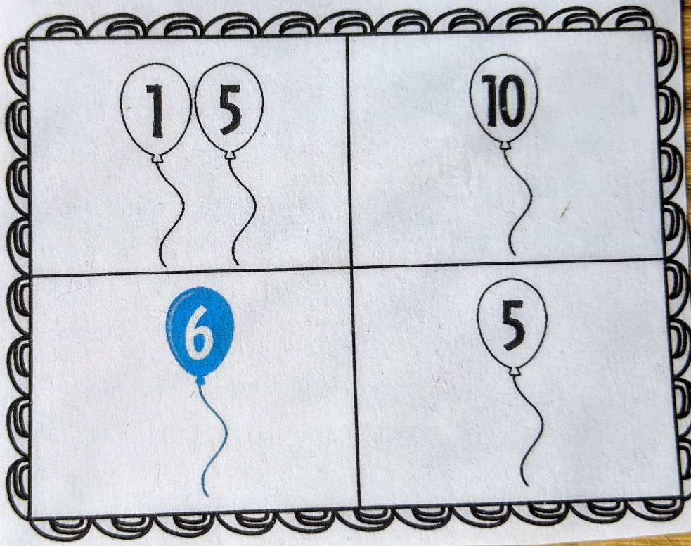
For the domino card you could argue that the 4 and 0 domino doesn’t belong because all of the others have two sets of dots. It could also be argued that the 2 and 2 domino doesn’t belong because it is the only double.
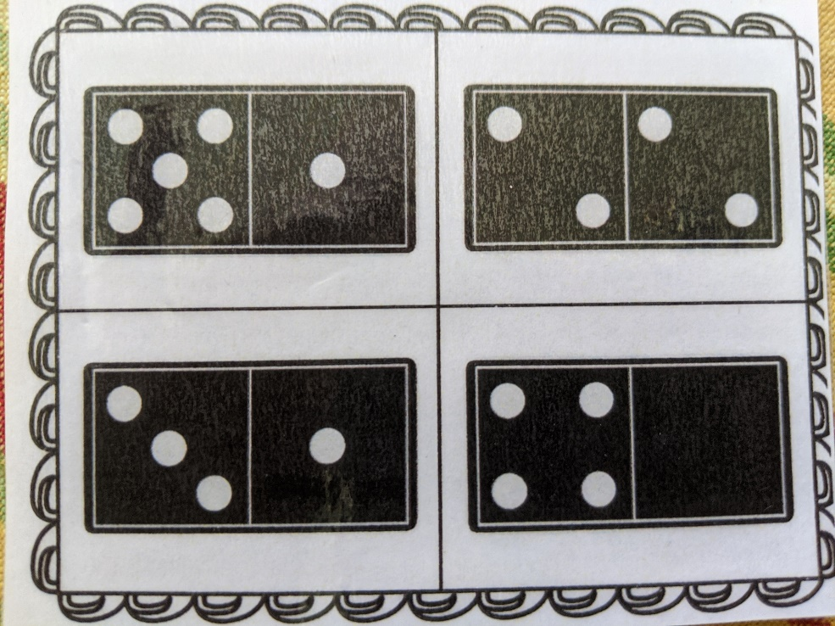

There are other arguments to match with these cards; I’ve only provided a few to explain how the process works. I would love to hear your child’s explanations of their thinking if you feel like sharing a video.
Science
This week our science is looking at simple machines, forces and motion! Watch this little video and see if you can build a car at home!
Can’t watch the video? Here is a link for the activity guide!  https://www.thediscoverycentre.ca/wp-content/uploads/2020/04/Reinventing-the-Wheel-Instructions-V5.pdf | Don’t have a box? Design your own car!  Trace your design on a piece of paper and then cut two out of cardboard. Then some rectangles to space the two pieces apart! Glue it together!  Check out my deisgn!  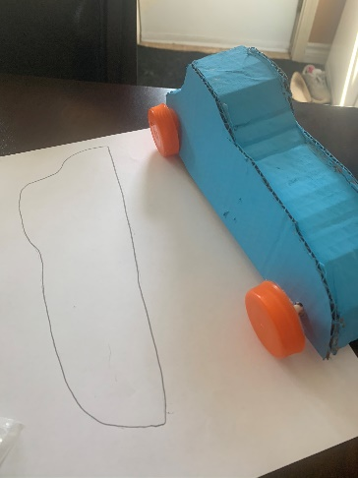

Online resources for music
https://scratch.mit.edu/ or www.code.org Students who wish to access their account can email alison.bush@nbed.nb.ca for their login and password.
https://musiclab.chromeexperiments.com/Song-Maker/ - Make some music. Share your links with Ms. Bush!
https://www.incredibox.com/demo/ - Make beatbox rhythms on this site! A definite favourite in the older grades!
http://isleoftune.com/ - a creative music making site!

Physical Education
Physical Education is self directed at home but if you are looking for a couple of suggestions check out these!
All about heart!  Watch the following about how your heart works and ways to keep it active. It includes a Pokemon activity!  file:///C:/Users/alison.bush/Downloads/Pokemon%20Scavenger%20Hunt%202.0.pdf (don’t have a printer? Draw your own cards! |  |  |  |  | Add some choice in your Physical Education. Check out my virtual Physical Education Classroom  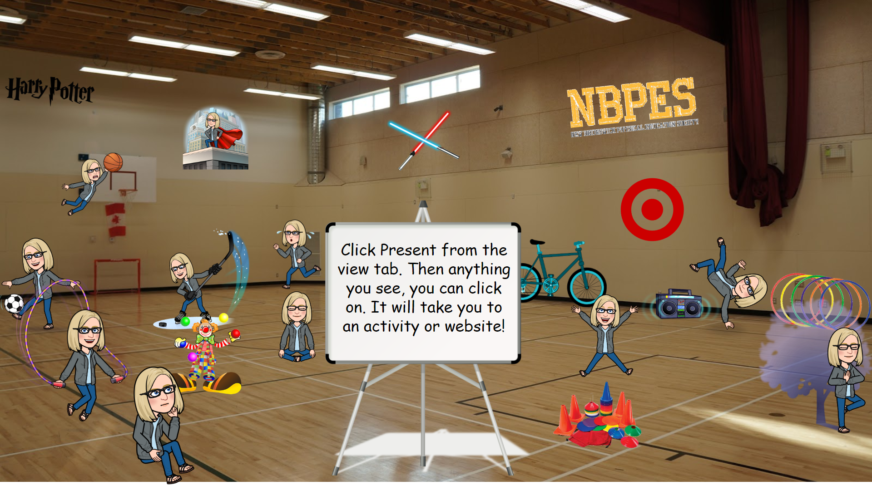  https://docs.google.com/presentation/d/e/2PACX-1vSoleLqNo0Y-SrGckkagN0hQkdwA8G5nOGwAlz9NWyCDrXWkcn6fS1iZR6BnTKj_aRehm4Dp7GIaxro/pub?start=false&loop=true&delayms=60000&slide=id.g77d9c60409_0_0
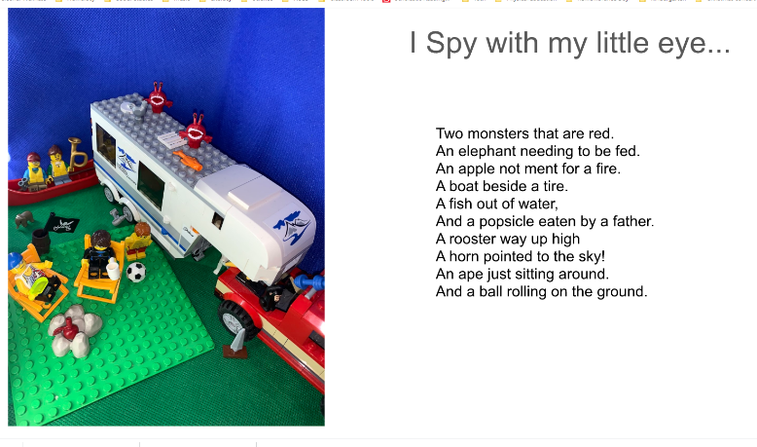
Weekly Challenge – Create an I-Spy with your toys! Check out the link for an example. Share your work with me and I will put all the pictures into a book! Alison.bush@nbed.nb.ca
https://docs.google.com/presentation/d/e/2PACX-1vTn8WArQ9D_kSNT5Zq056sD6k1jcuo4oonDtfi4ZsBnFMgydz5Ur3o2z0wM7VIfAd5R89D_2bYYq5vL/pub?start=true&loop=false&delayms=3000

