May 30-June 5, 2020
Hello Friends!
I loved our group chats! It was so fun to see some of your smiling faces together. We’ll have some more video chats this week, so hopefully you’ll be able to join in. You are all doing a wonderful job with your home learning and going with the flow as things change. I’m very proud of you! I love to see what you are up to at home, so keep sending me pictures/videos of all the fun things you are doing. I miss you all so much!

Parents/Guardians:
We are in the home stretch! Please continue trying to choose one activity from each choice mat to make up your hour of daily learning. I know that some of you are heading back to work and your child may be heading back to daycare. This is yet another adjustment for families so please do not feel pressured to complete a full hour of learning activities in the evenings. Fit in what you can, when you can. I do recommend reading, practicing sight words and math (either skip counting or math facts) daily and writing activities when possible.
I will be setting more group video chats on Teams this week. I’ll send out the schedule by Monday. I want to accommodate as many schedules as possible, so please let me know if there are limited times when your child would be available.
Thank you for all of the pictures and videos that you have shared with me. I truly appreciate you including me in your lives.

In addition to the activities suggested below, everyday students are encouraged to:

- Read for 15 minutes- Take time to read to or with your child and encourage them to read independently. This would be a great time to use Raz-Kids or GetEpic.
- Be physically active for 30 minutes. Please see Ms. Bush’s amazing activities below.
- Take time to play and/or create something. Exercise those imaginations!
- Staff will be returning to school this week so I will not be holding ‘office hours’ but please feel free to email me at any time and I will respond as soon as I am able. If your child has something they would like to share or are struggling with a particular activity please reach out and we can do a video chat or phone call at any time.

Writing Activities
Select an activity each day to complete. You can select different activities or repeat your favourites. Some activities will be completed over multiple days.
We write lists ALL the time! A list is how we keep our thoughts organized using words or short sentences. A list has:  a title  words or short sentences connected to your title (main idea)  You list could also include pictures.  Practice making a list on whatever topic you are interested in. Some ideas to get you started:  -toys in your room  -favourite foods  -things you see outside  -grocery list  -your schedule for the day | Write a letter or make a card for someone. You could send it in the mail, email it or deliver in person. This would be a great chance to practice writing your last name and address.
Visit https://jarrettlerner.com/activities/ and check out the “Finish This Comic!” section. You can print them off or use them as inspiration and draw your own version. Remember that comics use speech bubbles to tell what the characters are thinking and saying. Below is an activity from the website.  You can check out all of the other fun activities on his page too. | Write about something that is your favourite. IT could be your favourite food, game, toy, place to go…anything you want. Tell why it is your favourite.  One of my favourite colours is yellow. I like it because it reminds me of the sun and flowers. It makes me feel happy when I see yellow things.
Go through a photo album or photos on your phone and tell your child the story of that photo, focusing on the story elements of: beginning, middle, end, where it took place (setting) and who was there (characters). Have your child choose a different photo and tell a story that matches the photo. Have them write their story down after they tell it. | Draw a picture of an imaginary creature. It could be a dragon, a monster, unicorn or a creature that you make up. Write a story about your creature. Will your character be a hero or a villain? Does it have magical powers?  I would love it if you would share your story with me!
Students should spend around 20 minutes writing each day. Remind your child that writers:
-start their sentences with capital letters and use lower case letters the rest of the time. Names of people and places, days and months and titles of books and movies also get capital letters.
-level finger spaces between each word.
-do their best to represent every sound they hear when sounding out a word.
-use books, word lists and environmental print to help them spell words.
-take their time and print neatly.

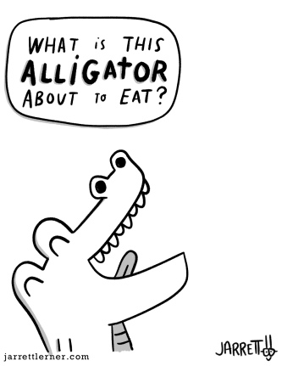

Reading and Word Work Activities
With more nice weather in the forecast it’s a great time to take sight word practice outside. Have your child write several sight words with chalk then use a qtip dipped in water or a wet rag to erase the word after reading it. You could also do some target practice and try to hit the sight words with water balloons or water guns.  Pick 5 words (familiar and unfamiliar) from the sight word list and write them several times each. Ask your child to circle/cross off/underline all the times they see a given word. Below I’ve included a picture of how you could play this inside with a piece of paper or a white board. | Click on the link below and select a story on Bookflix. http://teacher.scholastic.com/products/bookflix/#/  User name: Learning20  Password Clifford  Does this story remind you of anything?  Did you notice anything about the pictures?  How did the story make you feel?  Retell the story by telling where the story happened (setting), who was in the story (characters) and what happened at the beginning, the middle and the end.
Take your books outside, find a comfy spot and read! | Play sight word SPLAT or try one of the other games from the previously provided list. Let me know if you would like another copy of the list.  Can you make up your own game to practice your sight words?
Make a list of CVC (consonant vowel consonant) words. Try to think of a few words for each vowel (a,e,I,o,u). Add a bossy e to the end of the word and read it. Does it make a new word or a nonsense word?  cap -> cape  dog-> doge | Listen to Mrs. Davis read a book. After you listen to the story talk about what you noticed in the book. Was it a rhyming story?  Did you notice anything about the pictures?  How did the story make you feel?  Retell the story by telling where the story happened (setting), who was in the story (characters) and what happened at the beginning, the middle and the end.  https://www.youtube.com/channel/UCy-GqPVIe9AG60eKQ4ESpCQ  I have posted the first 2 chapters of a Junie B Jones book. More chapters will come later this week.
Try to practice a few sight words each day. You can put the words on the fridge and have your child read them each time they are in the kitchen. You can also put them in other high traffic areas (bathroom door, on the bathroom mirror, their bedroom door) and have them read the words or point to a word that you say. Tape the word on a wall and have your child jump to high five the word as you say it or they read it. As part of your bedtime routine you could go through the flashcards you made for incremental rehersal.

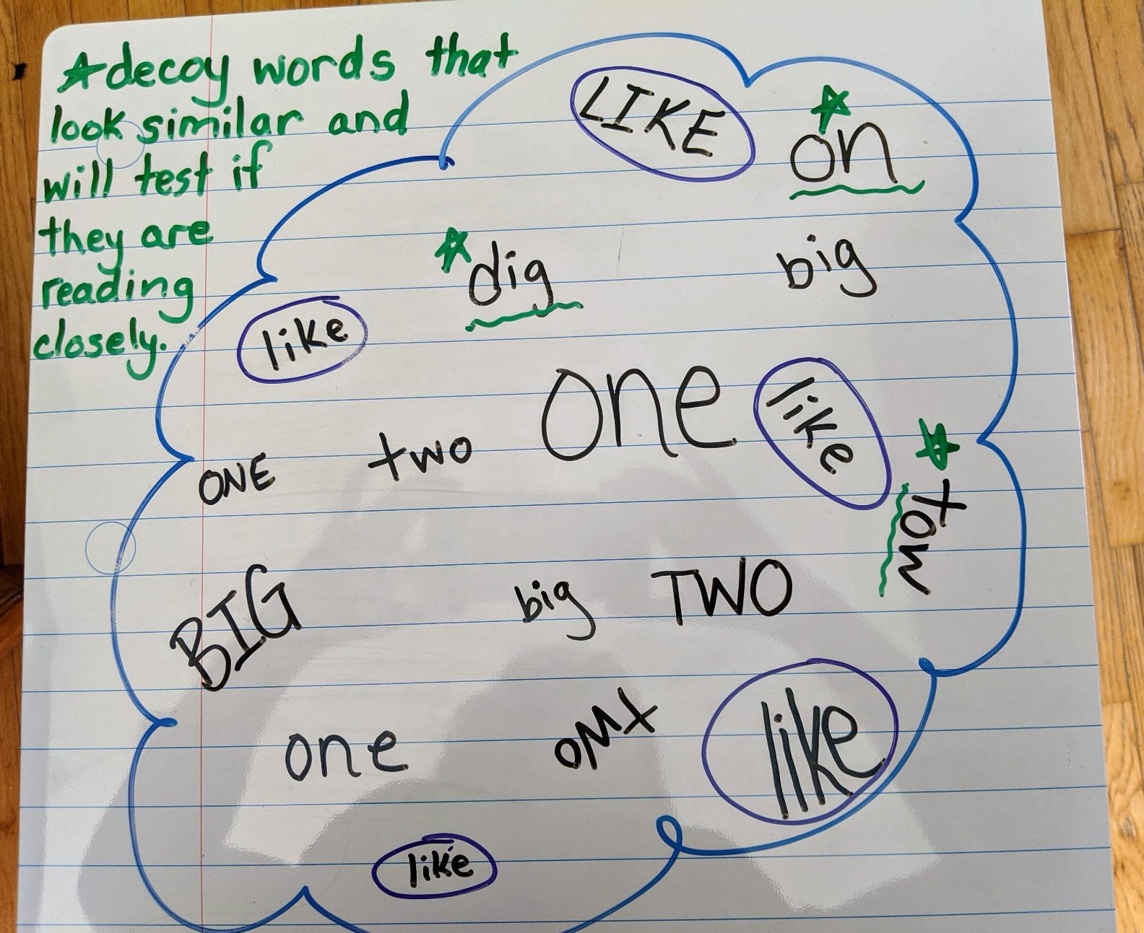

Math Activities
Select an activity each day to complete. You can select different activities or repeat your favourites.

Addition and Subtraction (N10)  Play Friends of 10  On a piece of paper have your child write the numbers 1-9. Use a spinner with the numbers 1-9 on it or use a deck of cards with the face cards removed. When your child spins a number/draws a card have them cover the number on their paper that is the 10 partner of the number they drew/spun. If I spun a 7 I would cover the 3 because 7 and 3 make 10. Continue until all of the numbers are covered.  You can write the numbers out twice and play against your child to see who can cover all of their numbers first.  Adding to 10 is a foundational mental math strategy. | Addition and Subtraction (N9, N10)  Have your child roll two dice, use a spinner or draw two cards from a deck. Get them to use those numbers to create an addition or subtraction story problem. They can act it out or write it down and then solve it.  Encourage them to use the counting on strategy where they say the greater number and then count on to add the lesser number. If I spin a 6 and an 8 I would say 8 and then count on 6 more…9, 10, 11, 12, 13, 14 (instead of starting at 1 and counting to 8 then counting 6 more).  https://www.didax.com/math/virtual-manipulatives.html (for dice and spinners)
Skip Counting (N1)  Head outside with some chalk and play hop scotch. Practice skip counting by filling in the squares with the numbers you would say when counting by 2s, 5s or 10s.  If playing outside isn’t an option you can bring the game indoors using post it notes or taping numbers to the floor. | Patterns (PR1)  Make a pattern with three to five elements. The core should repeat at least three times.  You could draw the pattern using different colours, use Legos or head outside and use sticks, rocks, flowers, etc.
Online math options:  www.dreambox.com/canada  www.mathplayground.com  www.abcya.com (free to use on a desktop/laptop) There is an app that you can download for use on an iPad, but there’s a fee.  https://www.didax.com/math/virtual-manipulatives.html | Number of the Day (N1, N3, N4, N7, N8)  Complete the Number of the Day page that was sent home in the page protector. Focus on numbers 11-20. Once your child has mastered those (representing it in different ways, can count on to that number, knows the word) you can move on to numbers to 50.  Add on questions: will you say the number of the day if you skip count by 2s? by 5s? by 10s? Try it to see if your prediction was correct.  What two numbers could you add together to equal the number of the day?

Science
This week we are looking at looking at the question: What makes boats float? This is the perfect project for a hot day! Fill a pool or a bucket to test your boats outside. I bet you won’t stay dry!
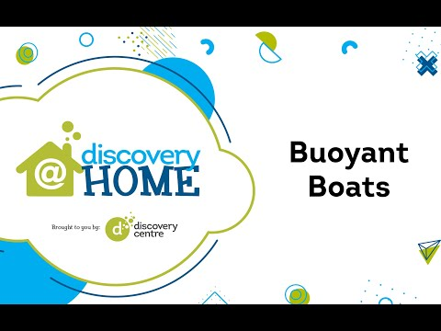  Can’t watch the video? Here is a link for the activity guide!  https://www.thediscoverycentre.ca/wp-content/uploads/2020/05/Buoyant-Boats-Learning-Guide.pdf | Just for fun,Have some fun with the scientifc method:  1.Collect objects from around your home.  2. Make a prediction as to whether they float or sink.  3. Test to see if your prediction was correct.  Can you make any conculsions? Are there certain types of objects that always float?

Physical Education
Physical Education is self directed at home but if you are looking for a couple of suggestions check out these!
A Deck of Fitness is a great way to have fun and get some fitness into the day!  Activity Procedures:  - Today’s friendly competition is Deck of Fitness. The object of the game is to do as many repetitions as you can of each exercise.  - When you draw a card, you’ll use the exercise chart to determine which exercise to do. Complete the number of repetitions shown on your card. For example, if you draw the 4 of hearts, perform 4 jumping jacks.  - Face cards (e.g., a king) are worth 10 repetitions. Aces are worth 11 repetitions.  - In round 1, you and your friends will play together and select 1 card for everyone to perform. In round 2, you can compete: Everyone will choose their own card and complete their own repetitions/exercises.  Tips:  - Make sure you pace your activity safely. Don’t give up form for the sake of speed.  - Be sure you have enough activity space for safe movement.  - Follow this format, or create your own:  - Hearts = Jumping Jacks  - Clubs = Push-Ups  - Diamonds = Invisible Jump Rope Jumps  - Spades = Squats  https://openphysed.org/wp-content/uploads/2018/09/OPEN-At-Home-06-DeckOfFitness.pdf |  |  |  |  | Add some choice in your Physical Education. Check out my virtual Physical Education Classroom  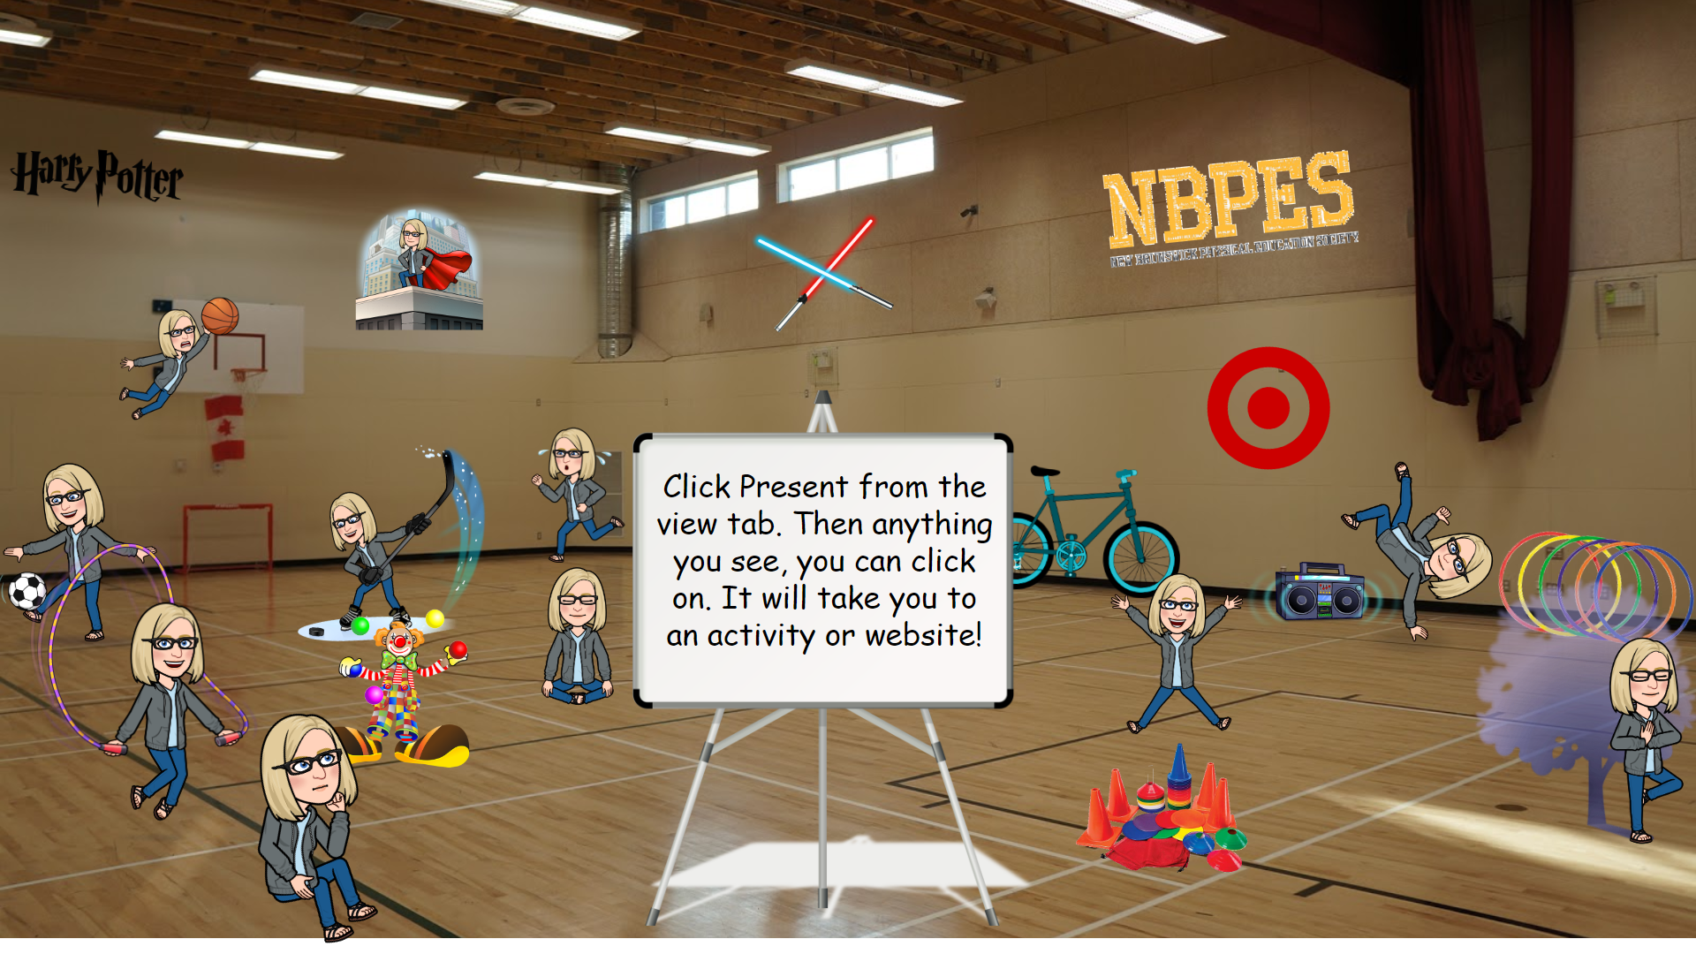  https://docs.google.com/presentation/d/e/2PACX-1vSoleLqNo0Y-SrGckkagN0hQkdwA8G5nOGwAlz9NWyCDrXWkcn6fS1iZR6BnTKj_aRehm4Dp7GIaxro/pub?start=false&loop=true&delayms=60000&slide=id.g77d9c60409_0_0  The Warm weather is upon us!! Be sure to stay hydrated:  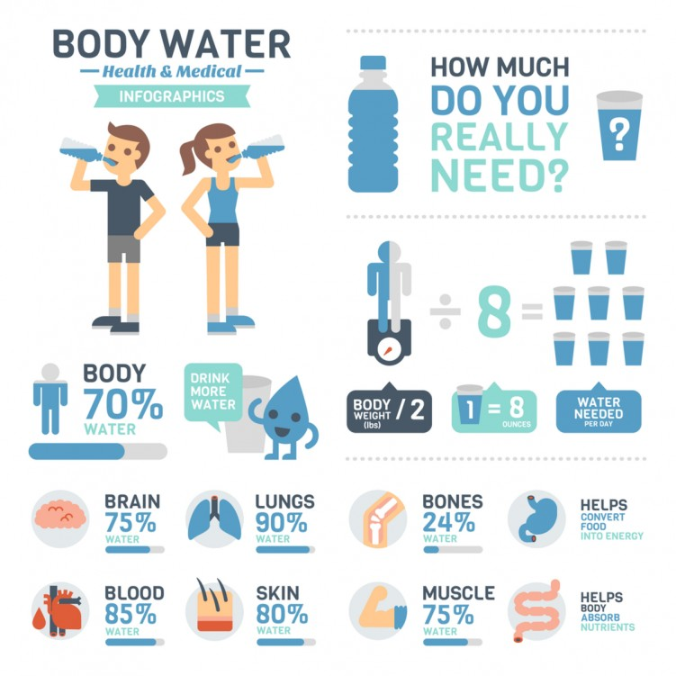
Weekly Challenge – Have some fun with Math/Art Challege from Science East!
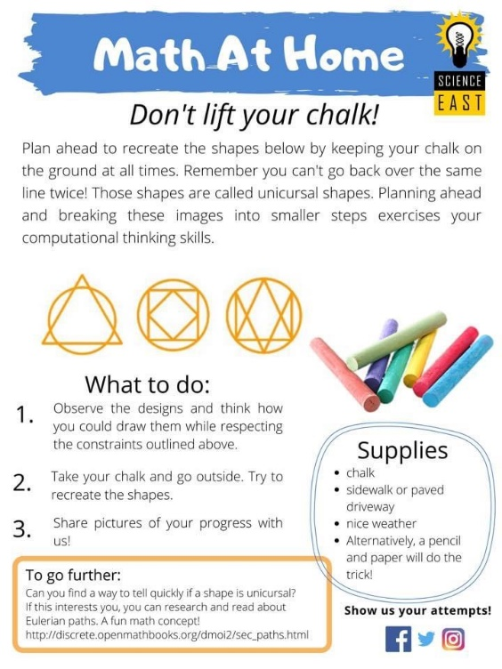

Online resources:
https://scratch.mit.edu/ or www.code.org Students who wish to access their account can email alison.bush@nbed.nb.ca for their login and password.
https://musiclab.chromeexperiments.com/Song-Maker/ - Make some music. Share your links with Ms. Bush!
https://www.incredibox.com/demo/ - Make beatbox rhythms on this site! A definite favourite in the older grades!
http://isleoftune.com/ - a creative music making site!

