June 5-12, 2020
Hello Friends!
I can’t believe this is our last week of home learning lessons! Our school year went by so fast. Even though we didn’t get to be together for the whole year I LOVED being your teacher. I am SO PROUD of how much you learned and grew this year. It was a big change for us and you did so well. I hope you have a wonderful summer playing outside, eating ice cream, visiting with friends and family and going on some close to home adventures.
We will have one more set of group video chats next week and I have some fun things planned! I hope to see lots of you then and when you come to pick up your report card. I love you and will miss you this summer, but I can’t wait to see you in the fall!

Parents/Guardians:
We did it! We have reached the final week of home learning and I owe you all a huge THANK YOU! Thank you for supporting your child through these uncertain times. Thank you for being flexible and ‘going with the flow’ as we adapted lessons and expectations. Thank you for providing me with the feedback that I needed to make the home learning plans work. Thank you for the videos, pictures and video chats that you gave me with your child. It meant so much to me that I was able to maintain that connection with your child through all of this. You will never know how much I treasured those toothless grins and sweet voices. Please feel free to continue sending pictures over the summer
I will be setting up one final set of group video chats on Teams this week. Thank you for your patience with all of the tech/Mrs. Davis making mistakes issues!

In addition to the activities suggested on the choice mats, everyday students are encouraged to:

- Read for 15 minutes- Take time to read to or with your child and encourage them to read independently. This would be a great time to use Raz-Kids or GetEpic.
- Be physically active for 30 minutes. Please see Ms. Bush’s amazing activities below.
- Take time to play and/or create something. Exercise those imaginations!
- As I am back in the school I will not be holding ‘office hours’, but please feel free to email me at any time and I will respond as soon as I am able. If your child has something they would like to share or are struggling with a particular activity please reach out and we can do a video chat or phone call at any time.

Writing Activities
Select an activity each day to complete. You can select different activities or repeat your favourites. Some activities will be completed over multiple days.
Make a list of things that you would like to do this summer. This summer might be different than others and there may be things that you can’t do, but that’s okay. I included a list of summer words to help you.  Mrs. Davis’ Bucket List  -eat lots of ice cream  -take my dogs to swim in the river  -go to a beach  -have bon fires and roast marshmallows  -read some books  -plant some flowers | Silly Summer Sentence  Below is a silly sentence chart. Follow the instructions to create your silly sentences. You can draw a picture to go with each sentence and make a book. You could also turn your sentence into a story by writing other sentences to add more details.  Ex. Tell about what happened when Mrs. Burnett toasted marshmallows in the gym?
Visit https://jarrettlerner.com/activities/ and check out the “Finish This Comic!” section. You can print them off or use them as inspiration and draw your own version. Remember that comics use speech bubbles to tell what the characters are thinking and saying.  You can check out all of the other fun activities on his page too. | Write about something that is your favourite. It could be your favourite food, game, toy, place to go, season…anything you want. Tell why it is your favourite.  One of my favourite things about summer is having bon fires in my backyard. I love the smell of the wood burning and how toasty warm they are. I also love to toast sticky marshmallows.
Mad Libs are funny stories that you make by filling in missing words.  Verbs are action words (things you can do).  Nouns are people, places or things.  Adjectives are describing words.  Plural means more than one (add s to the end).  Fill in the mad libs below with someone in your family and compare your stories. Which one is the silliest? | What was your favourite things about grade 1? It could be a fieldtrip that we went on, a game we played, a special day that we had…  Draw a picture and write three sentences to tell about it. Why was it your favourite memory?  One of my favourite things about grade 1 was using our Story Maker boxes. I loved listening to the stories that you made up. You were all so creative!
Students should spend around 20 minutes writing each day. Remind your child that writers:
-start their sentences with capital letters and use lower case letters the rest of the time. Names of people and places, days and months and titles of books and movies also get capital letters.
-level finger spaces between each word.
-do their best to represent every sound they hear when sounding out a word.
-use books, word lists and environmental print to help them spell words.
-take their time and print neatly.
Roll a silly sentence: Summer
Roll a die and record the ‘who’. Roll again and record the ‘what’. Roll a third time and record the ‘where’. Roll a fourth time and record the ‘when’.
 | Who? (First) | What? (Second) | Where? (Third) | When? (Fourth)
1 | My best friend | planted flowers | in the backyard | over the summer.
2 | Mrs. Burnett | rode a bike | outside | on Wednesday.
3 | Mrs. Davis | went camping | by the river | two weeks ago.
4 | Mom | mowed the grass | down the street | in June.
5 | Dad | toasted marshmallows | on the soccer field | last night.
6 | I | went swimming | at the school | today.
Example: Mrs. Burnett toasted marshmallows in the gym over the summer.

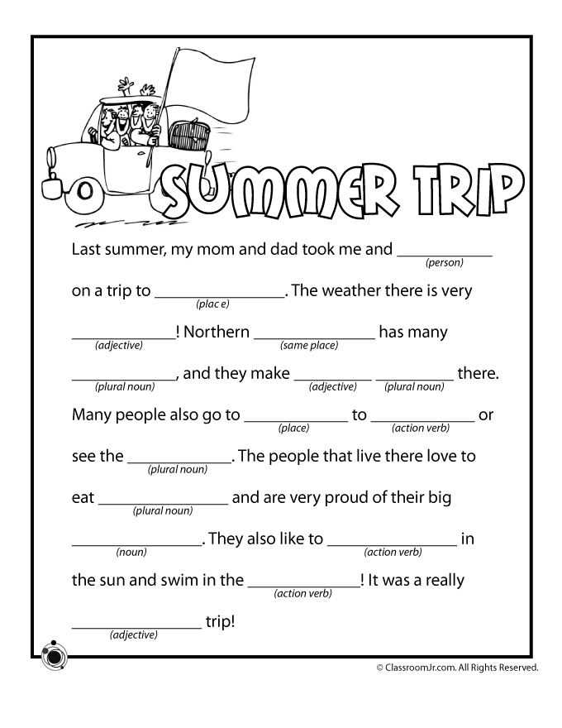

Reading and Word Work Activities
Time to take sight word practice outside. Have your child write several sight words with chalk and try to hit the sight words with water balloons or water guns. You can write sight words on cards and hide them around the yard (or inside on hot/rainy days).  Pick 5 words (familiar and unfamiliar) from the sight word list and write them several times each. Ask your child to circle/cross off/underline all the times they see a given word. | Click on the link below and select a story on Bookflix. http://teacher.scholastic.com/products/bookflix/#/  User name: Learning20  Password Clifford  Does this story remind you of anything?  Did you notice anything about the pictures?  How did the story make you feel?  Retell the story by telling where the story happened (setting), who was in the story (characters) and what happened at the beginning, the middle and the end.
Take your books outside, find a comfy spot and read! | Play sight word SPLAT or try one of the other games from the previously provided list. Let me know if you would like another copy of the list.  Can you make up your own game to practice your sight words?
Look are list of summer words. Make a chart and sort the words with long vowels.  Two vowels walking Bossy e at the end  Some of the words on the list are compound words. A compound word is a word made of two smaller words like doghouse. Find the compound words on the list and identify which two words make up the new word. | Listen to Mrs. Davis read some chapters from Junie B., Frist Grader Aloha-ha-ha!  How did the story make you feel?  Retell the story by telling where the story happened (setting), who was in the story (characters) and what happened at the beginning, the middle and the end.  https://www.youtube.com/channel/UCy-GqPVIe9AG60eKQ4ESpCQ

Try to practice a few sight words each day. You can put the words on the fridge and have your child read them each time they are in the kitchen. You can also put them in other high traffic areas (bathroom door, on the bathroom mirror, their bedroom door) and have them read the words or point to a word that you say. Tape the word on a wall and have your child jump to high five the word as you say it or they read it. As part of your bedtime routine you could go through the flashcards you made for incremental rehersal.

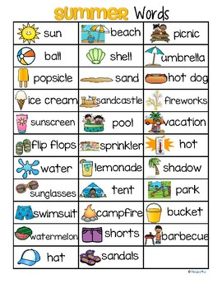

Math Activities
Select an activity each day to complete. You can select different activities or repeat your favourites.

Addition and Subtraction (N10)  Play Friends of 10 Go Fish  Deal 7 cards for each player. If you are playing with more than 3 people deal 5 cards. Place the rest of the cards in a pile in the middle of the players. Go around the circle taking turns asking the player to your left for a card that you need. Instead of trying to make a pair you will be asking for the number that will go with one of your cards to make 10. If I had a 7 in my hand I would ask for a 3. If the player gives me a 3 I lay my pair down and take another turn. If they don’t have a 3 they say “Go fish” and I take a card from the pile. The game is over when one player has no more cards in their hand. | Addition and Subtraction (N9, N10)  Have your child roll two dice, use a spinner or draw two cards from a deck. Get them to use those numbers to create an addition or subtraction story problem. They can act it out or write it down and then solve it.  Encourage them to use the counting on strategy where they say the greater number and then count on to add the lesser number. If I spin a 6 and an 8 I would say 8 and then count on 6 more…9, 10, 11, 12, 13, 14 (instead of starting at 1 and counting to 8 then counting 6 more).  https://www.didax.com/math/virtual-manipulatives.html (for dice and spinners)
Skip Counting (N1)  Head outside with some chalk and play hop scotch. Practice skip counting by filling in the squares with the numbers you would say when counting by 2s, 5s or 10s.  If playing outside isn’t an option you can bring the game indoors using post it notes or taping numbers to the floor. | Shapes (SS 4)  Compare 2D shapes to parts of 3D objects in the environment.  Go on a shape hunt outside or in your home. Find and name 3D objects and name the shapes that make up the object.  A can is a cylinder. Circles are part of a cylinder.
Online math options:  www.dreambox.com/canada  www.mathplayground.com  www.abcya.com (free to use on a desktop/laptop) There is an app that you can download for use on an iPad, but there’s a fee.  https://www.didax.com/math/virtual-manipulatives.html | Number of the Day (N1, N3, N4, N7, N8)  Complete the Number of the Day page that was sent home in the page protector. Focus on numbers 11-20. Once your child has mastered those (representing it in different ways, can count on to that number, knows the word) you can move on to numbers to 50.  Add on questions: will you say the number of the day if you skip count by 2s? by 5s? by 10s? Try it to see if your prediction was correct.  What two numbers could you add together to equal the number of the day?

Science
One of my favourite lessons to do is to mix a little STEAM with music. To do this we have to ask what we know about sound! Sound is all around us. Think of the many qustions you can have about sound and music. Watch the video and have some fun creating some musical instruments!
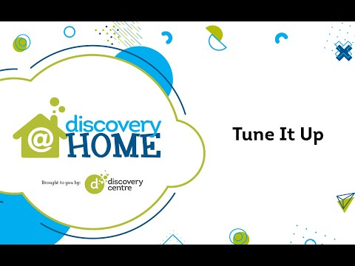  Can’t watch the video? Here is a link for the activity guide!  https://www.thediscoverycentre.ca/wp-content/uploads/2020/05/Tune-It-Up-Learning-Guide-v3.pdf | Why don’t you expirement with making some musical instruments with materials you find at home. What family of instruments would it belong? Do you blow in it to make a sound? It would be a woodwind instrument. Do you shake or hit it? That would make it a percussion instrument!  Here is a link to another homemade musical instrument!  http://www.housingaforest.com/popsicle-stick-harmonica/  Be sure to send me a picture or video of you playing your instrument!

Physical Education
Physical Education is self directed at home but if you are looking for a couple of suggestions check out these!
Check out the ASD-W Spring Games Challenge! This started last week but there are some really neat challenges!  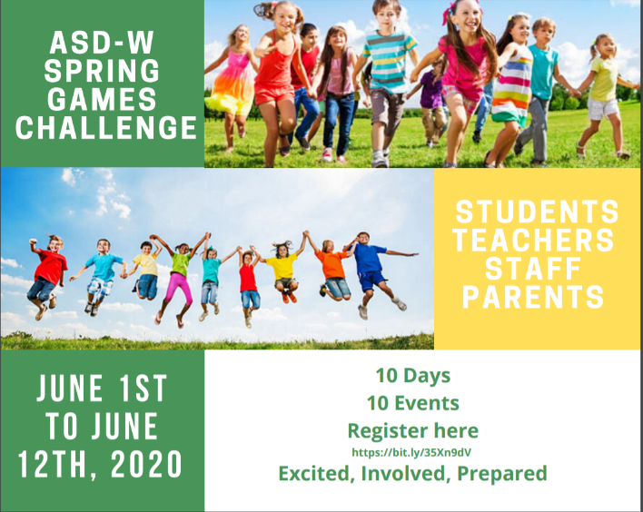  Follow the link below for the activities:  https://docs.google.com/presentation/d/e/2PACX-1vRGRtiPY267Ai8K8JpOb2lH6KE6tpLhswzIjFDLF81spoFvK1joseRELIpEnXgZVyQ_XFHqIjyzAyad/pub?start=true&loop=false&delayms=30000 |  |  |  |  | Add some choice in your Physical Education. Check out my virtual Physical Education Classroom  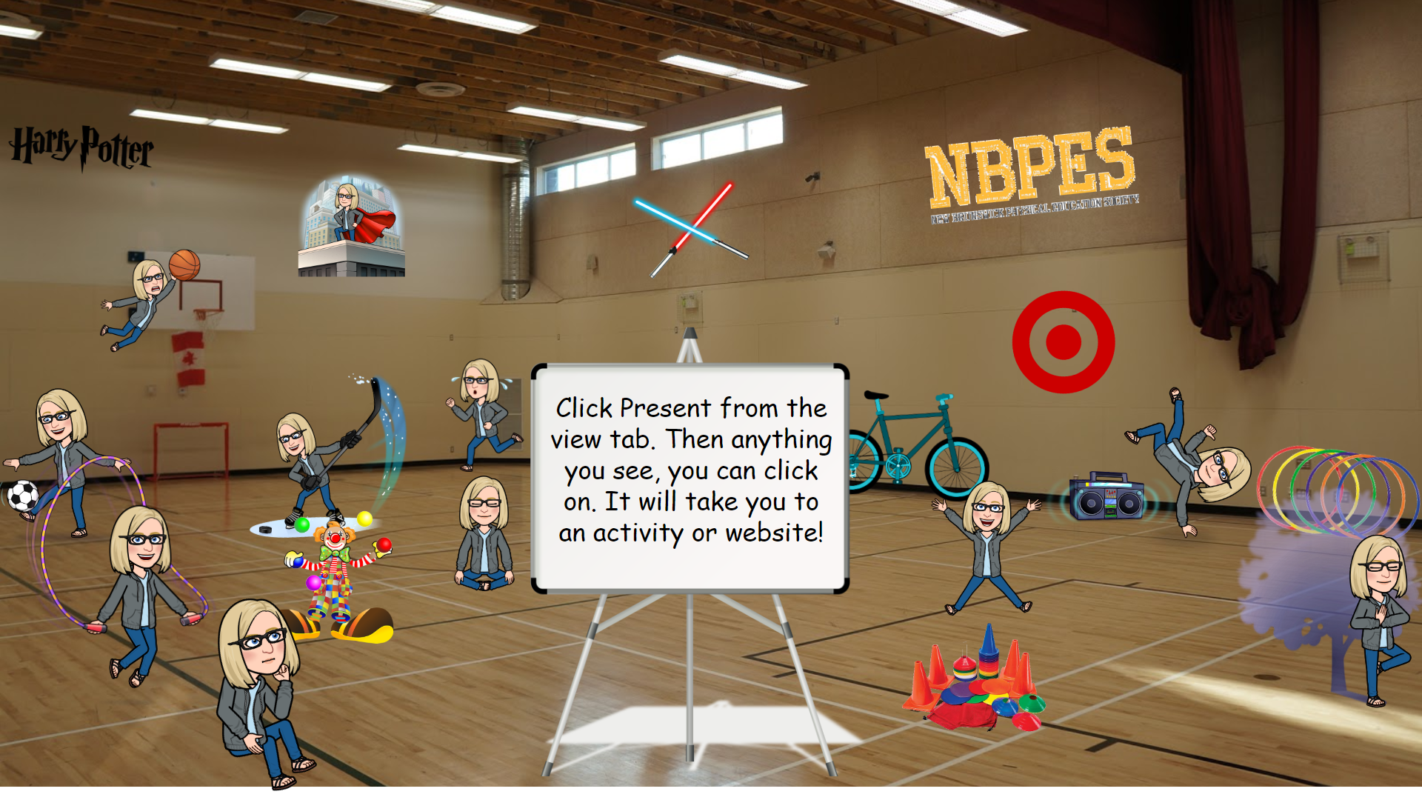  https://docs.google.com/presentation/d/e/2PACX-1vSoleLqNo0Y-SrGckkagN0hQkdwA8G5nOGwAlz9NWyCDrXWkcn6fS1iZR6BnTKj_aRehm4Dp7GIaxro/pub?start=false&loop=true&delayms=60000&slide=id.g77d9c60409_0_0
 |  |  | Weekly Challenge – Make some music! Creat a song a on the Song maker app! Be sure to share the link with me! I love seeing your musical creations! https://musiclab.chromeexperiments.com/Song-Maker/
Online resources:
https://scratch.mit.edu/ or www.code.org Students who wish to access their account can email alison.bush@nbed.nb.ca for their login and password.
https://www.incredibox.com/demo/ - Make beatbox rhythms on this site! A definite favourite in the older grades!
http://isleoftune.com/ - a creative music making site!

