Week 5 Grade 3 Continuation of Learning May 11-15, 2020.

Hello Everyone,
Just a reminder that you can reach me by email if you have any concerns or questions. I really like what parents are doing at home and appreciate your support.
In addition to the activities suggested, students are encouraged to:
- Read daily for 30 minutes- Take time to read to or with your child and encourage them to read independently.
Scholastic Read at home: divided up by day 1, 2 etc.., with activities and reading.
This is a great link for SCIENCE
2.https://classroommagazines.scholastic.com/support/learnathome/grades-1-2.html
Grades1-2
https://classroommagazines.scholastic.com/support/learnathome/grades-3-5.html Grades 3-5

3. EPIC books- available during the day
https://www.getepic.com/ - Our class code is zgc2046
4.Physical activity for 30 minutes:

This is a science resource that ASD-W sent teachers to share about birds:
https://evergreen.us6.list-manage.com/track/click?u=6e3aa88e67&id=8f017a5d00&e=9899ddd14f
In addition to the activities suggested, students are encouraged to:
- Read daily for 30 minutes
- Physical activity- with Ms.Bush
- ZEARN numeracy site- continue you mission by doing a few minutes a day. www.zearn.org

Literacy Learning at Home
Grade Three
EXPLORE
Explore your neighborhood using Google Maps. What does the bird’s-eye view of your home, street or road, and community look like? What did you notice? Create your own bird’s-eye view of the outside of your home.

CREATE
Here are some options for you to choose from to help improve your literacy
skills while you are at home. Challenge yourself to try one each day and have fun!

READ
Choose a Read a box of cereal from your cupboard. Look at the pictures and read the headings and information displayed. Does
this cereal box convince you to want to try it? Tell or write about your opinion and why you think that. Share with a family member and ask their opinion. Extension: Choose a second box of cereal and compare how each tries to sell their product. Which one is more convincing and why? Do others agree with you?

WRITE
Think of 5 things that the Earth provides for us and create a “Did You Know” fact book. (ie: Did you know that plants help to clean our air? Did you know that all the water in the world is the same water that was on our Earth since the time of the dinosaur?

Create the sequel to a story you have recently read or to a TV show you have watched.

SHARE
Share some positive words or an encouraging quote. Create a window poster where these words can be displayed for those driving or walking by your home.

Grade 3 Choice Board- pick one a day
Mental Math  The answer is 250. What might the question have been?  List different questions that have an answer of 250.  Can you think of questions for each operation? +, - , x, ÷ | Insect Symmetry  Take a walk outside. Investigate and observe closely any symmetry you may notice with insects such as beetles, spiders, ants, moths and butterflies. Is there symmetry in their body, legs, wings or color design?  Draw and describe what you have noticed.  Perhaps you may want to design your own symmetrical insect.  Art Idea – Symmetrical Insects | Ice Cream Graph  Interview family and friends to find out their favourite flavour of ice cream. Create a bar graph or pictograph to show the results. Sample graphs.
Let’s Get Cooking!  Measure ingredients for a recipe. Notice the units of measure. If you used fractions in your recipe, what would be the size of the “whole”?  Want a challenge?  Try doubling the recipe. | What Do You Notice?  Write at least 3 different things that you notice about the Lego. 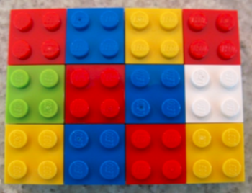  Other images to try! | Area of Garden  The area of a rectangle garden is 24 $m^{2}$. What could be the possible dimensions of the garden?  List different possibilities.  24 $m^{2}$
Number Riddle  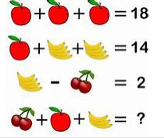  Create another number riddle for someone to solve. | Numeracy  Make the largest and smallest numbers you can find using the digits 9, 6, 1, 8 and 2. Find their sum and difference. | Play a Game  Enjoy playing a favorite card or board game at home: Checkers, Chess, Yahtzee, Battleship, Sudoku, Crazy Eights, Crib. You may want to complete a jigsaw puzzle or play I Spy by describing an objects’ attributes and geometrical form – cube, prism, cylinder, sphere.

