Week 3- Continuation of Learning April 28-May 01, 2020.
Grade 2

Hello everyone,
It was nice to speak on the phone and hear updates about the continuation of learning that is happening in homes.
Speaking to the students helped me with planning, as some families want more work to do. For this reason, I am providing choices for your child. Keep in mind the 1 hour a day expectation of work each day. I don’t expect all the writing assignments to be completed. I do know how independent my 3’s are, and many like to work each day on a project.

On Wednesdays I will be checking my email, from 10-11 am to answer any questions you may have. I really like what parents are doing at home and appreciate your support.
Reminders:
In addition to the activities suggested , students are encouraged to:
- Read daily for 30 minutes- Take time to read to or with your child and encourage them to read independently.
Scholastic Read at home: divided up by day 1, 2 etc.., with activities and reading.
This is a great link for SCIENCE
2.https://classroommagazines.scholastic.com/support/learnathome/grades-1-2.html Grades1-2
https://classroommagazines.scholastic.com/support/learnathome/grades-3-5.html Grades 3-5

3. EPIC books- available during the day
https://www.getepic.com/ - Our class code is zgc2046
4.Physical activity for 30 minutes:
*Parents- please contact Ms Bush regarding drama if you did not receive the email.
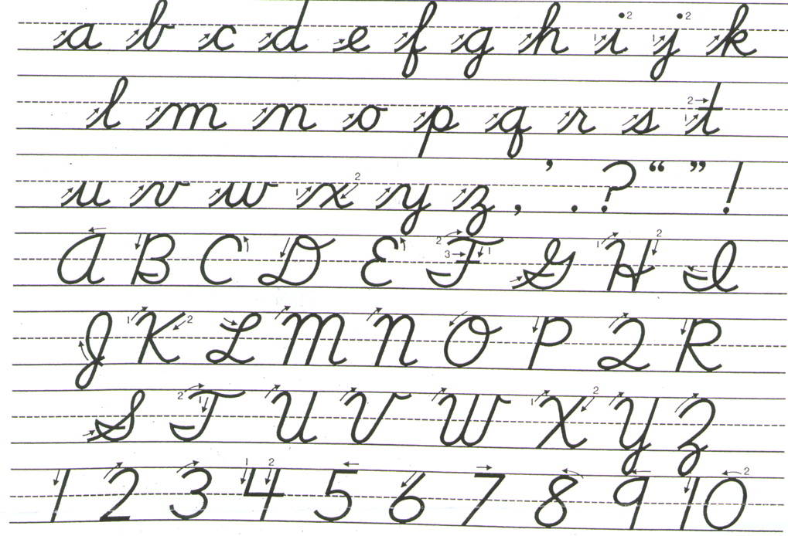

Please practise cursive writing for a few minutes each day. Practise makes perfect!
Literacy links sent home for Grade 2:
I am hoping to send work that the students know how to do with little guidance. I don’t want to overwhelm, but also know some families/students want lessons to do.

New: animal report link of you are interested: https://www.thecurriculumcorner.com/thecurriculumcorner123/wp-content/pdf/writing/animalresearch1.pdf

- Last week:
- I have included a link that is cross curricular for science and writing. This will help your child learn to organize facts and summarize findings about deciduous and coniferous trees.
- https://www.thecurriculumcorner.com/thecurriculumcorner456/wp-content/pdf/centersets/deciduousconiferous.pdf

I have included a link for any student who would like to explore graphic novel writing
- https://www.thecurriculumcorner.com/thecurriculumcorner456/wp-content/pdf/readingworkshop/graphicnovels.pdf

Numeracy games week 3- Please choose how many to play or do.
- This is an adding game using 10, 20, 100. Mental math
https://www.thecurriculumcorner.com/thecurriculumcorner123/wp-content/pdf/science/arctic/arcticmath10.pdf

2. Numeracy Games: find a fact and colour
https://www.thecurriculumcorner.com/thecurriculumcorner123/wp-content/pdf/facts/factgames/findafactadditionadventure.pdf

Literacy
Words Their Way- At Home
This is a weekly activity and should be visited each day to review spelling the new words and activities.
Please remember we are only asking that you do one hour total a day of literacy/numeracy/science.
In addition to this,30 minutes of reading each day, and 30 minutes of physical activity.
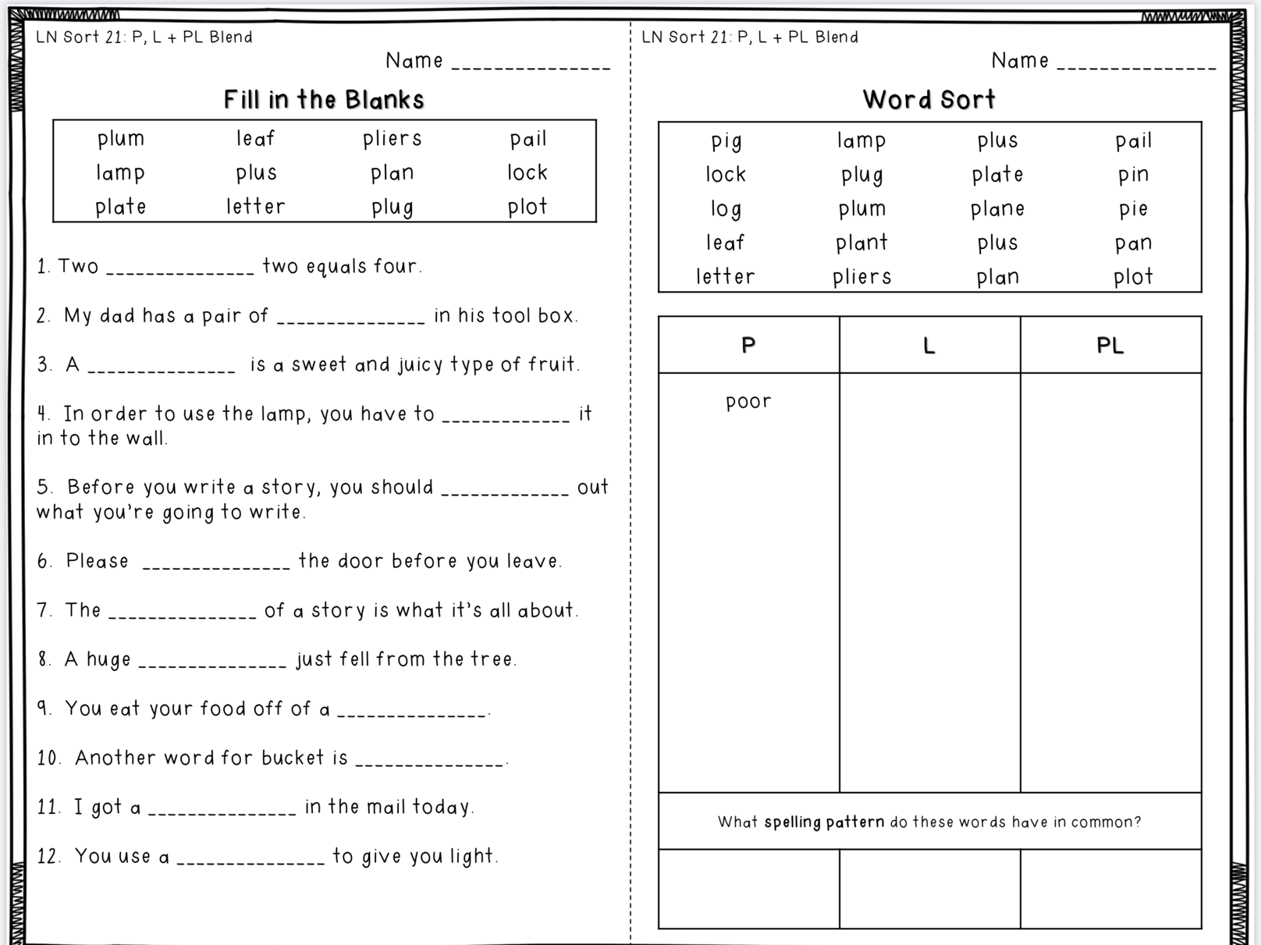
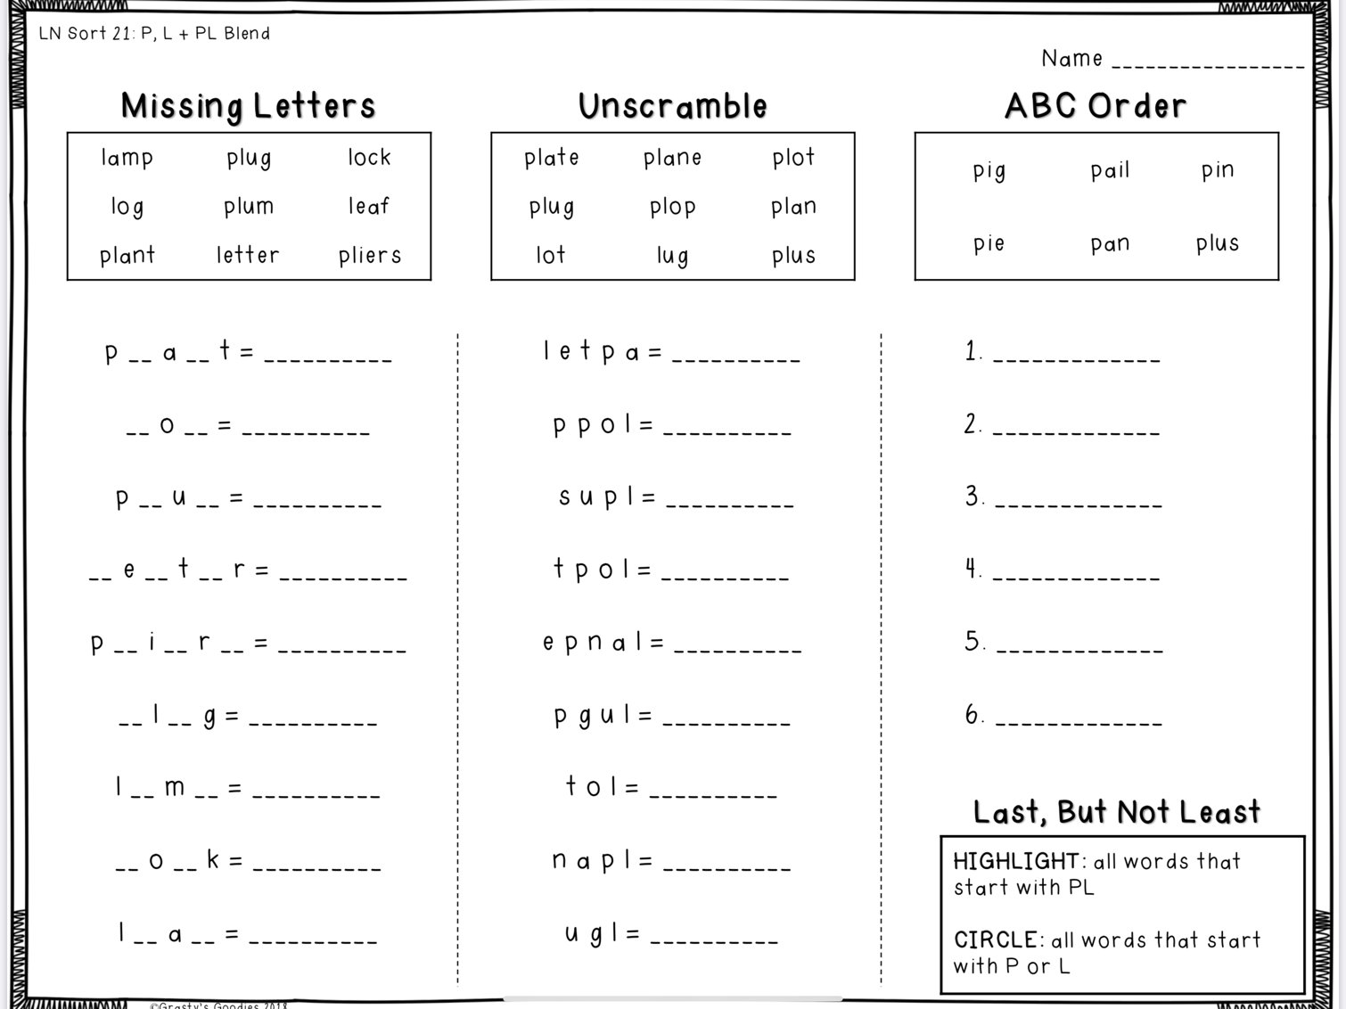
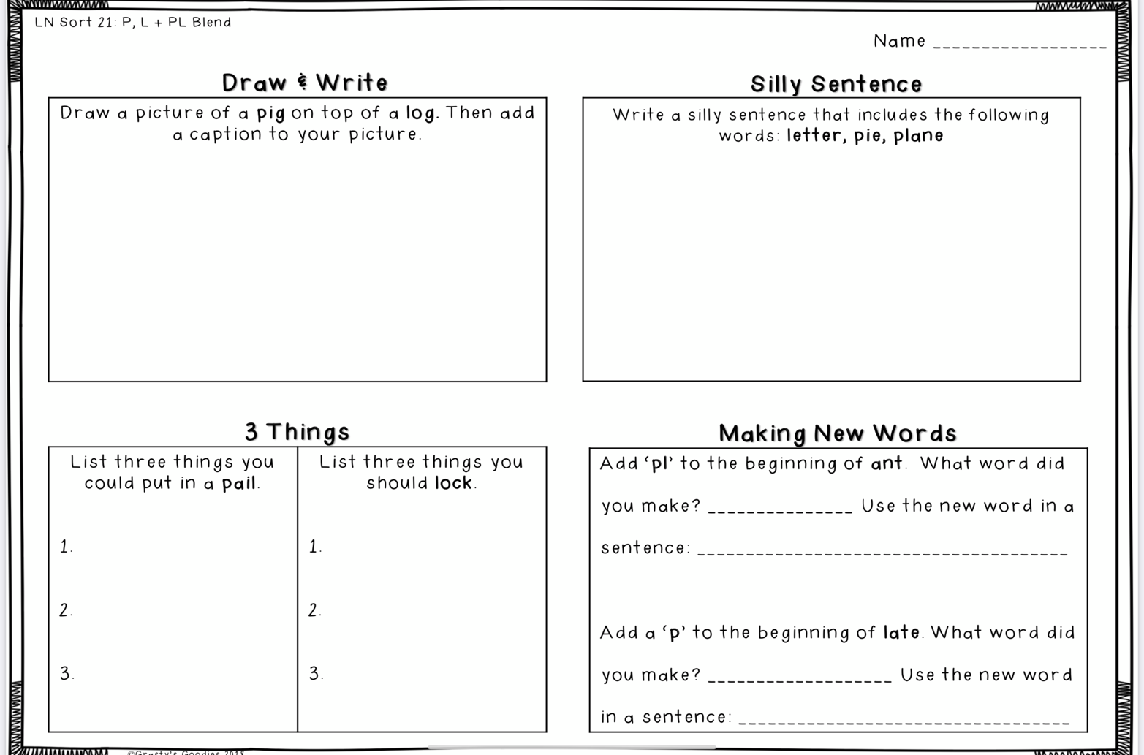
Day 1
Worksheet -Complete the worksheets for their sort. Please have your child complete this sheet at their own pace. They can read you the sentences and the words.
The work can be printed out for your child to do. Or, they can print out the sentences and add the answers. We use rulers to make our charts, so they can draw a sorting chart.
- Sort words – write the words on small cards/ post-it’s/ recipe cards cut in half.
Timed sort: set the timer, and sort. Record in your notebook. Time yourself three times and see if how much faster you can get.
2.Worksheet time
3. Writing time: Your choice
Write in your Journal about your hopes and dreams, like Morris. OR Work on one of the projects that I included.
*Reading for 30 minutes
DAY 1 NUMERACY:
ZEARN math has been very successful and well-liked by the students. Most have logged on, and are working at their own pace through the lessons. For this reason, my suggestion for learning is to continue with Zearn, as it will introduce concepts we haven’t covered, and review others.
Math games- keep a collections of all the math games sent, and I will add to this weekly. Spend time playing theses games, and repeat the ones you really like.

*************************************************************************************
Day 2
Literacy:
1.Write words in notebook – This could also be a good time to practise printing/writing for neatness. 2. Get Smiley Face - After they’ve written words in notebook, you can check their work. If any words are spelled wrong or written in the wrong category, put a small dot next to the word. They go back and fix their word. Once it’s all fixed, add a smiley face. 3. Worksheet time. 4. Write in your Journal about your hopes and dreams, like Morris or work on a report
*Reading for 30 minutes
Numeracy- continue with Zearn math
Play a math game
**************************************************************************************************
DAY 3
1.Test with Someone – call out the words as a spelling test - Think about the vowel combinations used to make sounds.
2.Any words that are not spelled correctly are the focus for practise:
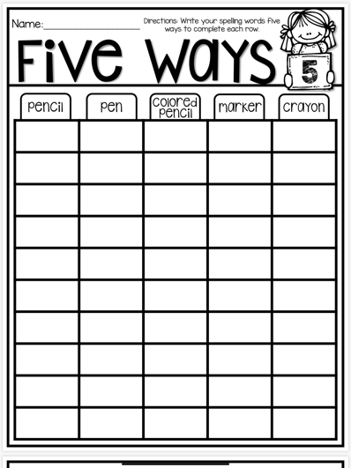
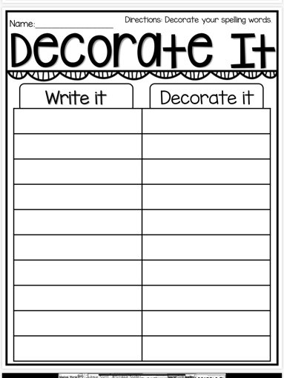
Ex:Rainbow Words – Set out markers, crayons, and coloured pencils. Let students write their words with different colours.
- Worksheet time. 4. Write in your Journal about your hopes and dreams, like Morris or work on a report

*Reading for 30 minutes

Numeracy- Zearn math and play a game

********************************************************************************************I
Day 4

Literacy – word work sheets
- journal/report writing
*Reading for 30 minutes

Numeracy- Zearn math and play a game

**************************************************************************************************
Day 5
Literacy
1.This is the day to look back and make sure you have completed all your word work activities and know
how to spell some new words from your sort.
2. Read over your journal entries for the week and fix up any words you know are spelled incorrectly.
3.Have you visited the EPIC website site this week? Try scholastic too!
4. Are you keeping a reading log? Update any new books. *Reading for 30 minutes
Numeracy- Zearn math and play a game

