Week 6 Grade 3 Continuation of Learning May 19-22, 2020.

Hello Everyone,
Just a reminder that you can reach me by email if you have any concerns or questions. I really like what parents are doing at home and appreciate your support.
If possible, please send me an email to check in and let me know how your family is doing. Could you include a photo of your child showing me something they’ve worked on?

*****New activity Link from ASD-W
https://www2.gnb.ca/content/dam/gnb/Departments/ed/pdf/promo/learning_at_home/SpringIntoAction.pdf

In addition to the activities suggested, students are encouraged to:
- Read daily for 30 minutes- Take time to read to or with your child and encourage them to read independently.
Scholastic Read at home: divided up by day 1, 2 etc.., with activities and reading.
This is a great link for SCIENCE
2.https://classroommagazines.scholastic.com/support/learnathome/grades-1-2.html
Grades1-2
https://classroommagazines.scholastic.com/support/learnathome/grades-3-5.html Grades 3-5

3. EPIC books- available during the day
https://www.getepic.com/ - Our class code is zgc2046

This is a science resource that ASD-W sent teachers to share about birds:
https://evergreen.us6.list-manage.com/track/click?u=6e3aa88e67&id=8f017a5d00&e=9899ddd14f
In addition to the activities suggested, students are encouraged to:
- Read daily for 30 minutes
- Physical activity- with Ms.Bush
- ZEARN numeracy site- continue you mission by doing a few minutes a day. www.zearn.org

Here is another literacy activity to try:

Literacy Learning at Home
Grade Three
EXPLORE
Have a conversation with someone about a topic of your choice. Aim for at least five back and forth exchanges. Try to avoid yes/no questions. Try instead, “Tell me more about...”, “I wonder why...?”, “Why do you think/feel that way?”

Here are some options for you to choose from to help improve your literacy
skills while you are at home. Challenge yourself to try one each day and have fun!

READ
Think about a book you have read or a show you have watched recently. If you
could have a conversation with one of the characters, what would you like to know? Write down 5 questions you would like to ask this character.

WRITE
Create a book with a sibling or a parent. Decide together who the main character of your story will be and what adventures they will go on. Take turns adding illustrations and words to your book.

CREATE

Think of an incredible moment with a special person and the place. Create
a storyboard with 5-6 panels using stick figures. Sketching helps you remember details.

SHARE

Design an award for each family member. Think of their strengths or areas they have worked hard to improve. Present the awards at a family award ceremony. Don’t forget to dress your best for the award gala!

Grade 3 Choice Board- pick one a day
Mental Math  How many ways can you mentally compute 100 - 46? Explain your thinking. | Symmetry  Go on a symmetry hunt.  Find shapes, objects, patterns and designs around your home that have lines of symmetry. Discuss whether they have horizontal, vertical or diagonal lines of symmetry. Look at wallpaper, floor tiles, pictures and designs on packaging | SORT and RECORD like a scientist.  Scientists use math to sort things into groups to organize and compare them.  *Each day this week, take a walk outside and record all the living things you see  (remember scientists use pictures too).  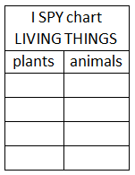  *Sort the list of living things into plants or animals.  *Make a graph to share your findings.  Did you see more plants or more animals each day? What factors do you think have affected your count?
Here is a short sequence of numbers.  Can you figure out the rule and fill  in the next three blanks?  2, 3, 5, 7, ___, ____, ____  Remember, what’s important is not which numbers you pick, but rather how you explain your answer. | Strike Out.  Draw a number line from 0-20  Player 1 chooses 2 numbers on the line that they want to find the sum or the difference of. They cross out the two numbers, find the sum or difference and circle the answer. Record the equation. Player 2 will begin with the circled number and choose another number not crossed out yet to either add or find the difference from and circle their answer. Players continue to take turns beginning where the previous player finished and using only numbers that have not been crossed off yet. The winner of the game is the player who stops their opponent from making a move.  Below is an example of three moves that were made on a number line and their recording.  4+3=7  7-1=6  6+12=18 | 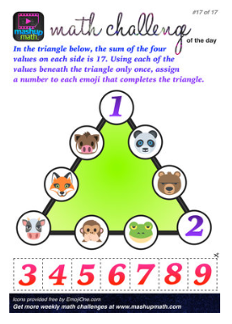
Solve Me  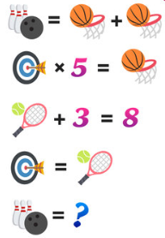  For more puzzles try:  https://mashupmath.com/blog/math-logic-puzzles-for-kids | Numeracy  How many ways can you make $3.25?  If you only use quarters how many would you need?  If you only use nickels how many would you need? | 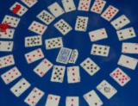  Game Time  The Game of Spiral: Use a deck of cards to create a number board game that twists and turns.  Materials: deck of cards, game pieces, and dice.  Steps: Arrange cards in a spiral for the game board, take turns rolling the dice and moving around the game board. When a player lands on a card, they multiply the value of their die with the value of the card. The other players will “fact check” their answer. If they’re correct, they stay where they are. If they’re incorrect, they move back to the previous position. The first player to get to the card at the center of the spiral wins.

