Week 8 Grade 3 Continuation of Learning June 1-5, 2020.

Hello Everyone,
We are down to the final two weeks of online continuation of learning. I’ve received photos and spoken to many on the phone. Thank-you for taking the time to connect with me.
On Wednesdays I will be checking my email, from 10-11 am to answer any questions you may have.
From Ms.Bush

****New Link from ASD-W****
What makes the world around us unique and special? Your child will explore this question by developing their observation skills and using their creativity to think about our connections to the Earth and our environment, and then recording their observations in a field journal. All activities can be completed without an electronic device. This Learning Plan was developed in collaboration with a team of EECD Learning Specialists.

https://www2.gnb.ca/content/dam/gnb/Departments/ed/pdf/promo/learning_at_home/ConectingToTheEarthThroughObservation.pdf

Let’s Grow Together! (Grades 3-5) In this activity, children will plan to plant a garden this summer, and along the way, they can explore measurement, journals, music, art, science, Indigenous ways of knowing, and so much more! These activities can be completed with materials typically found in many households.

https://www2.gnb.ca/content/dam/gnb/Departments/ed/pdf/promo/learning_at_home/LetsGrowTogether.pdf

Links:
Spring into Action (Grades 3-5) Children are naturally active and creative. Many children love to make up songs and rhymes, create dances, tell and act out stories, draw, colour, build, and move their bodies. In this learning plan, you will find a selection of activities that will encourage your children to express themselves creatively and to get up and move!

https://www2.gnb.ca/content/dam/gnb/Departments/ed/pdf/promo/learning_at_home/SpringIntoAction.pdf

In addition to the activities suggested, students are encouraged to:
- Read daily for 30 minutes- Take time to read to or with your child and encourage them to read independently.
Scholastic Read at home: divided up by day 1, 2 etc.., with activities and reading.
This is a great link for SCIENCE
2.https://classroommagazines.scholastic.com/support/learnathome/grades-1-2.html
Grades1-2
https://classroommagazines.scholastic.com/support/learnathome/grades-3-5.html Grades 3-5

3. EPIC books- available during the day
https://www.getepic.com/ - Our class code is zgc2046

This is a science resource that ASD-W sent teachers to share about birds:
https://evergreen.us6.list-manage.com/track/click?u=6e3aa88e67&id=8f017a5d00&e=9899ddd14f
In addition to the activities suggested, students are encouraged to:
- Read daily for 30 minutes
- Physical activity- with Ms.Bush
- ZEARN numeracy site- continue you mission by doing a few minutes a day. www.zearn.org

Here is another literacy activity to try:

Literacy Learning at Home
Grade Three
Here are some options for you to choose from to help improve your literacy
skills while you are at home. Challenge yourself to try one each day and have fun!

Make a list of interesting words that you notice while you are reading. If you don’t know what the words mean, ask a family member or use a dictionary. Try using some of these words in your writing this week (e.g. in your journal, a story, a poem, or a song)
READ

WRITE
• Create a book with a sibling or a parent. Decide together who the main character of your story will be and what adventures they will go on. Take turns adding illustrations and words to your book.

Generate a list of interview questions to help you make a timeline of your life or the life of someone important to you. Decide how to organize the timeline with pictures and words. This may be a scrapbook or video!
CREATE

SHARE

Find a few riddles or jokes to share with a family member.

EXPLORE

Find a ‘big word’. You can find words on food labels or in a book. Write the word down. Make new words using the letters in your ‘big word’. How many words can you make? Challenge yourself to make more words! Tip: If you’re finding it tricky, you can cut the letters apart so you can move them around and build new words..

Grade 3 Choice Board- pick one a day
You have a total of $1.45 in coins in your pocket. What are all the possible combinations of coins you could have . | Roll a die 3 times(or use number cards) to create a three digit number. Print your number on your score card that fits the description. Compare your answers with a partner score card.  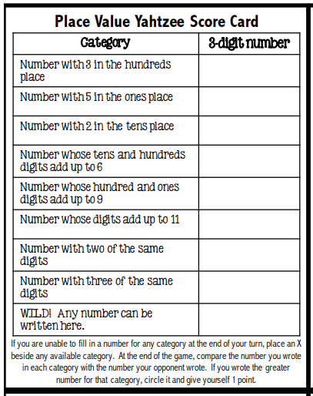 | Flip Three  Using a deck of cards with face cards removed set all of the cards in rows face down.  Players take turns to flip over three cards and attempt to make an equation using the three cards. The equation can be an addition, subtraction, multiplication or division, e.g. 3+3=6, 8-5=3, 2×1=2, 10÷2=5.  If the player can make an equation they keep the cards. If they can’t make an equation the cards are flipped back over in the same place.  Continue playing until only 7 cards remain. The winner is the player who has the most cards.
How many triangles can you find?  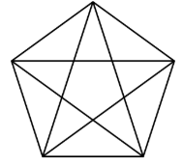 | Technology  www.mathstorytime.ca www.abcya.com | 