**Week 2 Continuation of Learning April 20-24, 2020.**

Grade Two

Here is the Physical Education Video <https://youtu.be/skUQxgR2lqw>

From Ms Bush

Hello everyone,

It was nice to hear from parents and hear updates about the continuation of learning that is happening in homes. On Wednesdays I will be checking my email, from 10-11 am to answer any questions you may have. I really like what parents are doing at home and appreciate your support.

|  |
| --- |
| **Reminders:**  In addition to the activities suggested, students are encouraged to:   1. **Read daily for 30 minutes**- Take time to read to or with your child and encourage them to read independently.   **Scholastic Read at home**: divided up by day 1, 2 etc.., with activities and reading.   1. <https://classroommagazines.scholastic.com/support/learnathome/grades-1-2.html> Grades1-2   <https://classroommagazines.scholastic.com/support/learnathome/grades-3-5.html> Grades 3-5  4. **EPIC books- available during the day**  <https://www.getepic.com/> - Our class code is zgc2046   1. **Physical activity for 30 minutes** |

|  |
| --- |
| **Literacy**  Words Their Way- At Home  This is a weekly activity and should be visited each day to review spelling the new words and activities.  Please remember we are only asking that you do one hour total a day of literacy/numeracy.  In addition to this,30 minutes of reading each day, and 30 minutes of physical activity.  I am hoping to send work that the students know how to do with little guidance. I don’t want to overwhelm, but also know some families/students want lessons to do.   * I have included a link that is cross curricular for science and writing. This will help your child learn to organize facts and summarize findings. * <https://www.thecurriculumcorner.com/thecurriculumcorner456/wp-content/pdf/centersets/deciduousconiferous.pdf> * This is voluntary.   I have included a link for any student who would like to explore graphic novel writing.   * <https://www.thecurriculumcorner.com/thecurriculumcorner456/wp-content/pdf/readingworkshop/graphicnovels.pdf>   **Games Help Children Math**  This week I have attached a few numeracy games ( as an attachment to the email) for you to choose from. Please refer to games I sent last week too  Card and dice games are powerful learning tools and enhance mathematical at any age.  Some benefits include:  **Counting…**  **Recognizing numbers…**  **Recognizing amounts (sets of dots on dice and ‘how many’ on cards)…**  **Ordinal Numbers…**  **Number Sense…**  **Valuable questions for parents to ask:**  “How many spaces did you move?”  “How much do you have to roll to get to the finish?”  “Can you get there in one roll…or two?”  “Do you notice any patterns when you roll odd numbers? Even numbers?”  “What’s the best number to roll to win this game? Why?”  “Would we land on the next number if we used 2 dice? Why?”  Is the win dependent upon chance and not ability? This is a very important idea to help support the excitement of continued Math learning….card games and dice games have this element of “chance”.  **Games can be powerful motivators and build positive ‘mathitudes’.**  **Who says math can’t be fun!**   * Journal writing ideas:   **Day 1**  **Worksheet -Complete the worksheets for their sort. Please have your child complete this sheet at their own pace. They can read you the sentences and the words.**  The work can be printed out for your child to do. Or, they can print out the sentences and add the answers. We use rulers to make our charts, so they can draw a sorting chart. |
| 1. Sort words – write the words on small cards/ post-it’s/ recipe cards cut in half.   Timed sort: set the timer, and sort. Record in your notebook. Time yourself three times and see if how much faster you can get.  2.Worksheet time  3. Writing time: Your choice  Write in your Journal about your hopes and dreams, like Morris. ( see poster)  OR  Work on one of the projects that I included.  **\*Reading for 30 minutes** |





DAY 1 NUMERACY:

**ZEARN** math has been very successful and well-liked by the students. Most have logged on and are working at their own pace through the lessons. For this reason, my suggestion for learning is to continue with Zearn, as it will introduce concepts we haven’t covered, and review others.

**Math games**- keep a collection of all the math games sent, and I will add to this weekly.

*************************************************************************************

|  |
| --- |
| **Day 2**  **Literacy:**  **1.**Write words in notebook – This could also be a good time to practise printing/writing for neatness**. 2.** Get Smiley Face - After they’ve written words in notebook, you can check their work. If any words are spelled wrong or written in the wrong category, put a small dot next to the word. They go back and fix their word. Once it’s fixed, add a smiley face. **3.** Worksheet time. **4.** Write in your Journal about your hopes and dreams, like Morris or work on a report  **\*Reading for 30 minutes** |

**Numeracy-** continue with Zearn math

Play a math game

**************************************************************************************************

**DAY 3**

**1.**Test with Someone – call out the words as a spelling test - Think about the vowel combinations used to make sounds.

**2.**Any words that are not spelled correctly are the focus for practise:

Ex:Rainbow Words – Set out markers, crayons, and coloured pencils. Let students write their words with

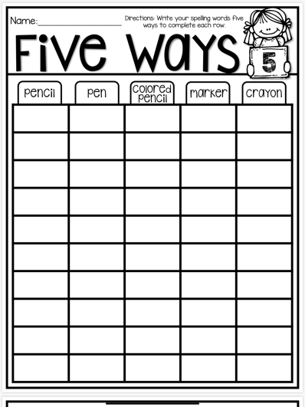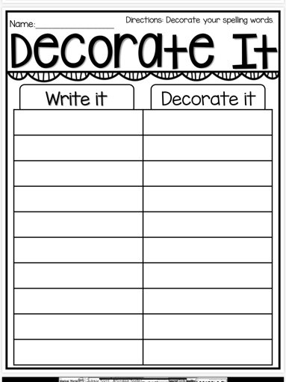 different colours.

1. Worksheet time. **4.** Write in your Journal about your hopes and dreams, like Morris or work on a report

**\*Reading for 30 minutes**

**Numeracy-** Zearn math and play a game

********************************************************************************************I

**Day 4**

Literacy – word work sheets

- journal/report writing

**\*Reading for 30 minutes**

**Numeracy-** Zearn math and play a game

**************************************************************************************************

**Day 5**

|  |
| --- |
| **Literacy**  1.This is the day to look back and make sure you have completed all your word work activities and know how to spell some new words from your sort.  2. Read over your journal entries for the week and fix up any words you know are spelled incorrectly.  3.Have you visited the EPIC website site this week? Look below for log-in info.  Try scholastic too!  4. Are you keeping a reading log? Update any new books. **\*Reading for 30 minutes** |

**Numeracy-** Zearn math and play a game