
Meduxnekeag Consolidated School
Virtual Newsletter May 2020

Monday | Tuesday | Wednesday | Thursday | Friday
1


4  MCS TALENT WEEK  Parents can pick up student belongings  9 am -3 pm | 5  MCS TALENT WEEK  Parents can pick up student belongings  9 am -3 pm | 6  MCS TALENT WEEK   | 7  MCS TALENT WEEK   | 8  MCS TALENT WEEK  
11  Colour Day  Staff and students:  K-2 wear white  3-5 wear red  6-8 wear black | 12 National Denim Day   | 13  Socially Distant  Twin Day  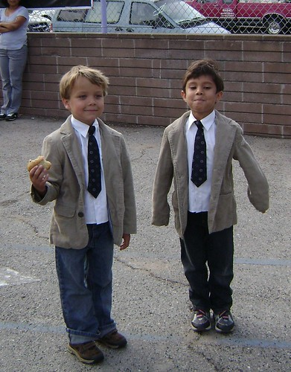 | 14  Kindness Counts Day   | 15  
18  Victoria Day Holiday   | 19  Pet Day   | 20  Take Me Outside Day   | 21 Dance Day   | 22  Flip Flop Friday  
25  Chore Day   | 26  Sports Day   | 27  ART DAY   | 28   | 29  SUPER HERO DAY  

