MHS Enrichment Coding Continuum – Code.Org Activity #2
Visit https://code.org/join and enter BNQKNY
Or: Direct URL: https://studio.code.org/sections/BNQKNY
You are to sign in to this website using the following information:
Username: mhsstudent2019__
Secret Words:________________
Skip Lesson 1. You must complete all 10 activities of Lesson 2: Introduction to Online Puzzles:
You may skip the video if you already know code.org, but # 2-10 must be completed.
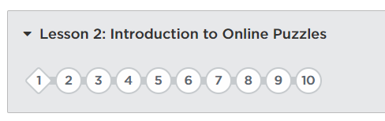
This is the screen that must be shown to the teacher before you can begin the SCRACH activities:
EVERY circle must be SOLID GREEN to prove that you did each one
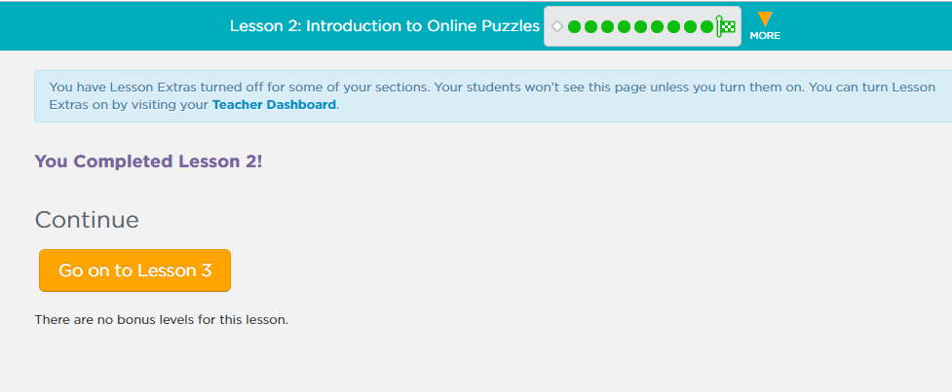
Reminder: You must get your Contiuum Card initialed by a teacher before going to next level!

