MHS Enrichment Coding Continuum – Makey-Makey ACTIVITY # 6

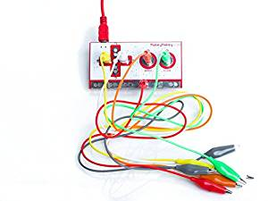
The purpose of this activity is to learn how to wire up a Makey-Makey, (or prove that you already know how).
You must show your continuum card that’s been initialed for steps 1-5 before you are given a Makey-Makey and supplies.
You now have to attach wires to the Makey-Makey and get it working with one of your SCRATCH projects. You can use aluminum plates/foil or playdo as a conductor.
Help can be found here:
https://makeymakey.com/pages/how-to#section1 (Click on “SETUP”)
and here:
https://learn.sparkfun.com/tutorials/makey-makey-classic-hookup-guide/all#hardware-hookup
or watch these videos:
https://www.youtube.com/watch?v=sT2kyPeULeU
https://www.youtube.com/watch?v=qg-Jw3plDTY
If you’re still struggling, ask a teacher for help.

To get teacher’s initials for this activity, all you have to do is show a teacher that your Makey Makey is controlling your Sprite project in some way. You do NOT need to have all 4 arrows working, as long as the Makey-Makey is working with your Scratch project.

Reminder: You must get your Contiuum Card initialed by a teacher before going to next level!

