MHS Enrichment Coding Continuum – Microbit ACTIVITY # 7,8,9
- Watch this video. It’s a 6 minute video but you can skip the first two minutes - I’ve set the URL so it begins at 1:52…
https://youtu.be/kaNtg1HGXbY?t=1m52s

- Go to this site to do the coding (click on “+ New Project”:
https://makecode.microbit.org/#

- Write the following code using the “Basic” and “Input” options:
Name it “Aorb” and download it to your microbit and show to the teacher you were successfully able to make this work:

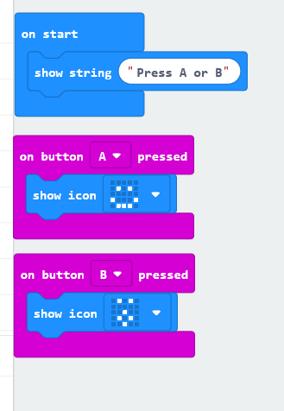
Once teacher has seen that you’ve successfully got the Microbit to perform the code above, try to complete any 2 of the following programs below:

Create any 2 of these Programs from here:
https://microbit.org/en/2017-03-07-javascript-block-resources/
or any 2 of these (or anything else you can find online)
- Flashing Heart:
https://microbit.org/en/2017-03-07-flashing-heart/

- Guess the number:
https://microbit.org/en/2017-03-07-guess-the-number/

- Die Roll Activity:
https://microbit.org/en/2017-03-07-die-roll/

- Smiley Buttons:
https://microbit.org/en/2017-03-07-smiley-buttons/

- Temperature Activity:
https://microbit.org/en/2017-03-07-temperature/

- Magic 8 Activity:
https://microbit.org/en/2017-03-07-magic-eight/

- Rock Paper Scissors:
https://microbit.org/en/2017-03-07-rock-paper-scissors/

