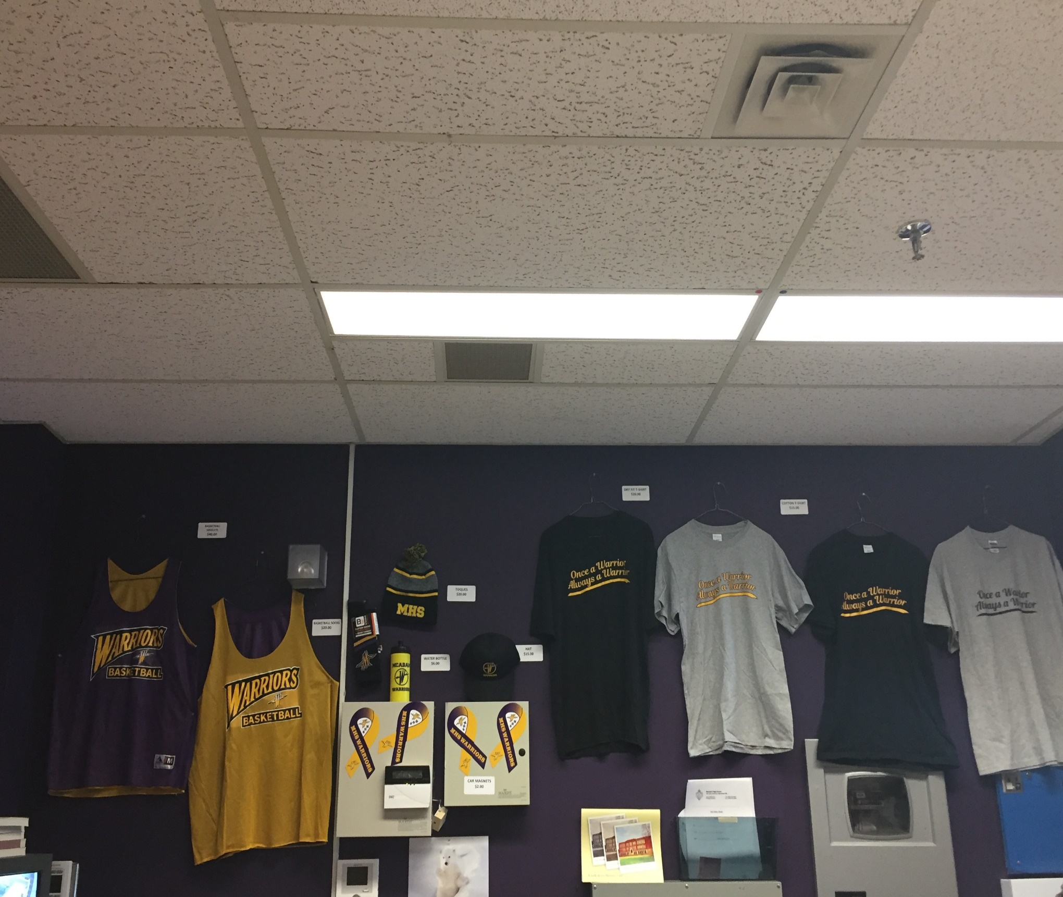

**McAdam High School Merchandise**

**Car Magnets - $2.00**

**Water Bottle - $6.00**

**Hats - $15.00**

**T-Shirt Cotton - $15.00 (Limited quantity & sizes)**

**Dry Fit T-Shirt $20.00 (Limited quantity & sizes)**

**Toques - $20.00**

**Basketball Singlets - $40.00**

**Basketball Socks - $20.00**