Weekly Update for McAdam High

Hello everyone, let’s get ready for another great week!
Monday
- Our small Social Emotional Learning groups happen this week during SPARK time. Students will be engaged in discussions and learning opportunities about Self-Awareness. 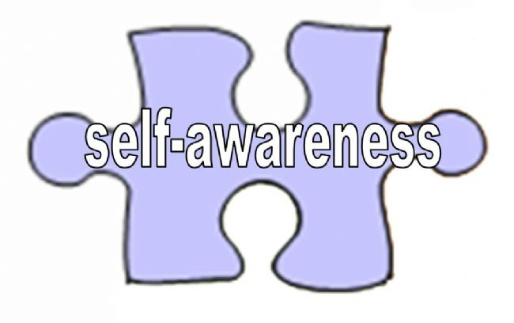
  - Self awareness is the biggest asset that you can have if you want to be successful in life. It is what you need in order to choose the right career, the right relationship and the right social circle. If you have to get from one city to the other, you have to know which city you are in on the map. Similarly self awareness is like knowing where you are on the map of life, so that you can chart a course to your destination.
Tuesday
- Jeremy Smith (Science Lead for the School Division) was in last week supporting our Biology class, this year the students will be involved in several fascinating labs lead by Mr. Glenen.
Wednesday

- Looks like a great day for learning!!

Thursday
- McAdam High will be undergoing some very exciting upgrades to the school that will be happening very soon! We are excited and cannot wait to share the details!
- We will be conducting a lockdown drill. These drills are part of our comprehensive safety plan.

Friday

- Ron Tremblay, the Grand Chief of the Wolastoq Grand Council will sharing his knowledge with the Outdoor Pursuits class.
  - Reminder: There is no class on Monday February 17th for staff or students. Enjoy the Family Day long weekend!

