Course: Grade 9 PIF
COURSE
OUTLINE
Teacher: Melanie Bostick (melanie.bostick@nbed.nb.ca)
School: McAdam High
Year: 2016
Required Materials:

- Three-ring binder and paper
- Pencils/Eraser
- Occasionally you might need markers, glue, scissors, etc… (you will be notified ahead of time)
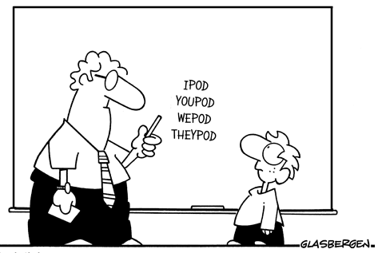

Units:
- Le petit écran – La télévision
- La musique
- La responsabilité sociale

The focus on our post-intensive French class is to develop your conversational skills. This will be done mainly through classroom and group discussions, presentations, mini-projects and final projects. You will also be required to do some writing and reading during each unit. My focus is to find topics that are interesting for you to talk about, however it’s difficult to please everyone at the same time. Please be patient and respectful. Your participation is essential in this class!

Assessments:

- Class/Group discussions
- Presentations
- Assignments
- Mini-projets
- Projet final

Evaluation:
Oral 35%
Writing 25%
Reading 25%

Final exam: Oral scheduled interview ……………………………………………………………….……………………………15%
*Note: In grades 9 & 10 there are NO exemptions for half-year courses. Passing grade for a high school course is 60%)*

TOTAL …………………………………………………………………………………………………………………………………………100%

Most evaluations will be informal and based on observation (using a rubric). If you come to class, try your best, participate, are respectful and follow the model that I will be providing, you will easily be able to pass this class.

Missed Work:
If you miss class time for any reason, it is your responsibility to catch up on the missed work as soon as possible. Since most of the work is done through discussion in class and your participation, regular attendance is essential to succeed.

Extra help:
Extra help will be provided upon request by either the student or the teacher.

