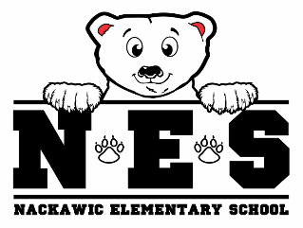 | Name:_____________  Class: _____________  Date: _____________ | Name:_____________  Class: _____________  Date: _____________ | Name:_____________  Class: _____________  Date: _____________ | Name:_____________  Class: _____________  Date: _____________
MONDAY | TUESDAY | WEDNESDAY | THURSDAY | FRIDAY
All paper orders must be in by Monday at 9:00 am for the week.  All online orders must be placed by Sunday evening of each week.  No late orders will be accepted.  If a child is away  and not able to  receive the order it will be carried over for the next week.  Payment online preferred.  Cash and cheques  accepted. Please send correct change or make cheques out to Nackawic Elementary School.  Please fill out name,  class and date at top of  each order slip. Slips  will be cut apart.  Attach payment to order form.  Please circle choices  clearly.  Please use one order form per child.  If you need more  menus please check  this box | Milk Only | Milk Only | Robin’s  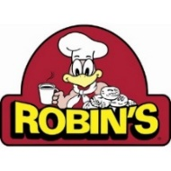 | Milk Only
Sandwich &
Orange Slices.

Bread: (circle)
White
Whole Wheat

Select kind: (circle)
Steak
Ham
Bacon
Turkey
__________________
Circle toppings:
Cheese
Onions
Tomatoes
Lettuce
Pickle
Mayo

Mustard
Honey Mustard
 | Price: (Circle)  50¢ just milk  White Chocolate | Price: (Circle)  50¢ just milk  White Chocolate | Price: (Circle)  $5.00 meal with milk  $4.50 meal without milk  50¢ just milk  White Chocolate | Price: (Circle)  50¢ just milk  White Chocolate
Nackawic Elementary School Menu Order Form
When placing an order, please complete menu regardless of payment
PLEASE CHECK: ( ) Paid Online ( ) Payment Attached

