Making a Difference

Borrowed from nrich.maths.org
There are a number of ways the digits 2, 5, 7, 8 can be placed in a subtraction sum like the one below:
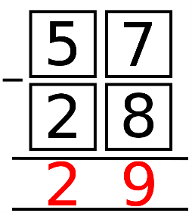 In this example, the answer is 29.
Can you rearrange the four digits to find ALL the (positive) answers it is possible to make?
Here are two follow-up questions you might like to consider:
- Can you work out which four digits you need to start with to be able to get all the possible answers 7, 9, 11, 13, 18, 22, 29 and 31?
- Can you show that, if we're only allowed to use consecutive digits
(e.g. 5, 6, 7, 8), 31 is the largest possible answer and 7 is the smallest?

