4 Dom
Use these four dominoes to make a square that has the same number of dots on each side. You are to total ALL the dots on each domino when finding the common sum of each side of the square.
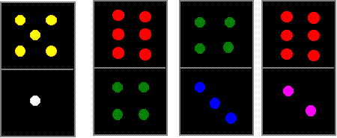

We would love to see pictures of your completed square. Email us, please!

(Taken from nrich.maths.org)

