Grade 8 Science
Body System Project

For this project, you may work individually or with a partner. Remember that when working with a partner your project must reflect the work of two people.
For this project, your task is to create a poster OR powerpoint/Prezi/Smart board presentation that you can use to present to the class. Your presentation must include the following:
- An overview of the system
- The structures and functions of the different parts of the system
- How the system works
- Problems/diseases of the system (pick one or two)

In your presentation you should include diagrams, pictures, photos, short video clips or animations to help with your presentation. Remember that you are teaching this material to the class in a short lesson, so be as thorough as you can.
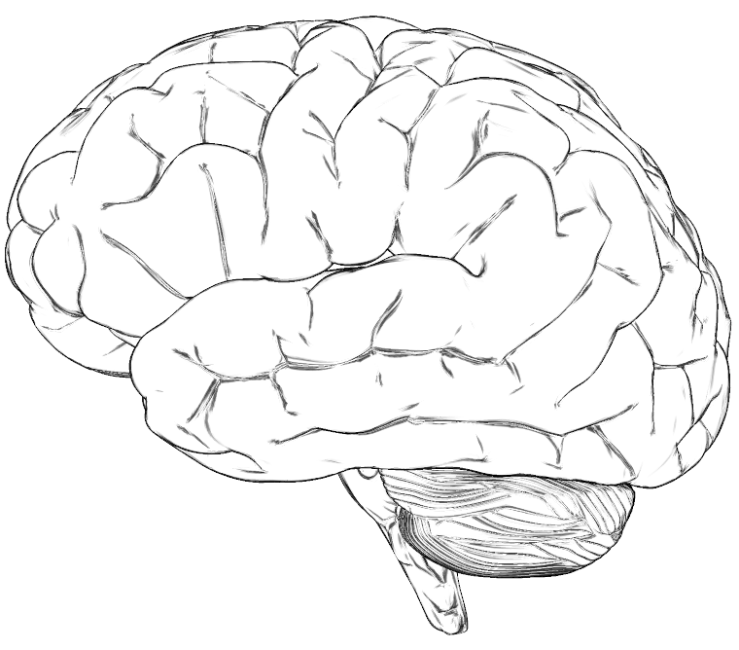
Your presentation should take between 15 and 20 minutes, depending on how many slides you have and class activities. A model or actual specimen e.g. heart, lung, liver can be brought in as well (just let me know ahead of time).
You also need to create/provide a tool for the class to use as a review when you are finished. Examples such as a worksheet, quiz, diagrams (to label), a word search, crosswords, games, online tests etc. are fine to use.
Use the rubric provided to help you determine what to include in your presentation.

Body System PowerPoint/Prezi
Teacher name: Mr. Liston
Student(s) Name ___________________

CATEGORY | 4 | 3 | 2 | 1
Text - Font Choice & Formatting | Font formats (e.g., color, bold, italic) have been carefully planned to enhance readability and content. | Font formats have been carefully planned to enhance readability. | Font formatting has been carefully planned to complement the content. It may be a little hard to read. | Font formatting makes it very difficult to read the material.
Sequencing of Information | Information is organized in a clear, logical way. It is easy to anticipate the type of material that might be on the next card. | Most information is organized in a clear, logical way. One card or item of information seems out of place. | Some information is logically sequenced. An occasional card or item of information seems out of place. | There is no clear plan for the organization of information.
Use of Graphics | All graphics are attractive (size and colors) and support the theme/content of the presentation. | A few graphics are not attractive but all support the theme/content of the presentation. | All graphics are attractive but a few do not seem to support the theme/content of the presentation. | Several graphics are unattractive AND detract from the content of the presentation.
Background | Background does not detract from text or other graphics. Choice of background is consistent from card to card and is appropriate for the topic. | Background does not detract from text or other graphics. Choice of background is consistent from card to card. | Background does not detract from text or other graphics. | Background makes it difficult to see text or competes with other graphics on the page.
Originality | Presentation shows considerable originality and inventiveness. The content and ideas are presented in a unique and interesting way. | Presentation shows some originality and inventiveness. The content and ideas are presented in an interesting way. | Presentation shows an attempt at originality and inventiveness on 1-2 cards. | Presentation is a rehash of other people's ideas and/or graphics and shows very little attempt at original thought.
Content - Accuracy | All content throughout the presentation is accurate. There are no factual errors. | Most of the content is accurate but there is one piece of information that might be inaccurate. | The content is generally accurate, but one piece of information is clearly flawed or inaccurate. | Content is typically confusing or contains more than one factual error.

Score:
Body System Poster
Teacher name: Mr. Liston
Student(s) Name ___________________

CATEGORY | 4 | 3 | 2 | 1
Required Elements | The poster includes all required elements as well as additional information. | All required elements are included on the poster. | All but 1 of the required elements are included on the poster. | Several required elements were missing.
Originality | Presentation shows considerable originality and inventiveness. The content and ideas are presented in a unique and interesting way. | Presentation shows some originality and inventiveness. The content and ideas are presented in an interesting way. | Presentation shows an attempt at originality and inventiveness on 1-2 cards. | Presentation is a rehash of other people's ideas and/or graphics and shows very little attempt at original thought.
Labels | All items of importance on the poster are clearly labeled with labels that can be read from at least 3 ft. away. | Almost all items of importance on the poster are clearly labeled with labels that can be read from at least 3 ft. away. | Many items of importance on the poster are clearly labeled with labels that can be read from at least 3 ft. away. | Labels are too small to view OR no important items were labeled.
Graphics - Relevance | All graphics are related to the topic and make it easier to understand. All borrowed graphics have a source citation. | All graphics are related to the topic and most make it easier to understand. Some borrowed graphics have a source citation. | All graphics relate to the topic. One or two borrowed graphics have a source citation. | Graphics do not relate to the topic OR several borrowed graphics do not have a source citation.
Attractiveness | The poster is exceptionally attractive in terms of design, layout, and neatness. | The poster is attractive in terms of design, layout and neatness. | The poster is acceptably attractive though it may be a bit messy. | The poster is distractingly messy or very poorly designed. It is not attractive.
Grammar | There are no grammatical/  mechanical mistakes on the poster. | There are 1-2 grammatical/  mechanical mistakes on the poster. | There are 3-4 grammatical/  mechanical mistakes on the poster. | There are more than 4 grammatical/  mechanical mistakes on the poster.

Score:

