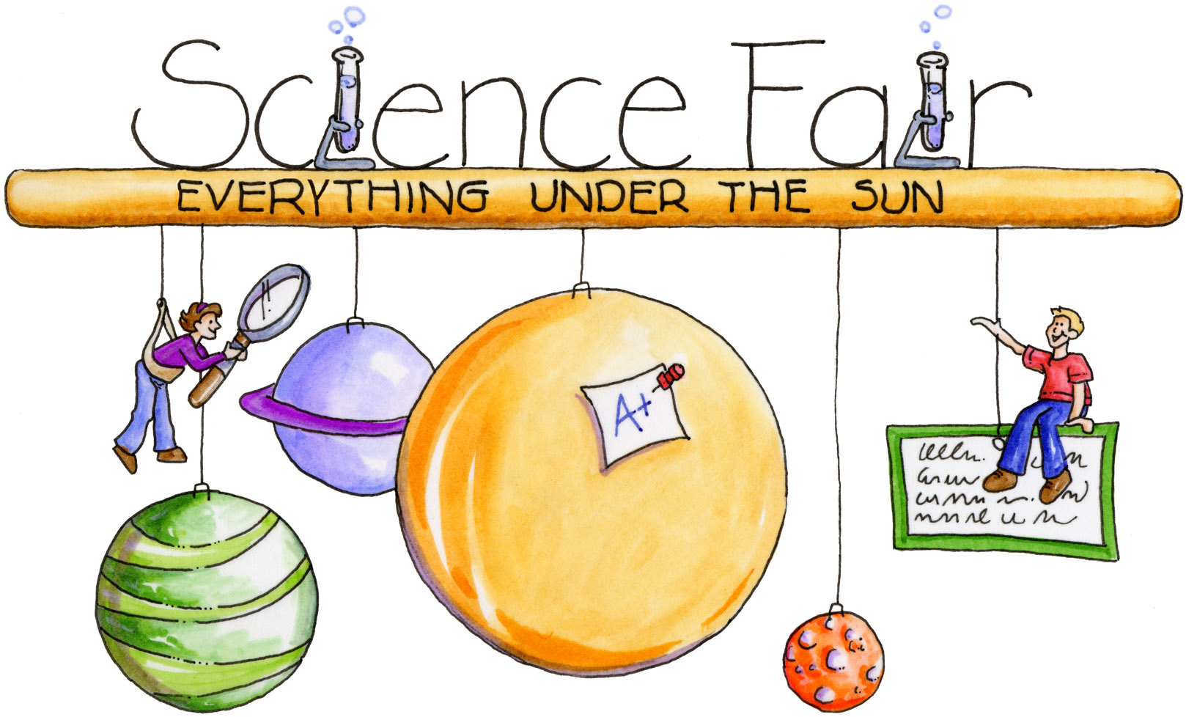
NMS Science Fair
Quick Reference Guide
- Our Science Fair follows the same guidelines
as the NB Science Fairs.
- Three Types of Projects
  - Experiment
  - Innovation
  - Study
- Each type of project has certain requirements:
  - Experiment
    - Design and conduct the experiment
    - Written Report (5 pg. max + bibliography)
    - Display
    - Oral presentation (5 min. max)
  - Innovation
    - Identify a need/problem that could be solved by an invention
    - Design the innovation (concept drawings)
    - Build a prototype and test it
    - Written Report (5 pg. max + bibliography)
    - Display
    - Oral presentation (5 min. max)
  - Study
    - Pick a topic of interest
    - Literature Review (background info)
    - Create a research question and explore it by gathering data and analyzing it
    - Written Report (5 pg. max + bibliography)
    - Display
    - Oral presentation (5 min. max)
- Projects are judged using the Regional Science Fair Project Evaluation Rubric
- Keep your project manageable – Set deadlines and try to meet them…this way you don’t run out of time.

