STUDENT STANDARDS AND TARGETS FOR MIDDLE LEVEL
MATHEMATICS
GRADE: 8

OUTCOME: PR1 Graph and analyze two-variable linear relations

WHAT WE WANT STUDENTS TO LEARN:

i) Determine the missing value in an ordered pair for a given equation.
ii) Create a table of values by substituting values for a variable in the equation of a
given linear relation.
iii) Construct a graph from the equation of a given linear relation (limited to discrete
data).
iv) Describe the relationship between the variables of a given graph.
v) Determine whether or not a graph would be shown with a solid line connecting
the plotted points.

NOTE:
- Clarify the difference between discrete and continuous data. With continuous data, points (ordered pairs) can be “connected” because values in-between these points are realistic; for example, time and distance. Values in-between co-ordinates for discrete data do not make sense; for example, quantities of people, points, etc must be whole numbers.

STANDARD ACHIEVEMENT TARGETS

Basic:

1) Complete the following table of values for the equation y = x + 6
PR1.ii

x | y
-4
-2
0
2
4

PR1.i
2) Each point on the graph is labeled with an ordered pair. Some numbers
in the ordered pairs are missing. Find the missing numbers.

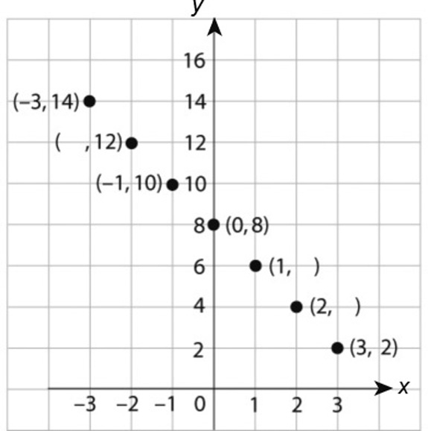

3) Which statement describes the relationship shown on this graph?
PR1.iv

a) y is half of x
b) y is 4 times x
c) y is 10 times x
d) y is a quarter of x

Mid-Range:

1) Decorations for the end of the year banquet costs $150. Each meal ticket costs $5. The cost
of the event is represented by c= 5d + 150.

a) What does d represent in this equation?

b) Complete a table of values for d= 50, 60, 70, 80, 100, 120
PR1.ii

c) If the total cost of the event is $600, how much was spent on food?

2) Describe the relationship. What is the expression for y in terms of x?
PR1.iv

X | -3 | -2 | -1 | 0 | 1 | 2
y | 1 | 3 | 5 | 7 | 9 | 11

High:

1) Eric is organizing a skating party. He has to pay $50 to rent the rink and $4 for lunch for
each person. He made a table of values, but he made an error in one of the costs.

# people p | 1 | 2 | 3 | 4 | 5 | 6 | 7 | 8
Cost ($) c | 54 | 58 | 62 | 68 | 70 | 74 | 78 | 82
PR1.ii
- Identify and explain the error made in Eric’s table of values.

PR1.ii
- Create a new table of values without errors.

- Graph the ordered pairs from your new table of values.
PR1.iii
PR1.v

