Grade 8 Health C2 Facts about Smoking - what everyone should know
Source : www.hc-sc.gc.ca (Health Canada)
- More than 37,000 people will die this year in Canada due to smoking.
Of those …
- More than 300 non-smokers will die of lung cancer
- At least 700 non-smokers will die of heart disease caused by exposure to second-hand smoke.

Tobacco smoke contains over 4,000 chemicals, including at least 70 that cause, initiate or promote cancer such as tar, ammonia, carbon monoxide, oxides of nitrogen and benzopyrene.
Although the amount of chemicals in each cigarette is small, it is cumulative. It adds up and is stored in the body. It increases with each puff of a cigarette. There are over 10 puffs per cigarette. By smoking 1 pack a day, they will inhale 73,000 puffs of dangerous chemicals each year.

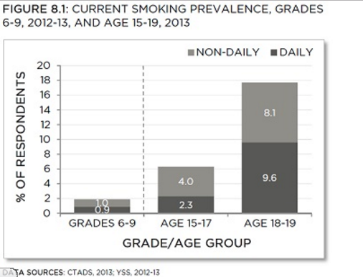
Smoking in youth in Canada

When surveyed, 85.5% had never tried
smoking. 30% stated that they may
smoke in the future, they are susceptible
to smoking.

In 2012-13, the smoking rate among
students in grades 6-9 was about 2% .
This means 2 out of 100 will smoke.
These smokers will smoke about 11 cigarettes a day.

Among adolescents aged 15-19, 10.7% were current smokers in 2013.
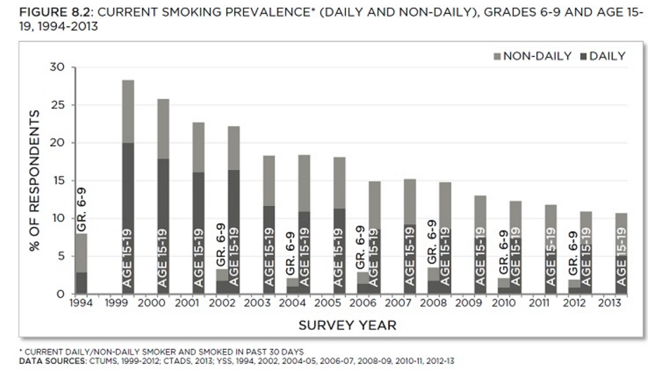

Overall smoking in New Brunswick
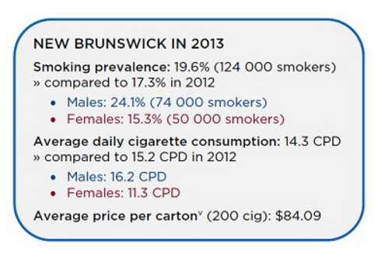
In 2013, smoking prevalence in New Brunswick was 19.6%, well above the national average of 14.6%

Assignment –
Write a 1 page reflection based on the information you have received today. It is a reflection therefore you should NOT be retelling me what we have covered. Your reflection should include supporting details .Here are some prompts to help you:
- Did your opinion change on the subject? How?
- What was the most useful piece of information you heard and how will you use it?
- Were you surprised by the information and why?
- Could you relate the information presented today to person, place or event? Explain.
- Did the presentation make you sad, angry, or mad? Explain why.

