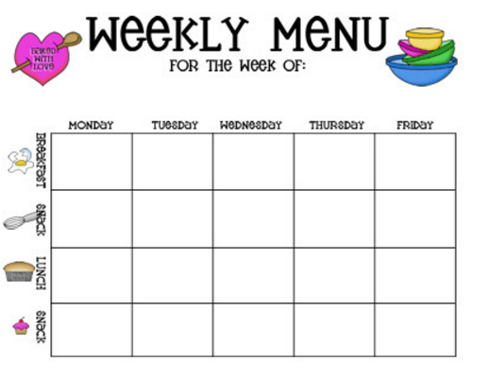

Cookies

56

Chocolate milk

83

Chocolate milk

83

Chips

536

Chips

536

Rabbit food

(salad)

100

Grilled cheese

497

Pizza

266

Orange

47

Apple

52

Waffles

250

Toast

170

Muffin

377

Cereal

125

Grapes and banana

156