**Homework 7**

**Test Unit 3 will be Wednesday December 18th.**

**Week 13 (December 9 – 13)**

**Monday :**

1. **Add and subtract decimal numbers :**
2. 12.48 + 5.10 b) 4.15 + 2.56 d) 7.14 – 1.22
3. **Multiply and divide decimal numbers. Remember to make an estimation first in order to figure out where to put the decimal:**
4. 2.7 x 0.8 b) 1.8 x 0.6 c) 32.5 ÷ 2.6

**Tuesday :**

1. After school, Mrs. Gagné and Mrs. Briggs went to the store to buy some snacks. They bought 3 chocolate bars at $0.50 each, one bag of chips for $1.05 and a jug of juice for $2.50. If they gave $10.00 to the cashier, how much change in return should they be receiving?
2. **Place the following on the number line. Remember you can change fractions to decimals or percentage in order to make the ordering easier.**

0,27  52% 215% 

0 1 2

**Wednesday**

**5.** of cats in the SPCA are males. Is 54% a good **estimation** for this fraction? Explain.

**Thursday :**

6. The cost of a Montreal Canadiens hat is $24. But today there is a huge sale, the hat is 75% off. How much money would you save?

Solve this problem by using a double number line.

100%

0%

50%

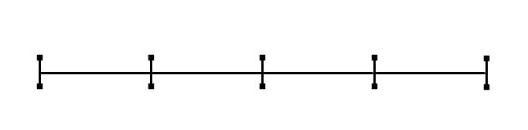

24$

$0

7. Which is biggest : 0,2 ou ? Explain by using words, numbers or drawing.

**Mental-Math**

____________ ÷ ___________ = 9.3 0.93 x _________ = 9.3

____________ ÷ ___________ = 12.8 1.28 x _________ = 12.8

____________ ÷ ___________ = 14.2 1.142 x _________ = 114.2

____________ ÷ ___________ = 0.82 0.82 x __________ = 820

**Homework 7**

Parent Signature :

_____________________________

**Week 13 (December 9 – 13)**

1. **Calculate equivalent fractions . Multiply the denominator and numerator in order to find the equivalent fraction.**

X3

X3

X3

X3

1. ** b)  c)  d) **

X3

X3

X3

X3

1. **Circle true or false.**
2.  True or False b)   True or False

c)  True or False d)   True or False

e)   True or False f)  True or False

1.  True or False h)   True or False
2. Write the following decimal numbers in order, from least to greatest.

0.1 0.5 0.03 1.5 1.3 2.07

_________________________________________________________

1. **For each underline decimal number identify the position value.**

Unit tenth hundredths thousandths

**Here are the position values for this decimal number: 1.105**

|  |  |
| --- | --- |
| 1.**3**25 | **tenths** |
| 0.**1** |  |
| 0.3**4**5 |  |
| **3**.36 |  |
| 0.0**7** |  |
| 1.83**5** |  |
| 2.**3**78 |  |

1. **What is half of the following numbers?**
2. **18 = _________ b) 12 = ________ c) 6 = ________ d) 22 = __________**
3. **What is one third of the following numbers?**
4. **18 = _________ b) 12 = ________ c) 6 = ________ d) 9 = __________**

**Homework 7**

Parent Signature :

_____________________________

**Week 13 (December 9 – 13)**

1. **A draw circles to represent each set of numbers. Then draw a line to separate them in half**

|  |  |
| --- | --- |
| **2** |  |
| **4** |  |
| **6** |  |
| **8** |  |
| **10** |  |

1. **Circle the representations that are equal to ½.**

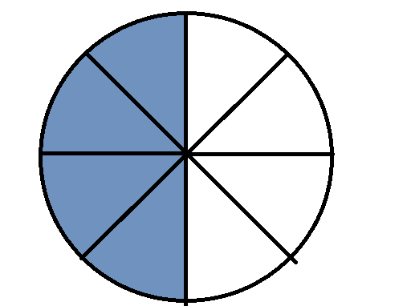 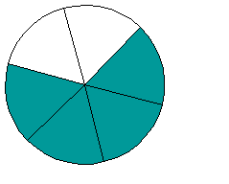[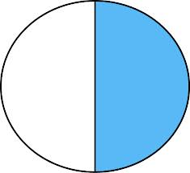](http://www.google.ca/imgres?um=1&safe=active&rls=com.microsoft:en-us:IE-SearchBox&rlz=1I7GGIE_en&hl=en&biw=1366&bih=587&tbm=isch&tbnid=5T16t_wqr87NbM:&imgrefurl=http://www.mycutegraphics.com/graphics/math/math-fraction-half.html&docid=bnde1Ze9pYkDlM&imgurl=http://content.mycutegraphics.com/graphics/math/math-fraction-half.png&w=468&h=429&ei=pT6SUv-5DMHK2AWEzID4BQ&zoom=1&iact=hc&vpx=2&vpy=2&dur=801&hovh=215&hovw=235&tx=117&ty=94&page=2&tbnh=135&tbnw=147&start=22&ndsp=30&ved=1t:429,r:45,s:0,i:217)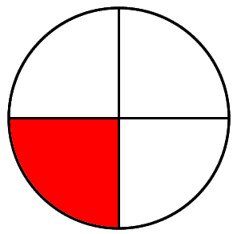

1. **Separate in half. You can draw in order to show your work.**
2. If I have 4 cookies and I want to share them equally with my friend. How many cookies will my friend and I have each?
3. If I have 6 candy canes and I want to share them equally with my friend. How many candy canes will my friend and I have each?