**Homework Math 7**

Signature du parent :

________________________

**Week of December 11-15**

**MONDAY :**

**1. Draw a line between the fractions and the correct shape.**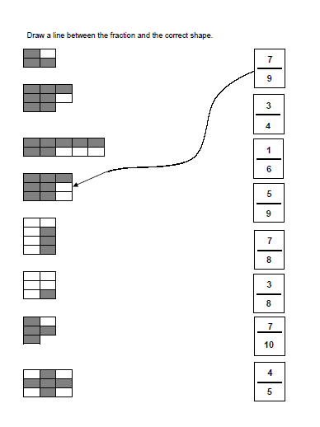

Tuesday**:**

1. **Write the mixed number and improper fraction for each drawing.**

|  |  |  |
| --- | --- | --- |
|  | **Mixed Number** | **Improper Fraction** |
|  |  |  |
|  |  |  |
|  |  |  |

**Wednesday :**

1. **Make a drawing with a circle or rectangle to represent the mixed number or improper fractions below. :**

|  |  |
| --- | --- |
| **Fraction** | **Drawing** |
|  |  |
|  |  |
|  |  |
|  |  |
|  |  |