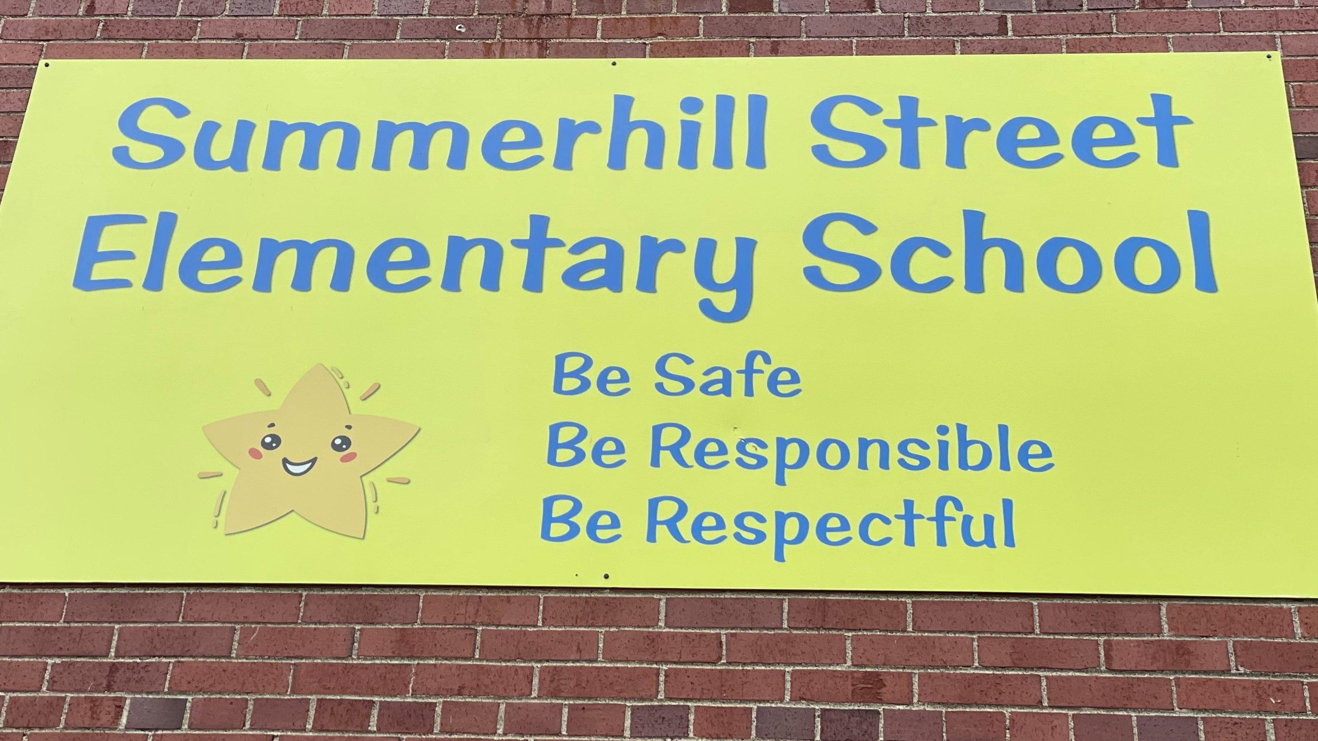

Mrs. Shannon Atherton Mrs. Crys Myrie Ms. Sheila Morgan
Principal Administrative Assistant Acting Vice-Principal

Our School Website: http://summerhill.nbed.nb.ca/
Please see our website for upcoming events, newsletters, school supply lists, PSSC information, school hours, staff and important information regarding our school.

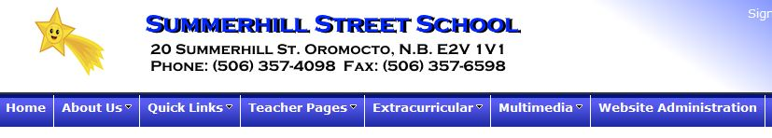

Please follow us on TWITTER: @StarsSummerhill

Summerhill Street Elementary School Mission/Vision

BE SAFE, BE RESPECTFUL, BE RESPONSIBLE.
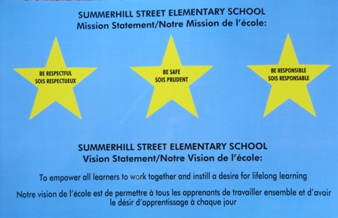

Anglophone West School District
2022-2023 Calendar

2022 2023______________________

September 6 – FIRST DAY OF CLASSES January 2-6 Holidays

October 10 – Thanksgiving Day (No School) January 9 – First Day back for students

October 11 – 14 – Registration for students entering Kindergarten February 20 - Family Day (No School)

November 11 - Remembrance Day (No School) March 6 - 10 - March Break

November 18 – Professional Learning Day for Staff (No School) March 24 – Prof. Learning Day for Staff (No School)

December 1 – Report Cards Issued (K – 8) April 6 – Report Cards Issued (K -12)

December 2 – K – 12 School Improvement Planning (No School) April 7 – Good Friday

December 9 - Parent – Teacher interviews/PL for Staff (No School) April 10 – Easter Monday

December 23 - Last Day of Classes April 14 – Parent Teacher Interviews/PL for staff

December 26 – 30 – Holidays May 5 – NBTA Council Day (No School)
May 15 – NBTA Branch Meeting (No School)

May 22 – Victoria Day (No School)
June 23 - Last Day for Students
You can find a more detailed calendar on the Anglophone West School District Home page:
asdw.nbed.ca

HOURS OF INSTRUCTION

**Supervision for bus students begins at approximately 7:35 am, upon the arrival of the first bus**

Monday, Tuesday, Wednesday and Thursday

8:05 am Students walking or getting dropped off can start arriving through front door

8:25 am Entrance Bell

Recess and Lunch Times
10:30 – 10:50 - Morning Recess

12:25 – 12:45 – Eat

12:45 – 1:05 – Lunch Recess

3:15 pm Dismissal

***** FRIDAY - Students are dismissed at 12:00

EDUCATION ACT
The Education Act for the Province of New Brunswick states:

Roles of Parents

13(1) In support of the learning success of
his/ her child and the learning
environment at the school, a parent is expected to:
- encourage his or her child to attend to assigned homework,
- communicate reasonably with school personnel employed at the school his or her child attends as required in the best interests of the child,
- cause his or her child to attend school as required by this act,
- ensure the basic needs of his or her child are met and,
- have due care for the conduct of his or her child at school and while on the way to and from school.

Duties of Pupils

14(1) It is the duty of a pupil to
- participate in the learning
opportunities to his or her
potential,
- accept increasing responsibility for his or her learning as he or she progresses through his or her schooling,
- attend to assigned homework,
- attend school regularly and punctually,
- contribute to a safe and positive learning environment,
- be responsible for his or her conduct at school and while on the way to and from school,
- respect the rights of others, and
- comply with all school policies

School Programs and Instruction

The Minister of Education and Early Childhood Development (EECD), through the Curriculum Branch of EECD, determines the curriculum that is taught in New Brunswick schools. Textbooks for the various programs at the primary level are provided free of charge to New Brunswick students. Additional school supplies required by students are the parents’ responsibility.

School Library
Students at Summerhill Street Elementary School will benefit from the school library, where they will be able to borrow books. (Due to the high cost of library books, it is necessary for the school to charge parents for replacement of lost or damaged books in accordance with their age and condition).

Homework
Homework is assigned at the discretion of the classroom teacher and will vary between grade levels. If a parent has concerns regarding a homework activity, it is best to contact the classroom teacher to discuss the concerns. Keep in mind that all children will benefit from reading and being read to every night!

Evaluation
Assessment is ongoing and a variety of assessments are used to monitor student achievement. Report cards during the 2022- 2023 school year will be sent home 3 times. Parent-teacher interviews will be conducted 2 times in the school year. Additional interviews may be arranged for other times by contacting the classroom teacher to set a mutually agreeable time. Please feel free to contact your child’s teacher at any time if you have concerns about your child’s progress. Appointments need to be made prior to meeting with a teacher. Regular communication is crucial to student success at school!

School Behavioral Expectations
Behavioral expectations are outlined in EECD Provincial Policy 703 – Positive Learning and Working Environment and the Provincial Student Code of Conduct Guidelines.

Provincial Student Code of Conduct
As a student,
- I am responsible for my own behavior to the best of my abilities.
- I will be responsible for my own personal choices.
- I will respect others’ differences, ideas and opinions and treat everyone fairly.
- I will not tolerate bullying of any kind and I will report bullying when I have knowledge of it.
- I will do whatever I can to help those around me who may be struggling.
- I will respect the school’s rules.
- I will attend my classes, do my homework, and be prepared and on time.
- I will behave in a way that is empathetic, responsible and civil to those around me.
- I will resolve my conflicts in a constructive manner.
- I will treat school property and the property of others with respect.
.

GENERAL SCHOOL RULES - Please see the BEHAVIOR EXPECTATION MATRIX

Additional things to remember:

- Remove caps and hats upon entering the school.

- Dress appropriately for school. Clothing should be clean and comfortable and conducive to a public school environment.

- Toys, cards or electronics are not the responsibility of the school. We appreciate children not bringing any items to school that are valuable to them.

- Cell phones are not permitted at school.

PLAYGROUND SAFETY RULES

- Do not throw anything that could injure someone else.
- Use proper language (no swearing, name-calling)
- Wear clothing appropriate to the weather conditions.
- Do not use any physical contact (fighting, pushing, hitting, tackling, kicking etc.) We are a “hands off/feet off” school.
- Play in the spirit of respect and cooperation with one another. Lead by good example.
- Remain in the schoolyard at all times.
- Respect school property and environment. Use garbage cans.
- Enter the school as soon as the bell rings.

The staff works hard to create a positive atmosphere in which students can learn. We believe that our students are responsible for their own behavior. Efforts are made to be proactive in terms of student discipline, and we work with parents to take appropriate action when needed.

-----------------------------------------------------------------------------------------------------------------------------------------------------------------------------------------------

Pyramid of Support & Positive Behaviour Intervention Program (PBIS)

Summerhill Street Elementary School has adopted the philosophy of Positive Behaviour Intervention & Supports Program. The staff of Summerhill Street Elementary School promote and foster positive student behaviour to ensure a safe, inclusive, and healthy environment. Daily, our 3 stars are encouraged, modelled and practiced. We believe that having a positive learning and working environment will support students’ academic, behavioural and social emotional well-being and success. The strategies in our PLWEP (Positive Working and Learning Environment Plan) works to support students and staff with this.

Our 3 STARS:

 | 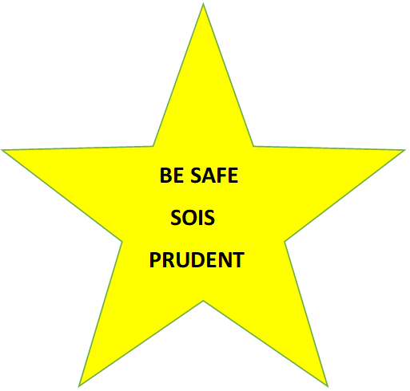 | 
GREEN ZONE LISTENING | THINK BEFORE YOU ACT | DO YOUR WORK AND SHOW INITIATIVE
SAY PLEASE, THANK YOU AND EXCUSE ME | HANDS-OFF/FEET OFF | FOLLOW ALL RULES
TREAT OTHERS THE WAY YOU WOULD LIKE TO BE TREATED | ON THE BUS/PLAYGROUND AND IN THE CLASSROOM | DO WHAT YOU ARE ASKED
OPEN THE DOOR FOR OTHERS OR PICK UP GARBAGE ON GROUND |  | BE A GOOD CITIZEN
GREET OTHERS BY SAYING HELLO OR GOOD MORNING |  | LOOK AFTER YOUR BELONGINGS

We use a Pyramid of Support as a guide for managing and helping promote more positive behaviour.

- Tier 1 level of behaviour involves the re-teaching and reinforcement of what is expected and involves the classroom teacher support. Our emphasis is on teaching correct behaviour, so the student may need to practice and, in some situations, may need time outside of instructional hours (recess or lunch) to meet with the teacher for a tutorial session. With Tier 1 level supports, teachers will use various behaviour management strategies to assist the student to improve their behaviour. The student is encouraged to make better choices and at this level, teachers will be documenting behaviours that need to improve. As well, teachers will discuss these behaviours with families when the behaviour starts to impact the student negatively or is impacting others in the class. *** New: A blue “Solve the Problem” Reflection sheet may be sent home if your child’s behaviour has required some discussion and reflection on how to make it right. Proactive and positive communication between home and school has proven to be helpful with supporting and encouraging positive behaviour.

- If the unexpected behaviour continues and is not resolved after many strategies have been put in place, students will move to Tier 2 support which will involve school administration and the Educational Services Team. At Tier 2, the teacher will review all Tier 1 (teacher) supports that have been put in place to assist the student. The school administration will discuss a plan with the student’s parents and the Guidance Counselor may be involved to develop a behaviour contract. Such a contract would be in place to outline accommodations needed to help the student attain certain behavioral goals. The “Solve the Problem” sheets may still be used, but communication between home and school may increase (ie. Communication book, weekly email, meetings, etc.)

- If it becomes necessary to move to Tier 3, school administration and the Educational Support Services Team will consult with the Anglophone West District Educational Support Services Team. As well, a behaviour plan will be developed to continue to support the student. Integrated Service Delivery Model (ISD) may also be an option.

It is important to note that most behaviours will be handled according to the pyramid of support, however, in the case of serious misconduct (as outlined in Policy 703 – Positive Working and Learning Environment), students will be referred to administration. Behaviour tracking forms will be completed and submitted to the office and the information will be entered into Power School.

Examples of serious incidents can include:

- Playground issues will be dealt with on an individual basis (fighting, bullying, aggressive behaviour)
- Certain behaviours may lead to an in-school or out-of-school suspension (i.e. fighting, bullying, aggressive behavior, throwing objects, inappropriate language or harassment).
- Certain unacceptable classroom behaviours (i.e. refusal to do work, defiance, continued disruption of the learning environment) will be addressed by the teacher first, then administration as required.

Please remember that communication between home and school is instrumental in helping your child to succeed emotionally, socially, and academically in school. Please feel free to contact your child’s teacher if you have any questions or concerns regarding behaviour that may be impacting your child’s learning.

SCHOOL POLICIES AND INFORMATION

- Attendance: Regular attendance is stressed. The Education Act requires students to be at school. A reason is required for any absence from a parent/guardian. Parents are requested to notify the school of your child’s absence by calling 357-4098 by 9:00 AM. We operate a Safe Arrival program and you will be notified by an electronic call if your child has an unknown absence. Emails are also acceptable (copy classroom teacher and administrative assistant).

- Appointments with teachers: As teachers are busy with students or planning for classes during the school day, we ask that you please call or write a note to request a meeting or telephone conversation with your child’s teacher to discuss concerns. Teachers will accommodate you at the first mutually agreed upon time.
- Student Arrival and Dismissal:
- Bus students are supervised from the time their bus arrives at school in the morning. Our first bus arrives at approximately 7:35am.
- Walkers or students who are dropped off should not arrive until 8:05 AM
- Please use the student drop off area in front of the school (by the office doors). You are not permitted to park or drop off in the bus zone.
- If your child is dropped off after 8:25 am, please ring the doorbell and let the administrative assistant know who you are dropping off. The administrative assistant will sign your child in.
- Student Departure: In order to maintain a safe and orderly environment, parents and caregivers are to wait outside until students are dismissed. Please do not enter grassy area past the sidewalk or come to the door of the school. We would appreciate if you could keep your pets inside your vehicle with you.
- If you are picking your child up throughout the school day, you must ring the doorbell and ask the administrative assistant to call your child down. Parents are not permitted to go to the classroom to get children during the school day.
- Our walking students and students getting picked up will be leaving slightly before the bell rings at 3:15. Students taking the bus will be loading the bus once walkers leave the classroom. Students will walk out the front doors to meet parents for pick up.
Bus departure time is 3:15 and students leave the building through the side door closest to bus zone.

If you are picking your child up throughout the school day, please call the front office to let Mrs. Myrie know. Please send a note or phone the school if someone else is picking up your child.
- Visitors: All persons not enrolled, working or affiliated with the school MUST call to make an appointment before coming to the school. If dropping off items to your child, please ring the doorbell and place the items in the basket inside the door.

We are a closed campus. This means that the doors to our school are locked when the students are in class. Please ring the doorbell at the front door for admittance.

Our school thanks you for supporting us in keeping our building a safe and positive learning environment for all.

- Emergency Contact Numbers: It is extremely important that we have an alternate emergency phone number for your child. This is used when school is cancelled during the day because of weather, as well as in case of sickness or emergency. Emergency contact forms are sent home at the beginning of each school year.
IF THERE IS ANY CHANGE IN EMERGENCY CONTACT NUMBERS, PARENTS’ WORK NUMBER OR HOME NUMBER DURING THE SCHOOL YEAR, PLEASE ENSURE THE SCHOOL IS NOTIFIED. We must be able to reach you at any time in case of emergency!

- School lunch program: You will be advised of the lunch program menu on a monthly basis. We do not have a microwave available for student use so please do not send lunch and snack foods that require heating. We are unable to supply cutlery to students unless lunch is purchased.

- Allergy Alert: Some students and/or staff of Summerhill Street Elementary suffer a range of allergy triggers. *Products containing nuts are not permitted school as we have some severe allergy cases.
*We request that you respect our attempt to provide a scent-reduced environment.
*Smoking is not permitted by Provincial Policy on any school property.
*If your child suffers from life-threatening allergies, please ensure that your child’s teacher is aware of the condition and emergency treatment, and that a medical form, as per EECD Policy 704, is completed by school staff.

- Medication: All prescribed medication must be blister-packed by a pharmacist and delivered to the school office by an adult. A medication form needs to be completed by the parent and signed also by the doctor. It is the parent’s responsibility to fill out the medical form and have it signed by the doctor. Non-prescription medicine may be administered at the school if necessary. A note must accompany this giving the teacher or designate permission to administer this. No medication should be given directly to a child for him/her to take without adult supervision.

9) PARENT SCHOOL SUPPORT COMMITTEE (PSSC)
In addition, our Parent School Support Committee is another important volunteer group. The PSSC works in an advisory capacity with the school administration. This committee addresses broad issues related to the education of all children in the school, with the goal of enhancing student learning. Elections for term positions on this committee are held each year. Please see the brochure about the PSSC that is attached if you are interested in this committee.

If you are looking for a bus # for your area, go to the ASDW website,
choose transportation at the top of the page and follow the directions for Oromocto Area.

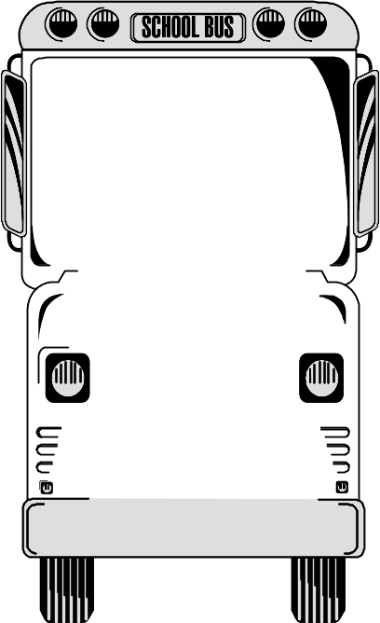

DEPARTMENT OF EDUCATION

SCHOOL BUS SAFETY GUIDELINES

1. Obey the driver promptly.
2. Avoid any unnecessary conversation with the driver while the bus is in motion.
3. Respect the driver and fellow passengers.
- Arrive on time and stand away from the roadway while waiting for the school bus.
- Wait until the bus comes to a complete stop before moving to get on.
- When crossing the road, wait for the driver’s signal and always cross at least 3 metres
in front of the bus. NEVER CROSS BEHIND THE BUS.
- Always keep a safe distance around the school bus.
- Go directly to your seat; allow others to sit with you. Remain seated.
- Sit facing forward, with your belongings on your lap or under the
seat. Keep the aisle clear.
- Obtain approval of the driver to open windows or emergency door.
Nothing must hang out or be thrown out of the windows of the bus.
- Talk quietly. Silence is required when approaching a railway crossing.
12. Eating and drinking are not allowed on the bus.
Use of tobacco is forbidden.
- Neither pets nor large objects are allowed on the bus.
- Anyone who intentionally damages the bus will be held
responsible. Financial restitution may be requested.
- Dress according to weather conditions. For safety reasons,
avoid drawstrings or loose objects on clothing and backpacks.

PUPIL TRANSPORTATION is a privilege – follow the rules.
VIOLATION may result in disciplinary action and possible loss of the privilege

An Important Message to Parents – School Closures Because of Weather Conditions

Anglophone West School District is committed to the safe and efficient transportation of students. The District recognizes it may be necessary to cancel bus runs, close schools, or delay school opening to ensure students are not endangered by hazards brought on by poor weather and road conditions.

Approximately 22,901 students attend 69 schools in the following areas: Perth-Andover, Bath, Florenceville-Bristol, Canterbury, Centreville, Debec, Plaster Rock, Hartland, Grand Falls, Burtts Corner, Millville, Nackawic, Edmundston, Woodstock, Chipman, Coles Island, Minto, Cambridge Narrows, Gagetown, Geary, Fredericton Junction, Burton, Oromocto, Lincoln, Upper Miramichi, Doaktown, Stanley, Harvey, McAdam, New Maryland, and the greater Fredericton area.

276 school buses transport approximately 15,000 students, travelling more than six million kilometers each school year. When a decision is made to close school, delay school opening, cancel bus runs, or delay bus runs, safety is the paramount factor.

Options Considered
- Schools open as usual: no communication required
- All schools closed for the day: see “Communication” section below
- A school or schools in a particular zone of the district closed: see “Communication” section below
- All school bus routes delayed by one hour: On these occasions, all schools in the district will open at their regular time to receive walking students and drop-off students. Students arriving late will not be penalized.
- Schools may be closed early on days when it is anticipated that weather conditions may deteriorate significantly. It is important that parents have alternate arrangements for their children if they or another adult will not be at home to receive the students. Please ensure that the school has up-to-date contact numbers for parents (work numbers, cell numbers, etc.) and at least one emergency contact. It will be announced that buses will run their afternoon runs one, two, or three hours earlier than usual, whatever time is determined.

Important Notes
There may be occasions when a particular bus route is hazardous because of varying weather conditions throughout the district, In cases where the bus driver has a safety concern, he or she has the responsibility to recommend either the cancellation or delay of his/her particular bus run.
On days that the weather or road conditions are poor, parents may exercise their prerogative to keep children at home. Students will not be penalized for such absences, however, parents must provide a written excuse to the student’s teacher when the child returns to school.
There are times when school buses run late for reasons unrelated to weather. Individual school buses expected to be more than 20 minutes late will be announced whenever possible. Parents are responsible for the safety of their children at the stop until the bus comes.

School Zones - please note we are zone 7

1. Edmundston
2. Perth-Andover, Plaster Rock, Grand Falls,
3. Centreville, Florenceville-Bristol, Bath, Woodstock, Hartland, Debec
4. Canterbury, Nackawic, Burtts Corner, Millville, McAdam, Harvey
5. Stanley, Boiestown, Doaktown
6. Greater Fredericton Area (including New Maryland, Keswick Ridge, Nashwaak Valley)
7. Oromocto, Geary, Burton, Lincoln, Sunbury West
8. Chipman, Minto
9. Cambridge Narrows, Coles Island, Gagetown

Decision Process
The Superintendent of Schools makes the decision to keep open or close schools after district transportation personnel provide current information about weather and road conditions. The school district transportation department has access to current weather and road conditions throughout the district through the Department of Transportation and Infrastructure road supervisors, a contracted weather information service provider, as well as other internet sites. Inclement weather predictions are monitored closely throughout the evening and again from 5:00 a.m. onward.

Communication
It is a school-based decision to use voice-messaging, if available. Parents should not rely on this means of notification for information about school closures. Announcements will be made on local radio stations, through a recorded message that can be heard by dialing the district public information line at 1-888-388-4455 (toll free) or 453-5454 any time after 6:00 a.m., and by checking the district website asdw.nbed.ca

The following is a list of radio stations that will be notified of a school closure/delay for announcements:
- CBD – CBC Radio One 91.3 FM Saint John  - CBZ – CBC Radio One 970 AM Fredericton  99.5 FM Fredericton  - CFAI – 101 Rock 105 101.1 FM Edmundston  - CFRK – Fred FM 92.3 FM Fredericton  - CFXY – 105 FM FOX 105.3 FM Fredericton  - CHSJ – Country 94 94.1 FM Saint John  - CHWV – The Wave 97.3 FM Saint John  - CIBX – Capital FM 106.9 FM Fredericton  - CIHI – UP 93.1 93.1 FM Fredericton | - CIKX – K93 93.5 FM Grand Falls  - CINB – NewSong FM 96.1 FM Saint John  - CIOK – K100 100.5 FM Saint John  - CIXN – Joy FM 96.5 FM Fredericton  - CJCW 590 AM Sussex  - CJCJ – CJ 104 104.1 FM Woodstock  - CJPN 90.5 FM Fredericton  - CJRI 94.7 FM Fredericton  - CJYC – 98.9 Big John 98.9 FM Saint John  - CKHJ 1260 AM Fredericton

PARENTS & STUDENTS PLEASE SIGN BELOW

We are looking forward to an exciting school year!

We, ____________________________________________ and
Student signature

________________________________________________
Parent signature

have read and agree to respect the policies and expectations of Summerhill Street Elementary School’s Student
Handbook.

Would you be able to share a hope, wish or dream for your child this year at Summerhill?

____________________________________________________________________________________
____________________________________________________________________________________

