Weekly What’s Up
June 13 –17, 2016
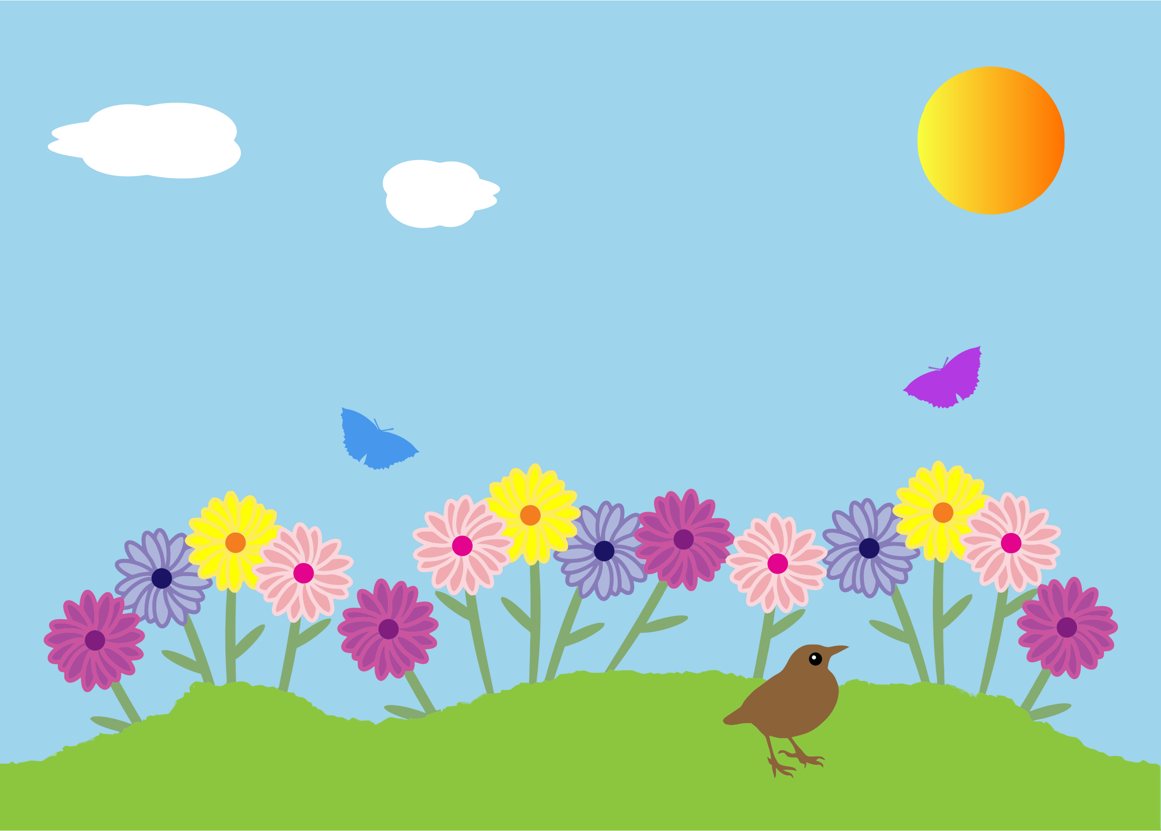
Monday, June 13, 2016
~ 10:05 Sonshine Club
~ Student Led Clubs Final Week
~ Grade 5 End of Year Field Trip to Greenhill Lake
~ Last Day for 4 Chetwynd Swimming 1:30 – 2:05
~ Webmaster Training for Webmasters with Carm Desjardins 3:15

Tuesday, June 14, 2016
~ 2:30 K-2 PLC meeting
~ 10:05 Puppet Club in Mr. Gorham’s classroom
~ Fredericton Library Summer Reading Club Presentation to classes 1:00 all grade 1’s and ½, 1:15, all grade 2’s, 1:30 all K’s (cafeteria), They may drop by the 3-5 classes after K-2 classes are finished.
Wednesday, June 15, 2016
~ Chinese Dance Club 10:05 stage
~ Garden Club at recess
~ Fluoride for Grades 1-5
~ K-2 Spelling Bee Club Meeting 10:05 cafeteria

Thursday, June 16, 2016
~ Grade 3 FI End of year field trip to Clay Café
Friday, June 17, 2016
~ K-2 Field Day (am)
~ Grade 5 Celebration
~ Last Day for Cafeteria

A Look Ahead

Monday June 20 ~ K-2 Field Day rain date 3:30 Staff Meeting, Final Report card comments due to all teachers
Tuesday, June 21 ~ K-2 Spelling Bee at 8:45 am
Wednesday, June 22 ~ Popcorn Day, EA PLC Meeting, 10:30 K Graduation Ceremony
Thursday, June 23 ~ 9:00 presentation for whole school “Jump Rope Jill” , Grade 5 Celebration swim 1:30 – 2:15
Friday, June 24 ~ Last Day of School!
Tuesday, June 28 ~ Last Day for Teachers!

