 | Monday | Tuesday | Wednesday | Thursday | Friday
Cafeteria/  Outside | Chatroom   | Chatroom | Chatroom | Chatroom | Chatroom
Supervisor | Walsh | Elliott | Hickey | Carroll | McGrath
Gym | Gr.6 Badminton  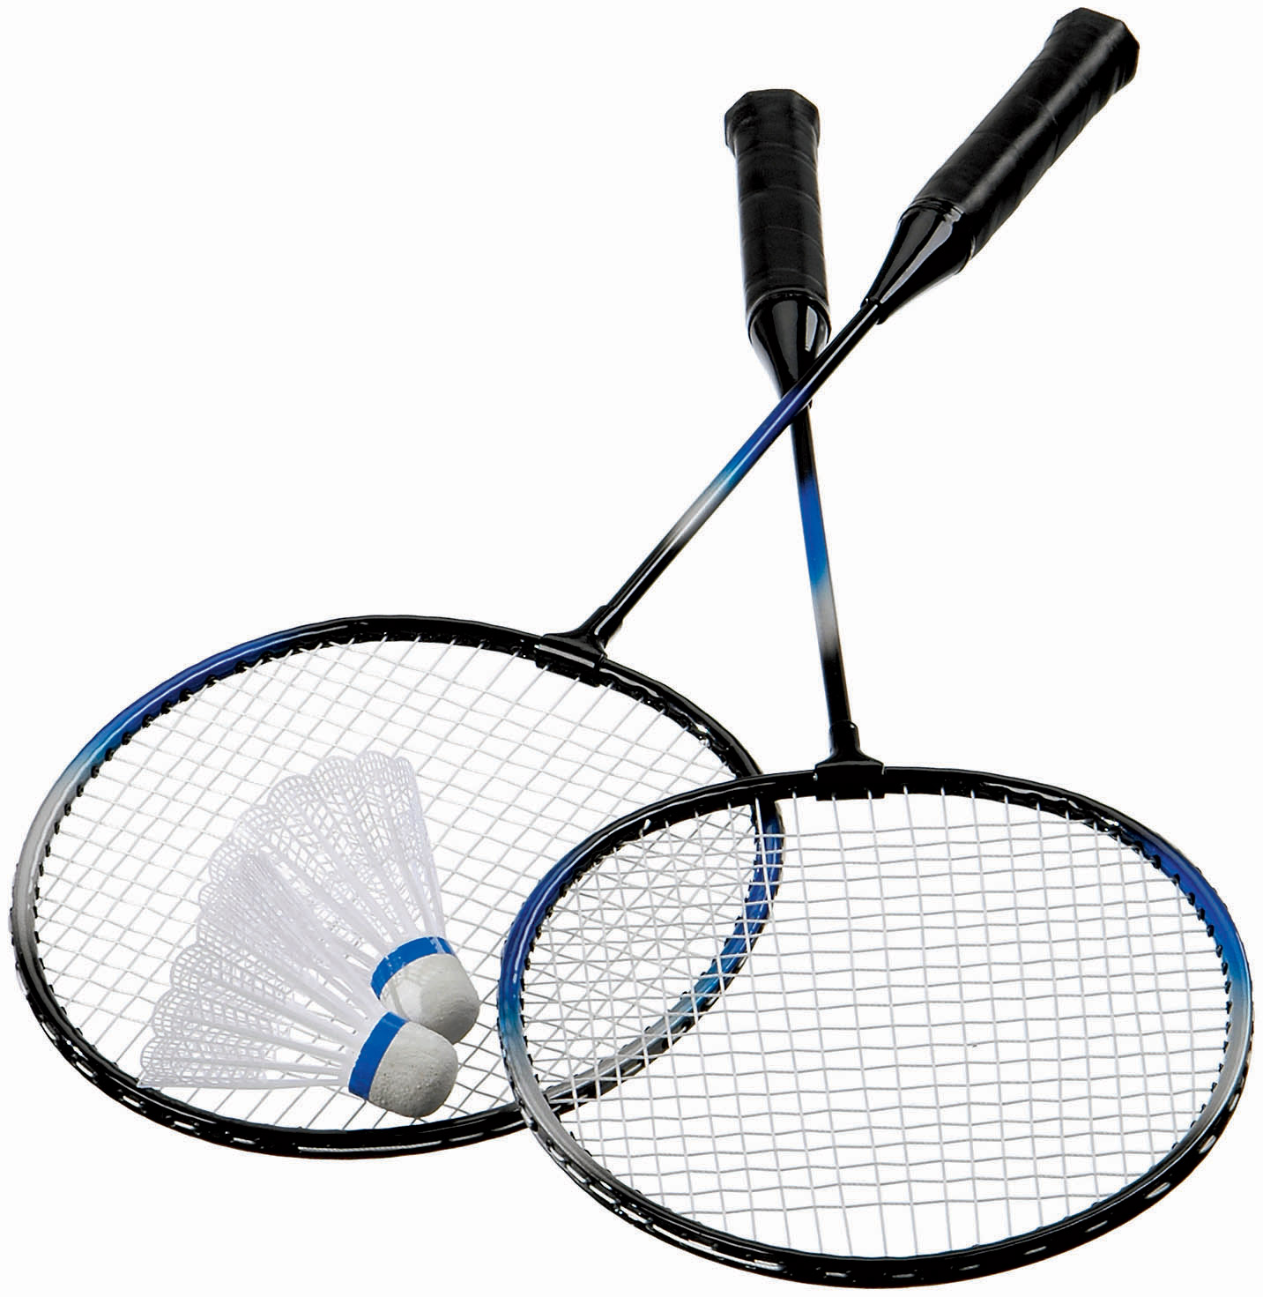 |  | Gr.8 Badminton | Gr.7 Badminton | Ultimate Frisbee  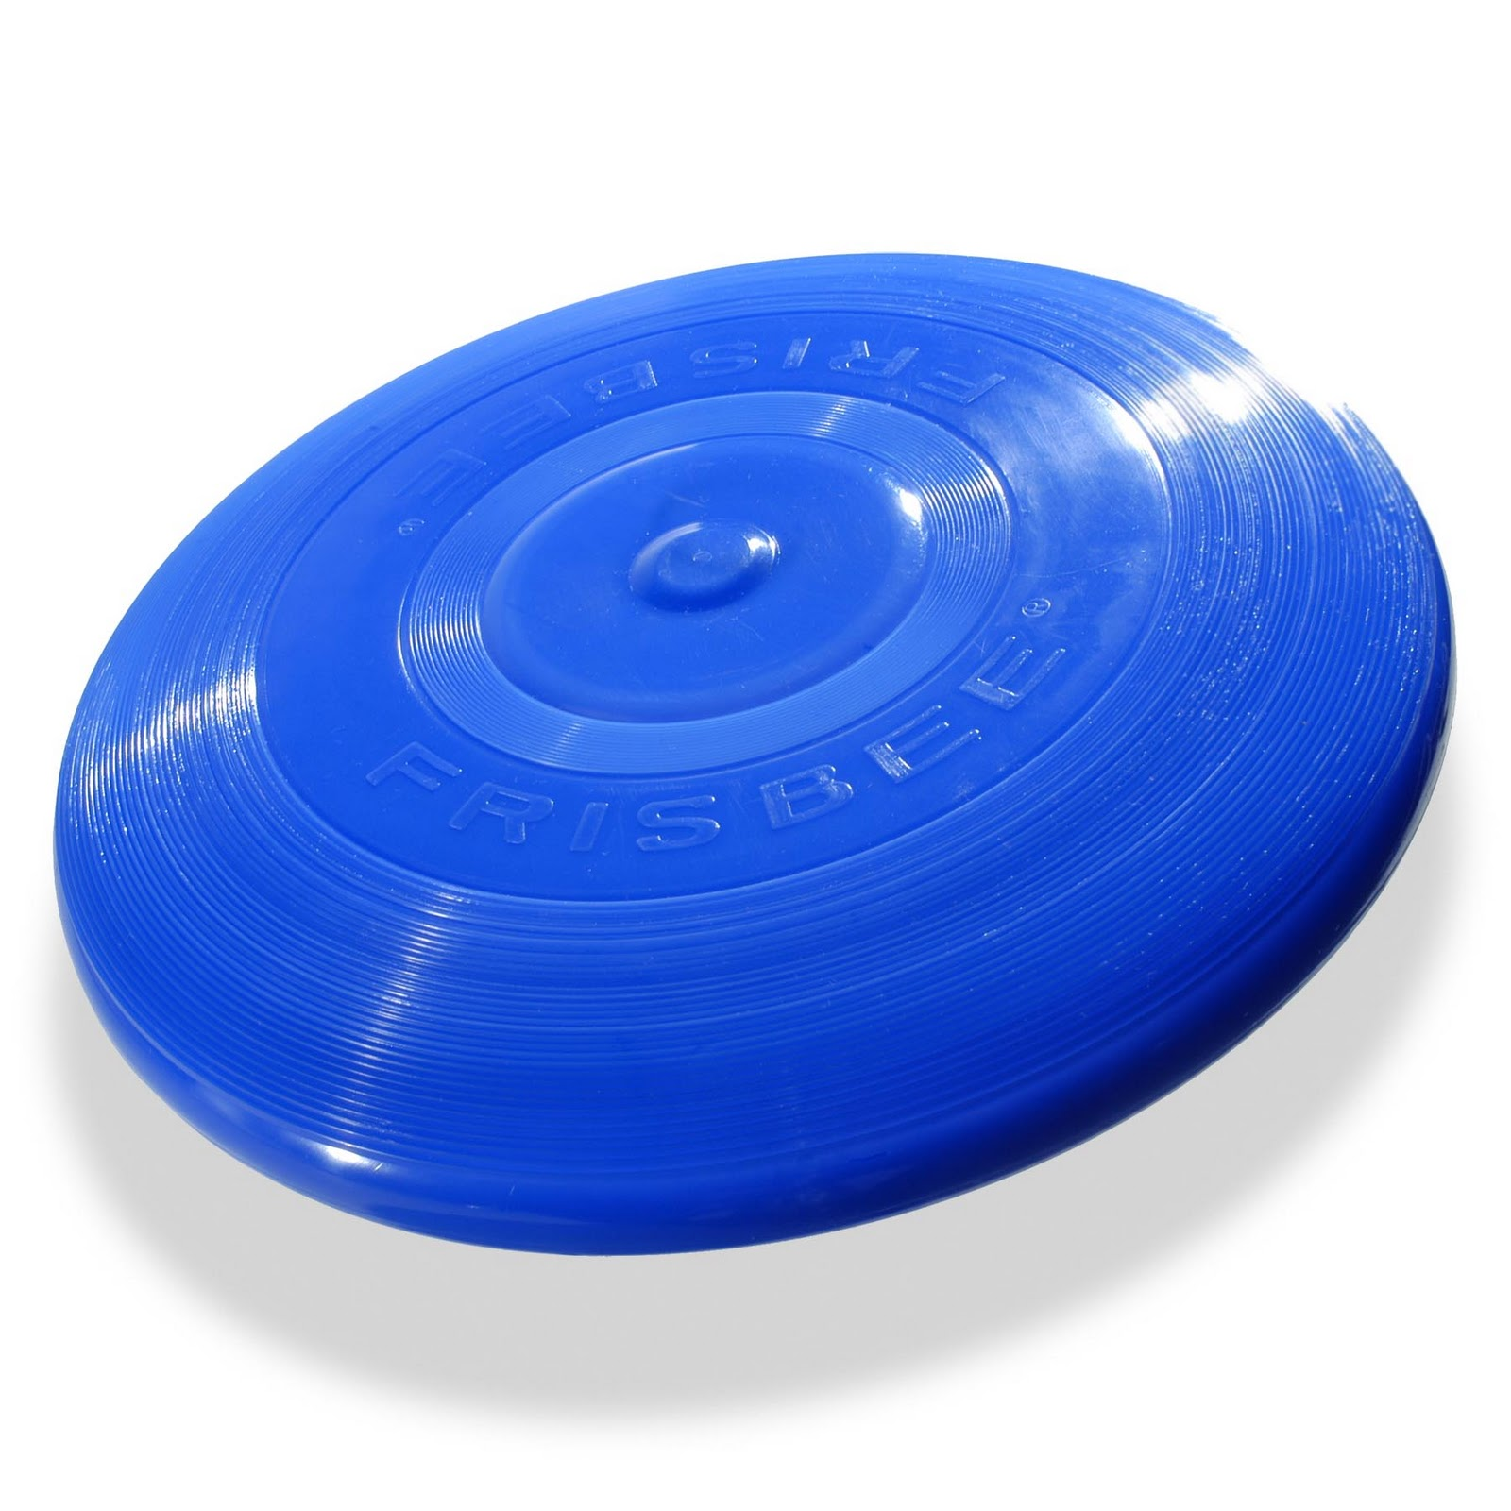
Supervisor | Shiels |  | S. Sullivan | Shiels | Elliott/Taylor
Teacher Workroom |   Homework  (in workroom by Science lab) | Homework  (Room 208) |  | Homework  (Room 211) | Homework  (in workroom by Science lab)
Supervisor | Jackson | Logan |  | McCormick | Sawyer
Tech Lab/  Art Room | Free Sketching   (Art Room) | Yearbook    (Tech Lab) | Photography    (Tech Lab) |  | Free Sketching  (Art Room)
Supervisor | Vincent | Vincent/Petit | Vincent |  | Vincent
Theatre | Drama   | Karaoke   | Drama | Karaoke
Supervisor | Atkinson | Leger | Atkinson | Leger
Other  Locations |  |  | Gr.7 FI Math Help    (Gr. 7 Room 201) | Pokémon    (Science Lab)
Supervisor |  |  | Taylor | Jackson & McGrath
Other  Locations |  |  |   and Nature Club   (Room 206) | Chill Center Drawing & Colouring    (Room 207) | GSA    (Room 218)
Supervisor |  |  | Thériault | Walsh | C. Sullivan
Other  Locations |   (Room 210) |  | Chess    (Room 211) | (Room 210)
Supervisor | Petit |  | McCormick | Petit
Other Locations |  | Ping Pong    (Drafting Room) | Heritage Fair    (Room 210) |  | Ping Pong  (Drafting Room)
Supervisor |  | Graham |  |  | Graham
Other Locations |  |  | Gr. 8 FI Math Help  (Room 220) | Crafts    (Room 105)
Supervisor |  |  | Elliott | Hudson

Activity Period: Round 2
October 31-January 13 (9 weeks)

