 | Monday | Tuesday | Wednesday | Thursday | Friday
Cafeteria/  Outside | Chatroom   | Chatroom | Chatroom | Chatroom | Chatroom
Supervisor | K. Walsh | S. Petit | T. McGrath | M. Leger | L. Taylor
Gym | Boys Volleyball   | Varsity Girls Volleyball |  | High Jump   | Ultimate Frisbee  
Supervisor | S. Sullivan | L. Taylor |  | R. Thériault | K. Elliott
Other  Locations | Free Sketching    (Art Room) | Free Sketching  (Art Room) |   Homework  (Room 208) | Free Sketching  (Art Room) | Card & Board Games  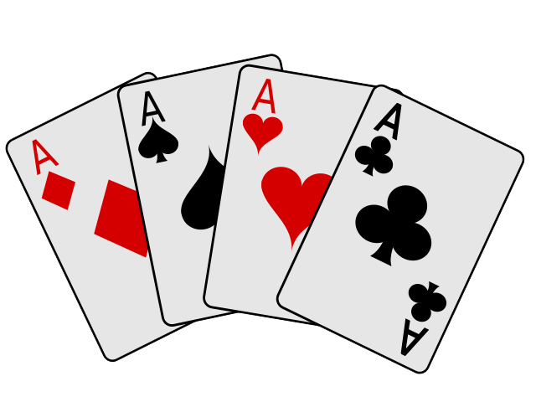  (Science Lab)
Supervisor | S. Carroll | K. McCormick | D. Logan | D. Sawyer | D. Sawyer
Tech Lab | Grade 8 Film   | Grade 8 Film | Grade 8 Film   | Grade 8 Film | Free Sketch/Rowing in Tech Lab  
Supervisor | L. Vincent | L. Vincent | L. Vincent | L. Vincent | L. Vincent
Theatre/  Music Room | Music Enrichment Rehearsal    (Music Room) |  |   (Theatre)  All welcome.  NO PHONES!! | Music Enrichment Rehearsal  (Music Room)
Supervisor | K. Atkinson |  | M. Leger | K. Atkinson
Other Locations | Learn to Speak Spanish    (Science Lab) | Ping Pong    (Drafting Room) | Babysitting Course    (Room 218) | Pokémon Club (Science Lab)   | Ping Pong  (Drafting Room)
Supervisor | D. Sawyer | T. Graham | J. Hickey | S. Jackson | T. Graham
Other  Locations |   (Room 210) |  | Grade 8 Music    (Music Room) | (Room 210) | GSA    (Room 218)
Supervisor | S. Petit |  | K. Atkinson | S. Petit | C. Sullivan
Other  Locations |  |  | Colour & Chill    (Room 216) | Grade 8 Cabaret    (Room 203) | Walking Club    (Room 211)
Supervisor |  |  | S. Carroll | S. Sullivan | K. McCormick
Other Locations | Green Adventurers Math Help    (Room 220) |  | Grade 7 FI Math Help  (Room 201) | French Help    (Room 207) | Grade 6 FI Math Help  (Room 210)
Supervisor | K. Elliott |  | L. Taylor | K. Walsh | S. Petit
Track | Track & Field   | Shot Put &  Long Jump   | Track & Field
Supervisor | D. Shiels | R. Thériault | D. Shiels

Activity Period - Round 5: May 8 – June 23 (7 weeks)

