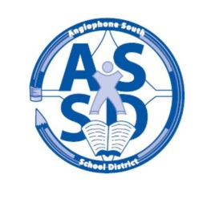
ANGLOPHONE SOUTH SCHOOL DISTRICT
REVISED 2015-16 SCHOOL CALENDAR

2015
August 31 Administration Day for Staff

September 1-2 Council Days for Staff
3 Administration Day for Staff

7 Labour Day – No Classes
8 All Kindergarten children will enter school through a staggered entry process on September 8 and 9 with half of the students attending on the 8th and half on the 9th. All kindergarten children attend on September 10. Schools will be in touch with parents with their scheduled time.
All grades 1-5 students attend on September 8.
For all middle and high school students there will be a “transition day” with grades 6 and 9 only attending on Sept. 8.
Grades K-8 schools will not have a Grade 6 transition day. Grades 6-12 schools will not have a Grade 9 transition day and Grades K-12 schools will have neither Grades 6 or 9 transition days as these days are intended for students who will be starting middle or high school in a different building.
9 All students grades 1 – 12 attend with the exception of Saint John Education Centre high schools where only grades 10 – 12 attend and grade 9’s do not attend

10 Classes for all students K-12 in the District

October 8-9 Professional Learning Days for Staff – No Classes
12 Thanksgiving Day – No Classes

November 11 Remembrance Day – No Classes
27 Parent Teacher Student Conferences K-12 – No Classes

December 18 Last Day of First Term – full day

2016
January 4 Professional Learning Day for Staff – No Classes
5 First Day for Students
25-29 High School Exam Week (Grades 9-12)

February 1-2 Turnaround Days (Grades 9-12 Only – No Classes)
3 Start of Second Semester

March 7-11 March Break – No Classes
25 Good Friday – No classes
28 Easter Monday – No Classes

April 1 Grades K-12 Parent Teacher Student Conferences – No Classes
22 Professional Learning Day for Staff – No Classes
25 Professional Learning Day for Staff – No Classes

May 5 Saint John Education Centre only – AEFNB & NBTA Meeting - No Classes
6 Provincial Council Day – No Classes
9 St. Stephen Education Centre only – NBTA Meeting - No Classes
20 Hampton Education Centre only - AEFNB & NBTA Meeting - No Classes
23 Victoria Day – No Classes

June 13-17 High School Exam Week (Grades 9-12)
24 Last Day for Students
27-28 Administration Days for Staff

