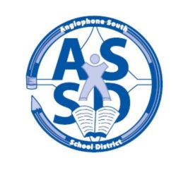

**ANGLOPHONE SOUTH SCHOOL DISTRICT**

**2017-18 SCHOOL CALENDAR**

**2017**

**August** **28** Administration Day for staff

**29-30** Council Days for staff

**31** Administration Day for staff

**September** **1** Professional Learning Day for Staff

**4** Labour Day – No Classes

**5** For all middle and high school students there will be a “transition day” with grades 6 and 9 only attending on Sept. 5.

6 Classes for all students K-12 in the District (Gr. 7 & 8 return to RVMS)

20 Half day for students K-12 - morning only. (Professional Learning for staff)

**October** **9** Thanksgiving Day – No Classes

**25** Half day for students K-12 – morning only. (Professional Learning for staff)

**November** **8** No Classes for K-8 students (Professional Learning and Report Card Preparation)

Half day for Grades 9 – 12 – morning only. (Professional Learning for staff in afternoon)

**13** Remembrance Day – No Classes

**24** Grades K-12 Parent Teacher Student Conferences – No Classes

**December**  **6** Half day for students K-12 – morning only. (Professional Learning for staff)

**22** Last Day of First Term – morning only

**2018**

**January**  **8** First Day for Students

**17** Half day for students K-12 – morning only. (Professional Learning for staff)

**February** **19** Family Day – No Classes

**March**  **5-9** March Break – No Classes

**14** No Classes for K- 8 students (Professional Learning and Report Card Preparation)

**29** Grades K-12 Parent Teacher Student Conferences – No Classes

**30** Good Friday – No Classes

**April** **2** Easter Monday – No Classes

**25** Half day for students K-12 – morning only. (Professional Learning for staff)

**May**  **4** Provincial Council Day – No Classes

**7** Branch NBTA/AEFNB Meetings – No Classes

**21** Victoria Day – No Classes

**June**  **22** Last Day for Students

**25-26** Administration Days for Staff