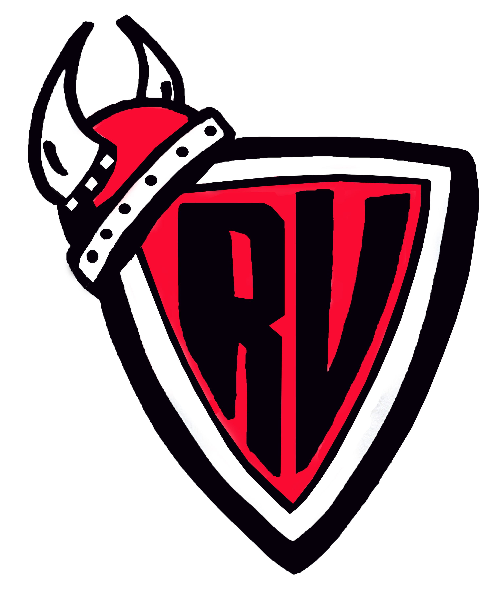
River Valley Middle School
33 Epworth Park Road
Grand Bay-Westfield, NB
E5K 1W1 (506) 738-6500

Ms. T. McGrath, Principal Ms. C. Gatien, Vice-Principal

December 2021

Dear Parents/Guardians,

As you are likely aware, our school practices Lockdowns and Hold & Secure drills as part of our Emergency Plan. Staff & students are familiar with these drills, but we wish to increase your knowledge of our procedures. It is important to understand that school staff will implement a Lockdown, or a Hold & Secure for a variety of reasons. Teachers will also be reviewing our emergency procedures with students over the next few days.

We practice these procedures in at RVMS every school year.

Lockdowns occur when there is imminent danger within the school or immediately outside the school. Once a school is placed in lockdown, all staff and students will remain in a secure location until the situation is resolved. Local police, in our case the RCMP, will respond to the situation. For the safety of all involved, follow the procedure below:

-Do not come to the school. Roadways need to be kept clear for emergency vehicles. Parent vehicles can slow police and other emergency responders from getting to and securing the area as quickly as possible.

-Do not call the school or attempt to text or call your child’s cellphone. In a lockdown situation, silence is important. Phones cannot be answered and ringing or vibrating phones may alert an intruder to the whereabouts of students or staff.

-Go to our designated parent location to receive information from police and school representatives. The designated parent location for RVMS is St. Matthew’s Worship Site located next to Sobeys/Foodland on Dollard Drive.

-Only rely on information that comes directly from the RCMP, the school or school district. Incorrect information and rumours often circulate during an event and can cause unnecessary stress and concern or, in extreme cases, compromise the safety of staff, students and responders. Some situations may also require that information be withheld until the situation is resolved. You may call ASD-S at 658-5300 for more information during any emergency situation. Our regular school messaging system may also be used to contact families in an emergency. Please keep your contact information up to date. During an emergency check your e-mail and voicemail for messages.

Following the lockdown, students may be brought to you at the parent location, or you may be given permission to go to the school.

Hold & Secure situations may occur if there is an emergency in our school or community which does not cause any direct danger to students and staff but may require students to stay in their classrooms. In this situation, all doors to the school are locked. Regular classroom operations continue but no one will be allowed to enter or leave the building until the situation is resolved. Hold & Secure situations have happened because of medical emergencies, train derailments and local police or community situations near a school etc. We also ask that you do not come to the school unless directed to by school staff.

Evacuation drills are practiced in the event that we need to leave the school, or the vicinity of the school for any reason. We also ask that you do not come to the school unless directed to by school staff. If students need to be picked up or are being sent home from one of our alternate sites (RVCC, Westfield School or St. Matthew’s Worship Site), parents will be notified.

We encourage you to discuss school safety with our child and to address any questions or concerns they may have.

We also welcome any questions parents/guardians may have related to the safety and security of our school. Please feel free to contact your child’s teacher or Ms. McGrath by phone or e-mail.

T. McGrath
Principal

