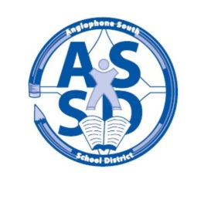
ANGLOPHONE SOUTH SCHOOL DISTRICT
2017-18 SCHOOL CALENDAR

2017

August 28 Administration Day for staff

29-30 Council Days for staff

31 Administration Day for staff

September 1 Professional Learning Day for Staff

4 Labour Day – No Classes

5 For all middle and high school students there will be a “transition day” with grades 6 and 9 only attending on Sept. 5.
7 Classes for all students K-12 in the District (Gr. 7 & 8 return to RVMS)

20 Half day for students K-12 - morning only. (Professional Learning for staff)

October 9 Thanksgiving Day – No Classes

25 Half day for students K-12 – morning only. (Professional Learning for staff)

November 8 No Classes for K-8 students (Professional Learning and Report Card Preparation)
Half day for Grades 9 – 12 – morning only. (Professional Learning for staff in afternoon)

13 Remembrance Day – No Classes

24 Grades K-12 Parent Teacher Student Conferences – No Classes

December 6 Half day for students K-12 – morning only. (Professional Learning for staff)

22 Last Day of First Term – morning only

2018

January 8 First Day for Students

17 Half day for students K-12 – morning only. (Professional Learning for staff)

February 19 Family Day – No Classes

March 5-9 March Break – No Classes

14 No Classes for K- 8 students (Professional Learning and Report Card Preparation)

29 Grades K-12 Parent Teacher Student Conferences – No Classes

30 Good Friday – No Classes

April 2 Easter Monday – No Classes

25 Half day for students K-12 – morning only. (Professional Learning for staff)

May 4 Provincial Council Day – No Classes

7 Branch NBTA/AEFNB Meetings – No Classes

21 Victoria Day – No Classes

June 22 Last Day for Students

25-26 Administration Days for Staff

