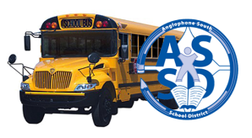
Anglophone South School District uses an online busing system to manage our bus routes and provide information to our families. Information will be available for the next school year in late June. Once next year’s data is made available, please confirm that we have the correct information and if not contact us so we can make adjustments before school begins in September.
https://asdsbp.nbed.nb.ca
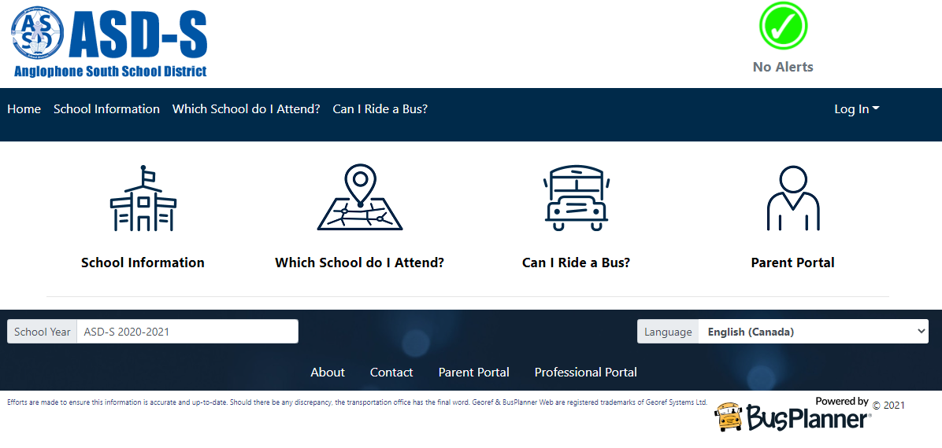
Parents and Guardians have online access to their children’s busing information by choosing the Parent Portal. To register for this service, you will need an email address and the following information:
Student NB Educational Number: ___________________
Student Date of Birth: ____________________________
School: ________________________________________
Grade: ______________

If you require busing to an alternate address for childcare and would like to submit a request for this courtesy service, you can complete the online request at http://asd-s.nbed.nb.ca found under the Transportation drop-down by clicking “Request Additional Address”. If you have issues with that service, you can access the BusPlanner site and choose “Contact” at the bottom of the page.

For all other busing related inquiries please contact:
Email: asds.ptms@nbed.nb.ca
Phone: 506-658-5603

