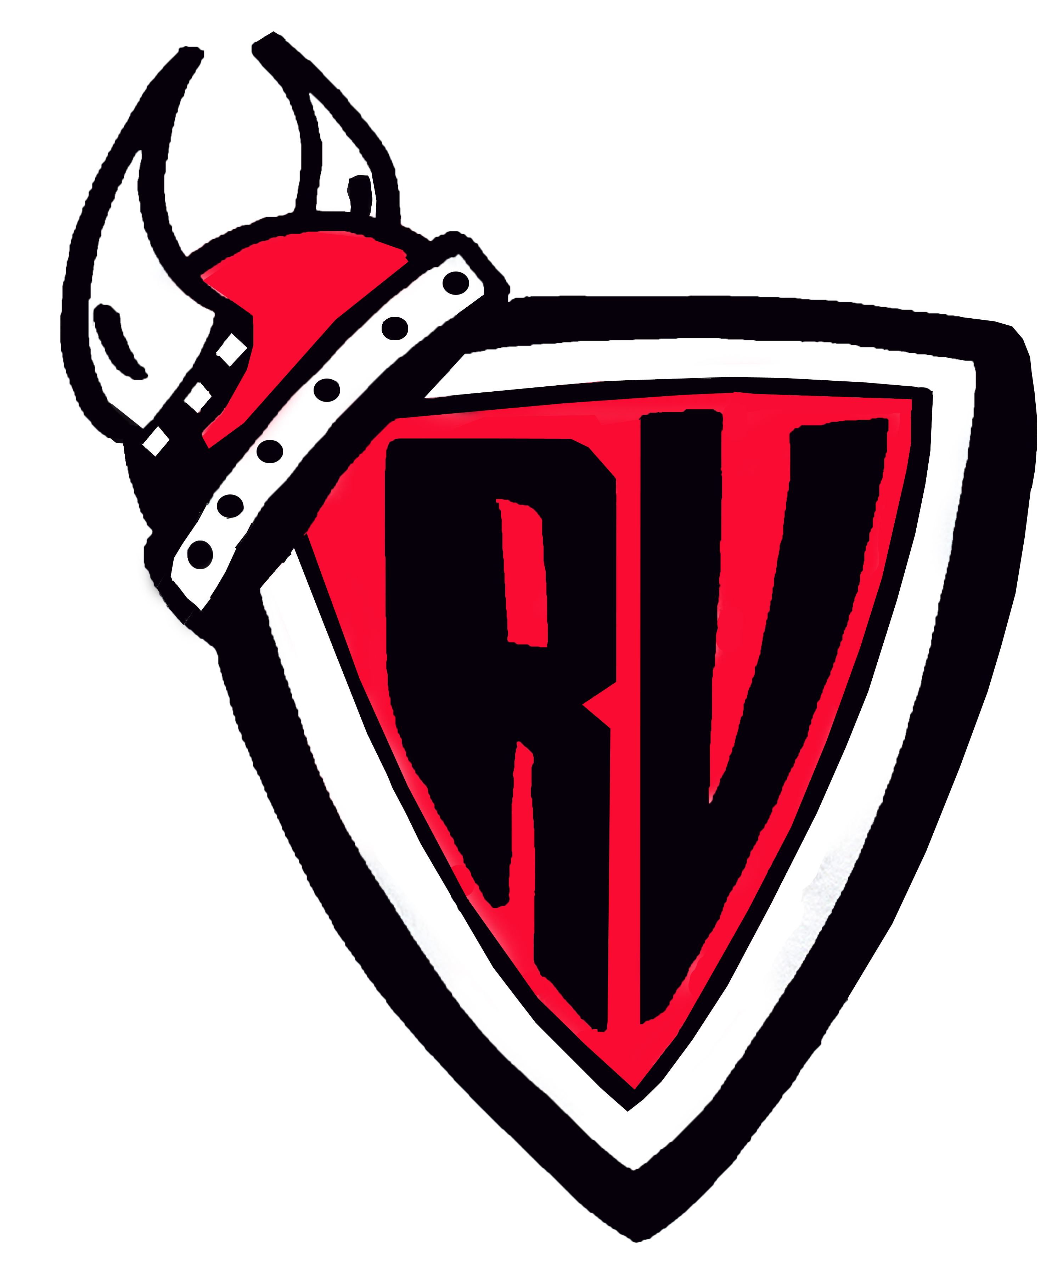
River Valley Middle School
33 Epworth Park Road
Grand Bay-Westfield, NB
E5K 1W1 (506) 738-6500

Ms. T. McGrath, Principal Ms. E. Nelson, Vice-Principal

Friday, October 12th, 2018

Dear Grade 8 Raiders of the Lost Ark Parent(s)/Guardian(s),

Your child’s excellent teaching team has arranged a field trip for Friday, October 26th, 2018. The team will be involved in both Physical Education and Science activities with visits to Timbre Top Adventures and the Irving Nature Park.

Please log on to Cashless Schools to make a payment. The link can be found on the school website at rvms.nbed.nb.ca under the “Make A Payment” Tab. No cash payments please.

The cost of the trip is $30. This covers the student entrance rate at Timbre Top Adventures. All other costs, including bussing, will be covered by the school. Students are asked to dress appropriately to climb in the trees and to hike through the Nature Park. Students must also bring water and a bagged lunch.

Students who do not want to take part in the Timbre Top Adventure may still attend and will participate in other activities with their teachers at Dominion Park.

Please sign below as permission for your child to participate in our field trip.

Thank you,

Mme Morrissey Mrs. Pattison
Mme Sawyer M Sullivan
Mr. Tomilson

------------------------------------------------------------------------------------------------------------------------------

□ Yes, my child, __________________________________________ can attend the grade 8 Raiders of the Lost Ark field trip to Timbre Top Adventures and the Irving Nature Park. I will remit payment online using the “Cashless Schools” payment system.

□ My child, _____________________ will attend but will not participate in the Timbre Top Adventure portion of the day. My child will travel with the group to the Irving Nature Park.

Parent/Guardian signature: _________________________________________

