**Bayview School Reminder**

**Christmas Basket**: Please pick up a little something to add to our Christmas Basket that we are selling tickets on. Any little ornament, craft, puzzle, book or treat would certainly make our basket a success. We would appreciate if you could send your donation in by Wednesday, December 5th. We will place a picture of our filled basket on the website for all to see.

**Tickets**: We have 3 separate tickets that the kids will be bringing home. These are:

The Christmas Basket: Students have been sent home with 2 books of tickets for the Christmas Basket to sell. If you need more tickets, please send in the ones you sold with the money and a note requesting more. We will gladly send more home. Funds from this fund raiser goes to help pay for many extra learning tools our students use.

Best Seat in the House: The winner of this draw will have reserved seating with a great view of the Holiday Concert.

VIP Parking: The winner of this draw will not have to worry about where they are going to park the day of the Holiday Concert. We will have a close space set aside for you.

**\*\***Tickets for Best Seat in the House and VIP Parking will be drawn on December 18th, and the lucky winner will be contacted. **\*\***

Concert date is **December 19th**, starting promptly at 8:45 AM.

**December 21st** is the last day before the break for the holidays, this is a **FULL** day.

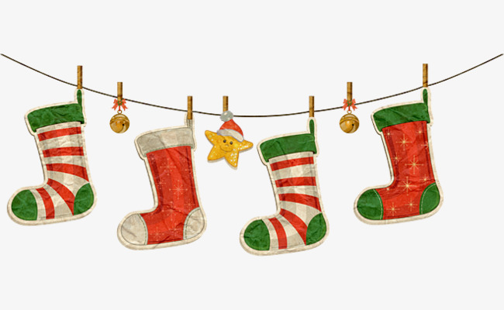Students return to school on January 8, 2019!!