No
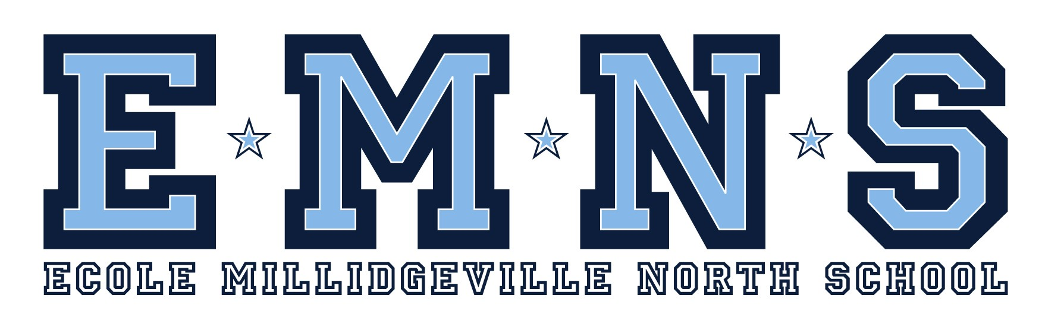
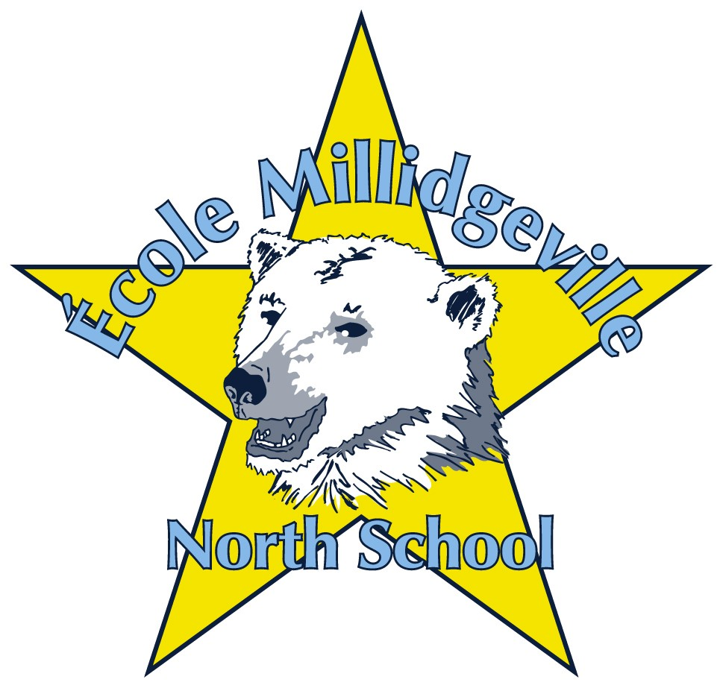
500 Woodward Avenue Saint John, NB E2K 4G7
Tel: (506) 658-5353 Fax (506) 658-2739

Dear Parents/guardians:

École Millidgeville North School is planning an educational trip to Ottawa for eligible grade 8 students. The tentative dates for the trip are June 11th – June 15th 2014. Although the itinerary is not yet set our usual list of activities include: guided tour of Ottawa, visits to Parliament, the Supreme Court, Byward market, science museum, war museum, museum of civilization and much more! All meals, accommodations and tours are included in the price of the trip.

The final cost of the trip depends on the number of students interested and the success of fundraising efforts. A final cost will be determined by November 29^{th.} The cost is typically under $600 and payments are taken in installments between October-May.

A $100 non-refundable deposit is due immediately with the return of the permission form in order to secure your child’s spot on the bus. Receipts will be issued for all payments. Please make cheques payable to École Millidgeville North School.

There will be fund raising opportunities available for all students to help pay for the trip. The first fundraising activity is selling Kiwanis calendars. In past years students have been able to make a significant dent in their school trip fee by selling these calendars. More information will be provided once deposits have been collected.

If you or a company you know are able to contribute financially towards the cost of the trip we would be happy to accept donations of any amount. To make a donation please contact Michael Whelton at 658-5353 or michael.whelton@nbed.nb.ca.

In order to be eligible for this trip, students must maintain good academic merit/effort and behaviour. If a student does not meet these requirements, he or she may be denied permission to go on the trip.

Should you wish to have your son/daughter participate on this trip, please sign and return the bottom portion of this letter with the deposit by November 1st.

Thank you,

Mrs. M. Kirkpatrick
Mme. M. Price
Mr. M. Whelton
--------------------------------------------------------------------------------------------------------

___ I wish to have my son/daughter participate in the trip to Ottawa in June 2014 and have attached a $100 non-refundable deposit.

_____________________________ _______________________________
Child’s Name Parent/Guardian Signature

Principal : Michael Whelton Vice-Principal : Michelle Price

