October 28, 2016

Dear Parent/Guardian:

This is a follow up to a letter you received in late September about the District Education Council for Anglophone South School District launching a long term, multi-year infrastructure planning process in Saint John. There are currently seven schools in central Saint John (K-8), serving a total population of 1,750 students. Since 2001, that number has declined by 27% and the average age of the seven buildings is 58 years old.

Schools in central Saint John include:

* four K-8 schools (St. John the Baptist/King Edward, Hazen-White/St. Francis, Princess Elizabeth, Prince Charles),
* one K-2 school (M. Gerald Teed Memorial),
* one K-5 school (Centennial), and
* one 3-8 school (Millidgeville North).

As outlined in the Department of Education and Early Childhood Development’s Policy 409, the District Education Council is mandated to submit a multi-year infrastructure plan for the district, including facility status reviews, school sustainability studies and major capital priority projects.

To begin that process, a study of central city schools (kindergarten to grade eight) was prepared by Ernst & Young. It recommends one new school (grades 6 to 8) be built, as well as several grade reconfigurations that will optimize district-owned facilities and vacate leased facilities. The full report is available on our website at <http://web1.nbed.nb.ca/sites/asd-s/Pages/welcome.aspx>.

The District Education Council is hosting a series of community meetings to discuss Ernst & Young’s recommendations, options, and to outline the process. The first meeting has been held for your school. The second public meeting allows for interested members of the school community and stakeholders to provide feedback and other options the District Education Council should consider. These meetings will be held from 6:30 to 8:30 p.m., according to the following schedule:

* Wednesday, November 23 – Millidgeville North School
* Wednesday, November 30 – Princess Elizabeth School
* Wednesday, December 7 – Prince Charles School

If you wish to present at the second meeting, please contact our Recording Secretary, Clare Murphy at

658-5325 or [clare.murphy@gnb.ca](mailto:clare.murphy@gnb.ca) by the day prior to your school meeting. We will ensure everyone has time to speak to us. You are also welcome to write to me at the above address or you can send any comments to the following e-mail: [asds.schoolreview@gnb.ca](mailto:asd.sschoolreview@gnb.ca)

...2

Page 2

October 28, 2016

A third and final public meeting will be scheduled once the full list of first and second meetings have been scheduled, likely in March 2017. School meeting dates and times will be publicized in the Telegraph Journal, and through the ASD-S Twitter feed.

Please review the full Ernst & Young report found on the ASD-S website, along with the power point presentation used at the first meeting at your school.

We look forward to your participation in the long range planning process.

Yours truly,

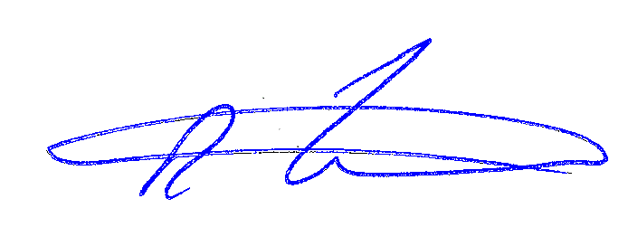

Rob Fowler, Chair

/cmm